Systemic immunomodulatory treatments for atopic dermatitis: a living systematic review and network meta-analysis
Supplementary Appendix for Baseline Review – Published online April 22, 2020
Table of Contents
1. Search Strategy 1
2. Table 1: Systemic immunomodulatory therapies studied in randomized controlled trials for atopic dermatitis included in our review 7
3. Table 2: Risk of Bias in trials 8
4. Table 3: Support for risk of bias assessments 13
7A. Network meta-analysis of change in EASI score up to 16 weeks of treatment 48
1. Network meta-analysis of change in EASI score up to 16 weeks of treatment– main analysis 48
2. Network meta-analysis of change in EASI score up to 16 weeks of treatment – analysis including only studies at low risk of bias 54
3. Network meta-analysis of change in EASI score up to 16 weeks of treatment – analysis including only studies that did not allow concomitant topical anti-inflammatory treatment 58
4. Network meta-analysis of change in EASI score up to 16 weeks of treatment – analysis including only studies that allowed concomitant topical anti-inflammatory treatment 62
5. Network meta-analysis of change in EASI score up to 16 weeks of treatment – analysis including only studies that report results as change in score from baseline 66
7B. Network meta-analysis of change in clinical signs on the standardized mean difference scale up to 16 weeks of treatment 70
1. Network meta-analysis of change in clinical signs on the standardized mean difference scale up to 16 weeks of treatment – main analysis 70
2. Network meta-analysis of change in clinical signs on the standardized mean difference scale up to 16 weeks of treatment – among medications currently in use 76
7C. Network meta-analysis of change in POEM scores up to 16 weeks of treatment 79
1. Network meta-analysis of change in POEM score up to 16 weeks of treatment – main analysis 79
2. Network meta-analysis of change in POEM score up to 16 weeks of treatment – analysis including only studies at low risk of bias 83
3. Network meta-analysis of change in POEM score up to 16 weeks of treatment – analysis including only studies that did not allow concomitant topical anti-inflammatory treatment 86
4. Network meta-analysis of change in POEM score – analysis including only studies that allowed concomitant topical anti-inflammatory treatment up to 16 weeks of treatment 90
7D. Network meta-analysis of withdrawal due to adverse event up to 16 weeks of treatment 94
1. Network meta-analysis of withdrawal due to adverse event up to 16 weeks of treatment – main analysis 94
2. Network meta-analysis of withdrawal due to adverse event up to 16 weeks of treatment - analyses using restrictive priors on treatment effects and heterogeneity parameters (all medications) 96
3. Network meta-analysis of withdrawal due to adverse event up to 16 weeks of treatment - analyses using restrictive priors on treatment effects and heterogeneity parameters (including only medications currently in use) 99
7E. Network meta-analysis of serious adverse event up to 16 weeks of treatment 102
1. Network meta-analysis of serious adverse event up to 16 weeks of treatment – main analysis 102
2. Network meta-analysis of serious adverse event up to 16 weeks of treatment - analyses using restrictive priors on treatment effects and heterogeneity parameters (all medications) 106
3. Network meta-analysis of serious adverse event up to 16 weeks of treatment - analyses using restrictive priors on treatment effects and heterogeneity parameters (including only medications currently in use) 109
7F. Network meta-analysis of change in DLQI scores up to 16 weeks of treatment 111
1. Network meta-analysis of change in DLQI score up to 16 weeks of treatment – main analysis 111
2. Network meta-analysis of change in DLQI score up to 16 weeks of treatment – analysis including only studies at low risk of bias 116
3. Network meta-analysis of change in DLQI score up to 16 weeks of treatment – analysis including only studies that did not allow concomitant topical anti-inflammatory treatment 120
4. Network meta-analysis of change in DLQI score up to 16 weeks of treatment – analysis including only studies that allowed concomitant topical anti-inflammatory treatment 124
5. Network meta-analysis of change in DLQI score up to 16 weeks of treatment – including only studies that reported change from baseline scores 128
6. Network meta-analysis of change in DLQI score up to 16 weeks of treatment– analysis including studies that report results as change from baseline and were at low risk of bias 132
7. Network meta-analysis of change in DLQI score up to 16 weeks of treatment – analysis including studies that report results as change from baseline and did not allow concomitant topical anti-inflammatory treatment 135
8. Network meta-analysis of change in DLQI score up to 16 weeks of treatment – analysis including studies that report results as change from baseline and allowed concomitant topical anti-inflammatory treatment 138
7G. Network meta-analysis of change in quality of life (QoL) on the standardized mean difference scale up to 16 weeks of treatment 141
1. Network meta-analysis of change in QoL on the standardized mean difference scale up to 16 weeks of treatment – main analysis 141
2. Network meta-analysis of change in QoL on the standardized mean difference scale up to 16 weeks of treatment – among medications currently in use 145
7H. Network meta-analysis of change in PPNRS scores up to 16 weeks of treatment 148
1. Network meta-analysis of change in PPNRS score up to 16 weeks of treatment – main analyses 148
2. Network meta-analysis of change in PPNRS score up to 16 weeks of treatment – analysis including only studies at low risk of bias 153
3. Network meta-analysis of change in PPNRS score up to 16 weeks of treatment– analysis including only studies that did not allow concomitant topical anti-inflammatory treatment 155
4. Network meta-analysis of change in PPNRS score up to 16 weeks of treatment – analysis including only studies that allowed concomitant topical anti-inflammatory treatment 158
5. Network meta-analysis of change in PPNRS score up to 16 weeks of treatment – analysis including only studies that report results as change from baseline 161
6. Network meta-analysis of change in PPNRS score up to 16 weeks of treatment– analysis including only studies that report results as change from baseline and were at low risk of bias 164
7. Network meta-analysis of change in PPNRS score up to 16 weeks of treatment – analysis including only studies that report results as change from baseline and did not allow concomitant topical anti-inflammatory treatment 166
8. Network meta-analysis of change in PPNRS score up to 16 weeks of treatment – analysis including only studies that report results as change from baseline and allowed concomitant topical anti-inflammatory treatment 169
9. Network meta-analysis of change in PPNRS score up to 16 weeks of treatment– analysis including only studies that report results as percent change from baseline 172
7I. Network meta-analysis of change in itch VAS scores up to 16 weeks of treatment 176
1. Network meta-analysis of change in itch VAS scores up to 16 weeks of treatment – main analysis 176
2. Network meta-analysis of change in itch VAS scores up to 16 weeks of treatment – analysis including only studies that allowed concomitant topical anti-inflammatory treatment 180
3. Network meta-analysis of change in itch VAS scores up to 16 weeks of treatment – analysis including only studies that report results as change from baseline 184
7J. Network meta-analysis of change in itch on the standardized mean difference scale up to 16 weeks of treatment 188
1. Network meta-analysis of change in itch on the standardized mean difference scale up to 16 weeks of treatment– main analysis 188
2. Network meta-analysis of change in itch on the standardized mean difference scale up to 16 weeks of treatment – among medications currently in use 192

1. Search Strategy

Eczema/atopic dermatitis Medline search
1 exp Eczema/ or eczema.mp.
2 exp Dermatitis, Atopic/
3 neurodermatitis.mp. or exp Neurodermatitis/
4 exp Dermatitis/ or dermatitis.mp.
5 or/1-4
6 Cyclosporine/
7 (c?closporin* or CyA or Cy-A or CsA or Cs-A or csaneoral or neoral or sandimmun*).tw.
8 exp Aminopterin/
9 (aminopterin or MTX or methotrexate).tw.
10 Azathioprine/
11 (az?thioprine or im?uran).tw.
12 Leukotriene Antagonists/
13 Quinolines/
14 (antileukotriene* or anti-leukotriene* or (leukotriene adj3 (antagonist* or block* or inhibitor*))).tw.
15 (leukast* or zafirlukast* or zileuton* or quinoline*).tw.
16 Peptide Fragments/
17 exp Thymus Hormones/
18 exp Recombinant Proteins/
19 Interferon-gamma/
20 (rIFN* or bioferon or biogen or immuneron or imukin or kw-2202 or polyferon or ru-42369 or ru42369 or s-6810 or sch-36850 or sun-4800).tw.
21 (Certilizumab pegol or Certolizumab Pegol or Immunoglobulin fab fragments or polyethylene glycols or cimzia or CDP 870).mp. or CDP870.tw.
22 (ustekinumab or IL 12 or IL 23 or stelara or CNTO 1275 or CNTO-1275).mp. or CNTO1275.tw.
23 (secukinumab or Cosentyx or AIN 457 or AIN-457).mp. or AIN457.tw.
24 (ixekizumab or taltz or IL17 or LY2439821).mp. or LY-2439821.tw.
25 (brodalumab or AMG 827 or AMG827 or AMG-827).mp. or siliq.tw.
26 guselkumab.tw.
27 (tildrakizumab or SCH 900222).mp. or MK-3222.tw.
28 risankizumab.mp. or C000601773.tw.
29 (apremilast or Otezla).mp. or C505730.tw.
30 (tofacitinib or tasocitinib or tofacitinib citrate or Xeljanz or CP 690,550 or CP 690550 or CP-690,550 or
CP-690550).mp. or CP690550.tw.
31 (nemolizumab or interleukin-31 or IL31).mp. or IL-31.tw.
32 (lebrikizumab or IL 13 or IL13 or interleukin 13).mp. or interleukin13.tw.
33 fezakinumab.tw.
34 baricitinib.tw.
35 ((r or recombinant) adj3 (interferon* or IFN or IFNg or IFNgamma)).tw.
36 ((Interferon* or IFN or IFNg or IFNgamma) adj3 (therap* or treat* or administ* or given or deliver* or systemic*or oral*)).tw.
37 (etanercept or enbrel or tnfr fc fusion protein).tw.
38 alefacept.tw.
39 (((tnf or tumor necrosis factor) adj2 receptor) or (tnf adj2 (fusion adj protein*))).tw.
40 Tumor Necrosis Factor-alpha/
41 (anti-TNF* or anti tumo?r necrosis factor).tw.
42 Antibodies, Monoclonal/
43 ((humanized adj8 (monoclonal* or antibod* or MoAb* or mAb or mAbs or fab*1)) or rhuMAb*).tw.
44 (chim?eric adj3 (monoclonal* or antibod* or MoAb* or mAb or mAbs)).tw.
45 ((against or anti) adj IgE adj2 (monoclonal* or antibod* or MoAb* or mAb or mAbs)).tw.
46 ((anti or against or block* or MoAb* or mAb or mAbs or antibod* or monoclonal*) adj3 (IL5 or IL-5 or interleukin-5 or LFA1 or LFA-1 or CD11a)).tw.
47 (interleukin antagonist* or interleukin inhibitor*).mp. or anti-interleukin.tw.
48 ((against or anti) adj (IL 23 or interleukin 23 or IL-23 or interleukin-23)).mp. or IL-23 inhibitor*.tw.
49 ((against or anti) adj (IL 17 or interleukin 17 or IL-17 or interleukin-17)).mp. or IL-17 inhibitor*.tw.
50 ((against or anti) adj (IL 31 or interleukin 31 or IL-31 or interleukin-31)).mp. or IL-31 inhibitor*.tw.
51 ((against or anti) adj (IL 22 or interleukin 2 or IL-22 or interleukin-22)).mp. or IL-22 inhibitor*.tw.
52 (omalizumab or (olizumab or hu-901 or hu901 or tnx-901 or tnx901 or xolair)).tw.
53 (infliximab or (avakine or remicade)).tw.
54 (efalizumab or raptiva or xanelim or hu1124 or hu-1124).tw.
55 (adalimumab or humira or D2E7 or trudexa).tw.
56 (rituximab or idec c2b8 or mabthera or rituxan or rituxin).tw.
57 (keliximab or sb 210396 or sb210396).tw.
58 (mepolizumab or bosatria or sb 240563 or sb240563).tw.
59 Mycophenolic Acid/
60 (mycophen?lat* or mycophenol* or mycofen?lat* or mycofenol* or mofetil* or MMF or erl-080* or erl080* or melbex
or myfortic or nsc-129185 or nsc129185).tw.
61 Immunoglobulins, Intravenous/
62 (((intravenous or IV) adj (immune globulin* or IG or immun?globulin* or antibod*)) or IVIG or HdIVIg).tw.
63 exp Prednisolone/ or Beclomethasone/ or exp Fluocinolone Acetonide/ or Adrenal Cortex Hormones/
64 (prednison* or methylprednis* or dehydrocortisone or dexamethason* or beclomethasone or flunisolide).tw.
65 exp pimecrolimus/ or (asm981 or asm 981 or elidel).tw.
66 exp tacrolimus/ or (fk506 or fk 506).tw.
67 ((systemic or oral* or sublingual* or "per os" or inhal* or nasal* or parenteral*) adj (steroid* or glucosteroid* or corticosteroid* or glucocorticosteroid*)).tw.
68 ((biological*1 or biologic*1) adj (treatment* or therap* or medicine* or drug* or agent* or product* or immunobiologic or immunomodulator*)).tw.
69 (biologic* response modifier* or BRM*).tw.
70 targeted therap*.tw.
71 small molecule*.mp.
72 janus kinase inhibitor*.mp. or JAK inhibitor*.tw.
73 (phosphodiesterase 4 inhibitor* or phosphodiesterase-4 inhibitor*).mp. or PDE4 inhibitor.tw.
74 ((systemic* or oral* or sublingual* or "per os" or inhal* or nasal* or parenteral*) adj3 (treat* or agent* or drug*1 or monotherap* or medication* or medicine* or administ* or given or deliver* or immunosuppres*)).tw.
75 dupilumab.tw.
76 Puva.tw. or Puva therapy/ or Psoralen ultraviolet A Therapy.tw.
77 or/6-76
78 randomized controlled trial.pt.
79 controlled clinical trial.pt.
80 randomized.ab.
81 placebo.ab.
82 clinical trials as topic.sh.
83 randomly.ab.
84 trial.ti.
85 (open label or open-label).ab.
86 78 or 79 or 80 or 81 or 82 or 83 or 84 or 85
87 exp animals/ not humans.sh.
88 86 not 87
89 5 and 77 and 88

Embase search
1 exp eczema/ or eczema.mp
2 exp atopic dermatitis/
3 neurodermatitis.mp or exp neurodermatitis/
4 dermatitis.mp. or exp dermatitis/
5 or/1-4
6 exp cyclosporine/
7 (c?closporin* or CyA or Cy-A or CsA or Cs-A or csaneoral or neoral or sandimmun*).tw.
8 exp aminopterin/
9 (aminopterin or MTX or methotrexate).tw.
10 azathioprine/
11 (az?thioprine or im?uran).tw.
12 exp leukotriene receptor blocking agent/
13 Quinolines/
14 (antileukotriene* or anti-leukotriene* or (leukotriene adj3 (antagonist* or block* or inhibitor*))).tw.
15 (leukast* or zafirlukast* or zileuton* or quinoline*).tw.
16 peptide fragment/
17 exp thymus hormone/
18 recombinant protein*.mp.
19 gamma interferon/
20 (rIFN* or bioferon or biogen or immuneron or imukin or kw-2202 or polyferon or ru-42369 or ru42369 or s-6810 or sch-36850 or sun-4800).tw.
21 (certilizumab pegol or certolizumab pegol or immunoglobulin fab fragments or polyethylene glycol* or cimzia or CDP 870).mp. or CDP870.tw.
22 (ustekinumab or IL 12 or IL 23 or stelara or CNTO 1275 or CNTO-1275).mp. or CNTO1275.tw.
23 (secukinumab or cosentyx or AIN 457 or AIN-457).mp. or AIN457.tw.
24 (ixekizumab or taltz or IL17 or LY2439821).mp. or LY-2439821.tw.
25 (brodalumab or AMG 827 or AMG827 or AMG-827).mp. or siliq.tw.
26 guselkumab.tw. (204)
27 (tildrakizumab or SCH 900222).mp. or MK-3222.tw.
28 risankizumab.mp. or C000601773.tw.
29 (apremilast or Otezla).mp. or C505730.tw.
30 (tofacitinib or tasocitinib or tofacitinib citrate or Xeljanz or CP 690,550 or CP 690550 or CP-690,550 or CP-690550).mp. or CP690550.tw.
31 (nemolizumab or interleukin-31 or IL31).mp. or IL-31.tw.
32 (lebrikizumab or IL 13 or IL13 or interleukin 13).mp. or interleukin13.tw.
33 fezakinumab.tw.
34 baricitinib.tw.
35 ((r or recombinant) adj3 (interferon* or IFN or IFNg or IFNgamma)).tw.
36 ((Interferon* or IFN or IFNg or IFNgamma) adj3 (therap* or treat* or administ* or given or deliver* or systemic* or oral*)).tw.
37 (etanercept or enbrel or tnfr fc fusion protein).tw.
38 alefacept.tw.
39 (((tnf or tumor necrosis factor) adj2 receptor) or (tnf adj2 (fusion adj protein*))).tw.
40 tumor necrosis factor/
41 (anti-TNF* or anti tumo?r necrosis factor).tw.
42 exp monoclonal antibody/
43 ((humanized adj8 (monoclonal* or antibod* or MoAb* or mAb or mAbs or fab*1)) or rhuMAb*).tw.
44 (chim?eric adj3 (monoclonal* or antibod* or MoAb* or mAb or mAbs)).tw.
45 ((against or anti) adj IgE adj2 (monoclonal* or antibod* or MoAb* or mAb or mAbs)).tw.
46 ((anti or against or block* or MoAb* or mAb or mAbs or antibod* or monoclonal*) adj3 (IL5 or IL-5 or interleukin-5 or LFA1 or LFA-1 or CD11a)).tw.
47 (interleukin antagonist* or interleukin inhibitor*).mp. or anti-interleukin.tw.
48 ((against or anti) adj (IL 23 or interleukin 23 or IL-23 or interleukin-23)).mp. or IL-23 inhibitor*.tw.
49 ((against or anti) adj (IL 17 or interleukin 17 or IL-17 or interleukin-17)).mp. or IL-17 inhibitor*.tw.
50 ((against or anti) adj (IL 31 or interleukin 31 or IL-31 or interleukin-31)).mp. or IL-31 inhibitor*.tw.
51 ((against or anti) adj (IL 22 or interleukin 2 or IL-22 or interleukin-22)).mp. or IL-22 inhibitor*.tw.
52 (omalizumab or (olizumab or hu-901 or hu901 or tnx-901 or tnx901 or xolair)).tw.
53 (infliximab or (avakine or remicade)).tw.
54 (efalizumab or raptiva or xanelim or hu1124 or hu-1124).tw.
55 (adalimumab or humira or D2E7 or trudexa).tw.
56 (rituximab or idec c2b8 or mabthera or rituxan or rituxin).tw.
57 (keliximab or sb 210396 or sb210396).tw.
58 (mepolizumab or bosatria or sb 240563 or sb240563).tw.
59 Mycophenolic Acid/
60 (mycophen?lat* or mycophenol* or mycofen?lat* or mycofenol* or mofetil* or MMF or erl-080* or erl080* or melbex or myfortic or nsc-129185 or nsc129185).tw.
61 Immunoglobulins, Intravenous/
62 (((intravenous or IV) adj (immune globulin* or IG or immun?globulin* or antibod*)) or IVIG or HdIVIg).tw.
63 exp prednisolone/ or beclomethasone/ or exp fluocinolone acetonide/ or adrenal cortex hormones/
64 (prednison* or methylprednis* or dehydrocortisone or dexamethason* or beclomethasone or flunisolide).tw.
65 exp pimecrolimus/ or (asm981 or asm 981 or elidel).tw.
66 exp tacrolimus/ or (fk506 or fk 506).tw.
67 ((systemic or oral* or sublingual* or "per os" or inhal* or nasal* or parenteral*) adj (steroid* or glucosteroid* or corticosteroid* or glucocorticosteroid*)).tw.
68 ((biological*1 or biologic*1) adj (treatment* or therap* or medicine* or drug* or agent* or product* or immunobiologic or immunomodulator*)).tw.
69 (biologic* response modifier* or BRM*).tw.
70 targeted therap*.tw.
71 small molecule*.mp.
72 janus kinase inhibitor*.mp. or JAK inhibitor*.tw.
73 (phosphodiesterase 4 inhibitor* or phosphodiesterase-4 inhibitor*).mp. or PDE4 inhibitor.tw.
74 ((systemic* or oral* or sublingual* or "per os" or inhal* or nasal* or parenteral*) adj3 (treat* or agent* or drug*1 or monotherap* or medication* or medicine* or administ* or given or deliver* or immunosuppres*)).tw.
75 Puva.tw. or PUVA/ or Psoralen ultraviolet A Therapy.tw.
76 or/6-75
77. crossover procedure.sh.
78. double‐blind procedure.sh.
79. single‐blind procedure.sh.
80. (crossover$ or cross over$).tw.
81. placebo$.tw.
82. (doubl$ adj blind$).tw.
83. allocat$.tw.
84. trial.ti.
85. randomized controlled trial.sh.
86. random$.tw.
87. or/26‐35
88. exp animal/ or exp invertebrate/ or animal experiment/ or animal model/ or animal tissue/ or animal cell/ or nonhuman/
89. human/ or normal human/
90. 88 and 89
91. 88 not 90
92. 87 not 91
93. 5 and 76 and 92
Non Subject Heading databases (CENTRAL, GREAT, LILACS, Clinical Trials.gov, ISRCTN)
- eczema or “atopic dermatitis” or dermatitis or neurodermatitis
- c?closporin* or CyA or Cy-A or CsA or Cs-A or csaneoral or neoral or sandimmun*
- aminopterin or MTX or methotrexate
- az?thioprine or im?uran
- leukotriene antagonist* or antileukotriene* or anti-leukotriene*or leukast* or zafirlukast* or zileuton* or quinoline*
- peptide fragment*
- thymus hormone*
- recombinant protein*
- interferon-gamma
- rIFN* or bioferon or biogen or immuneron or imukin or kw-2202 or polyferon or ru-42369 or ru42369 or s-6810 or sch-36850 or sun-4800
- certilizumab pegol or certolizumab pegol or immunoglobulin fab fragment* or polyethylene glycol* or cimzia or “CDP 870” or CDP870
- ustekinumab or IL 12 or IL 23 or stelara or CNTO 1275 or CNTO-1275
- secukinumab or Cosentyx or AIN 457 or AIN-457
- ixekizumab or taltz or IL17 or LY2439821 or LY-2439821
- brodalumab or AMG 827 or AMG827 or AMG-827 or siliq
- guselkumab
- tildrakizumab or SCH 900222 or MK-3222
- risankizumab.mp. or C000601773
- apremilast or Otezla or C505730
- tofacitinib or tasocitinib or tofacitinib citrate or Xeljanz or CP 690,550 or CP 690550 or CP-690,550 or CP-690550 or CP690550
- nemolizumab or interleukin-31 or IL31 or IL-31
- lebrikizumab or IL 13 or IL13 or interleukin 13 or interleukin13
- fezakinumab or baricitinib
- ((r or recombinant) adj3 (interferon* or IFN or IFNg or IFNgamma))
- ((Interferon* or IFN or IFNg or IFNgamma) adj3 (therap* or treat* or administ* or given or deliver* or systemic*or oral*))
- etanercept or enbrel or “tnfr fc fusion protein”
- alefacept
- (((tnf or tumor necrosis factor) adj2 receptor) or (tnf adj2 (fusion adj protein*)))
- tumor necrosis factor-alpha
- anti-TNF* or “anti tumo?r necrosis factor”
- monoclonal antibod*
- ((humanized adj8 (monoclonal* or antibod* or MoAb* or mAb or mAbs or fab*1)) or rhuMAb*)
- (chim?eric adj3 (monoclonal* or antibod* or MoAb* or mAb or mAbs))
- ((against or anti) adj IgE adj2 (monoclonal* or antibod* or MoAb* or mAb or mAbs))
- ((anti or against or block* or MoAb* or mAb or mAbs or antibod* or monoclonal*) adj3 (IL5 or IL-5 or interleukin-5 or LFA1 or LFA-1 or CD11a))
- (interleukin antagonist* or interleukin inhibitor*).mp. or anti-interleukin.tw.
- ((against or anti) adj (IL 23 or interleukin 23 or IL-23 or interleukin-23)).mp. or IL-23 inhibitor*
- ((against or anti) adj (IL 17 or interleukin 17 or IL-17 or interleukin-17)).mp. or IL-17 inhibitor*
- ((against or anti) adj (IL 31 or interleukin 31 or IL-31 or interleukin-31)).mp. or IL-31 inhibitor*
- ((against or anti) adj (IL 22 or interleukin 2 or IL-22 or interleukin-22)).mp. or IL-22 inhibitor*
- (omalizumab or (olizumab or hu-901 or hu901 or tnx-901 or tnx901 or xolair))
- (infliximab or (avakine or remicade))
- efalizumab or raptiva or xanelim or hu1124 or hu-1124
- adalimumab or humira or D2E7 or trudexa
- rituximab or idec c2b8 or mabthera or rituxan or rituxin
- keliximab or sb 210396 or sb210396
- mepolizumab or bosatria or sb 240563 or sb240563
- “mycophenolic acid”
- mycophen?lat* or mycophenol* or mycofen?lat* or mycofenol* or mofetil* or MMF or erl-080* or erl080* or melbex or myfortic or nsc-129185 or nsc129185
- intravenous immunoglobulin* or (((intravenous or IV) adj (immune globulin* or IG or immun?globulin* or antibod*)) or IVIG or HdIVIg
- prednisolone or beclomethasone or “fluocinolone acetonide” or “adrenal cortex hormone*” or prednison* or methylprednis* or dehydrocortisone or dexamethason* or beclomethasone or flunisolide
- pimecrolimus or asm981 or “asm 981” or elidel
- tacrolimus or fk506 or “fk 506”
- ((systemic or oral* or sublingual* or "per os" or inhal* or nasal* or parenteral*) adj (steroid* or glucosteroid* or corticosteroid* or glucocorticosteroid*))
- ((biological*1 or biologic*1) adj (treatment* or therap* or medicine* or drug* or agent* or product* or immunobiologic or immunomodulator*))
- “biologic* response modifier*” or BRM*
- “targeted therap*”
- “small molecule*”
- “janus kinase inhibitor*” or “JAK inhibitor*”
- “phosphodiesterase 4 inhibitor*” or “phosphodiesterase-4 inhibitor*” or “PDE4 inhibitor”
- ((systemic* or oral* or sublingual* or "per os" or inhal* or nasal* or parenteral*) adj3 (treat* or agent* or drug*1 or monotherap* or medication* or medicine* or administ* or given or deliver* or immunosuppres*))
- Dupilumab
- Puva or “puva therapy” or “Psoralen ultraviolet A Therapy”
- or/6-76
- 1 and 64

2. Table 1: Systemic immunomodulatory therapies studied in randomized controlled trials for atopic dermatitis included in our review

Drug | No. of included trials | No. of trials assessing Signs | No. of trials assessing Symptoms | No. of trials assessing QoL | No. of trials assessing Itch | No. of trials  assessing Safety
 |  |  |  |  |  | Withdrawal due to adverse event | Withdrawal due to serious adverse event
Abrocitinib | 1 | 1 | 1 | 1 | 1 | 1 | 1
Apremilast | 1 | 1 | 0 | 0 | 0 | 1 | 1
Azathioprine | 3 | 3 | 1 | 2 | 2 | 3 | 2
Baricitinib | 1 | 1 | 0 | 1 | 1 | 1 | 1
Cyclosporine | 9 | 3 | 0 | 4 | 3 | 9 | 5
Dupilumab | 9 | 8 | 8 | 7 | 9 | 8 | 9
Fevipiprant | 1 | 1 | 0 | 0 | 0 | 0 | 1
Fezakinumab | 1 | 0 | 0 | 0 | 1 | 1 | 1
GBR 830 | 1 | 1 | 0 | 0 | 1 | 1 | 1
Lebrikizumab | 1 | 1 | 0 | 1 | 1 | 1 | 1
Methotrexate | 3 | 2 | 1 | 2 | 1 | 3 | 3
Nemolizumab | 2 | 2 | 0 | 0 | 2 | 2 | 2
Tezepelumab | 1 | 1 | 0 | 0 | 1 | 1 | 1
Tralokinumab | 1 | 1 | 0 | 1 | 1 | 1 | 1
Upadacitinib | 1 | 0 | 1 | 0 | 1 | 0 | 1
Ustekinumab | 2 | 1 | 0 | 2 | 2 | 2 | 2
IVIG | 2 | 0 | 0 | 0 | 0 | 2 | 1
Interferon Gamma | 2 | 0 | 0 | 0 | 0 | 2 | 1
Omalizumab | 1 | 0 | 0 | 0 | 0 | 1 | 1
ZPL-3893787 | 1 | 1 | 0 | 0 | 1 | 1 | 1

3. Table 2: Risk of Bias in trials

Reference | Random sequence  generation | Allocation concealment | Blinding of participants and personnel | Blinding of outcome assessment | Incomplete  outcome data | Selective  reporting | Other bias
Sowden UK 1991¹ | Unclear | Unclear | Low | Low | High | Unclear | Low
Hanifin USA 1993² | Low | Unclear | Low | Unclear | High | Unclear | Low
Munro UK 1994³ | Unclear | Unclear | Low | Unclear | High | Unclear | Unclear
Czech Germany 2000⁴ | Low | Unclear | Unclear | Unclear | Low | Unclear | Unclear
Jang Korea 2000⁵ | Unclear | Unclear | Unclear | Unclear | Unclear | Unclear | Unclear
Granlund Finland 2001⁶ | Unclear | Unclear | High | High | Unclear | Unclear | Low
Berth-Jones UK 2002⁷ | Low | Unclear | Low | Unclear | High | Unclear | High
Pacor Italy 2004⁸ | Unclear | Unclear | Low | Low | Low | Unclear | Unclear
Bemanian Iran 2005⁹ | Unclear | Unclear | High | High | High | Unclear | Unclear
Meggit UK 2006¹⁰ | Low | Unclear | Low | Unclear | Unclear | Unclear | Low
Jee Korea 2011¹¹ | Unclear | Unclear | Unclear | Unclear | High | Unclear | High
Schram Holland 2011¹² | Low | Low | High | Unclear | Low | Low | Low
El-Khalawany Egypt  2013¹³ | Low | Unclear | High | High | Low | Low | Low
Iyengar USA 2013¹⁴ | Unclear | Unclear | Unclear | Unclear | Low | High | Low
Beck USA  2014^{15,16} | Low | Low | Low | Low | Low | Low | Low
Khattri USA  2017¹⁷ | Low | Low | Low | Low | Low | Low | Low
Simpson USA  2016 SOLO1¹⁸ | Low | Low | Low | Low | Low | Low | Low
Simpson USA  2016 SOLO2¹⁸ | Low | Low | Low | Low | Low | Low | Low
Thaci Germany 2015^{19,20} | Low | Low | Low | Low | Low | Low | Low
Blauvelt USA 2017²¹ | Low | Low | Low | Low | Low | Low | Low
Goujon France 2018²² | Low | Low | High | Low | Unclear | Low | Low
Ruzicka Germany 2017²³ | Low | Low | Low | Low | High | Low | Low
Saeki Japan 2017²⁴ | Low | Low | Low | Low | Low | Low | Low
Upadacitinib  abstracts 2019^{25,26} | Unclear | Unclear | Low | Low | Low | Unclear | Low
de Bruin-Weller  Netherlands 2018²⁷ | Low | Low | Low | Low | Low | Low | Low
Guttman-Yassky USA 2018 Fezakinumab²⁸ | Unclear | Unclear | Low | Low | Low | Low | Low
Guttman-Yassky USA  2018 Baricitinib²⁹ | Low | Low | Low | Low | Low | Low | Low
Simpson USA  2018 Lebrikizumab³⁰ | Low | Unclear | Low | Low | Low | Low | Low
Wollenberg USA 2018³¹ | Low | Low | Low | Low | Low | Low | Low
Blauvelt USA 2018³² | Low | Low | Low | Low | Unclear | Low | Low
Guttman-Yassky  USA 2019 Dupilumab³³ | Low | Low | Low | Low | Unclear | Low | Low
Guttman-Yassky USA 2019 GBR 830³⁴ | Low | Low | Low | Low | Low | High | Low
Simpson USA 2018  Apremilast³⁵ | Low | Low | Low | Low | Low | Unclear | Low
Simpson USA 2019  Tezepelumab³⁶ | Low | Low | Low | Low | High | Low | Low
Werfel Germany 2018³⁷ | Low | Low | Low | Low | High | Low | Low
NCT01785602;  Fevipiprant (QAW039)³⁸ | Unclear | Unclear | Low | Low | Unclear | Low | Low
Gooderham Canada 2019^{39,40} | Low | Low | Low | Low | High | Unclear | Low
Paller USA 2019  Dupilumab^{41,42} | Unclear | Unclear | Low | Low | Low | Low | Low
Silverberg USA 2019 Dupilumab^{43,44} | Low | Low | Low | Low | Unclear | Low | Low

1. Sowden JM, Berth-Jones J, Ross JS, et al. Double-blind, controlled, crossover study of cyclosporin in adults with severe refractory atopic dermatitis. Lancet 1991; 338(8760): 137-40.
2. Hanifin JM, Schneider LC, Leung DY, et al. Recombinant interferon gamma therapy for atopic dermatitis. Journal of the American Academy of Dermatology 1993; 28(2 Pt 1): 189-97.
3. Munro CS, Levell NJ, Shuster S, Friedmann PS. Maintenance treatment with cyclosporin in atopic eczema. The British journal of dermatology 1994; 130(3): 376-80.
4. Czech W, Brautigam M, Weidinger G, Schopf E. A body-weight-independent dosing regimen of cyclosporine microemulsion is effective in severe atopic dermatitis and improves the quality of life. Journal of the American Academy of Dermatology 2000; 42(4): 653-9.
5. Jang IG, Yang JK, Lee HJ, et al. Clinical improvement and immunohistochemical findings in severe atopic dermatitis treated with interferon gamma. Journal of the American Academy of Dermatology 2000; 42(6): 1033-40.
6. Granlund H, Erkko P, Remitz A, et al. Comparison of cyclosporin and UVAB phototherapy for intermittent one-year treatment of atopic dermatitis. Acta Derm Venereol 2001; 81(1): 22-7.
7. Berth-Jones J, Takwale A, Tan E, et al. Azathioprine in severe adult atopic dermatitis: a double-blind, placebo-controlled, crossover trial. The British journal of dermatology 2002; 147(2): 324-30.
8. Pacor ML, Di Lorenzo G, Martinelli N, Mansueto P, Rini GB, Corrocher R. Comparing tacrolimus ointment and oral cyclosporine in adult patients affected by atopic dermatitis: a randomized study. Clin Exp Allergy 2004; 34(4): 639-45.
9. Bemanian MH, Movahedi M, Farhoudi A, et al. High doses intravenous immunoglobulin versus oral cyclosporine in the treatment of severe atopic dermatitis. Iranian journal of allergy, asthma, and immunology 2005; 4(3): 139-43.
10. Meggitt SJ, Gray JC, Reynolds NJ. Azathioprine dosed by thiopurine methyltransferase activity for moderate-to-severe atopic eczema: a double-blind, randomised controlled trial. Lancet 2006; 367(9513): 839-46.
11. Jee SJ, Kim JH, Baek HS, Lee HB, Oh JW. Long-term Efficacy of Intravenous Immunoglobulin Therapy for Moderate to Severe Childhood Atopic Dermatitis. Allergy Asthma Immunol Res 2011; 3(2): 89-95.
12. Schram ME, Roekevisch E, Leeflang MM, Bos JD, Schmitt J, Spuls PI. A randomized trial of methotrexate versus azathioprine for severe atopic eczema. The Journal of allergy and clinical immunology 2011; 128(2): 353-9.
13. El-Khalawany MA, Hassan H, Shaaban D, Ghonaim N, Eassa B. Methotrexate versus cyclosporine in the treatment of severe atopic dermatitis in children: a multicenter experience from Egypt. Eur J Pediatr 2013; 172(3): 351-6.
14. Iyengar SR, Hoyte EG, Loza A, et al. Immunologic effects of omalizumab in children with severe refractory atopic dermatitis: a randomized, placebo-controlled clinical trial. International archives of allergy and immunology 2013; 162(1): 89-93.
15. Beck LA, Thaci D, Hamilton JD, et al. Dupilumab treatment in adults with moderate-to-severe atopic dermatitis. The New England journal of medicine 2014; 371(2): 130-9.
16. Tsianakas A, Luger TA, Radin A. Dupilumab treatment improves quality of life in adult patients with moderate-to-severe atopic dermatitis: results from a randomized, placebo-controlled clinical trial. The British journal of dermatology 2018; 178(2): 406-14.
17. Khattri S, Brunner PM, Garcet S, et al. Efficacy and safety of ustekinumab treatment in adults with moderate-to-severe atopic dermatitis. Exp Dermatol 2016.
18. Simpson EL, Bieber T, Guttman-Yassky E, et al. Two Phase 3 Trials of Dupilumab versus Placebo in Atopic Dermatitis. The New England journal of medicine 2016; 375(24): 2335-48.
19. Thaci D, Simpson EL, Beck LA, et al. Efficacy and safety of dupilumab in adults with moderate-to-severe atopic dermatitis inadequately controlled by topical treatments: a randomised, placebo-controlled, dose-ranging phase 2b trial. Lancet 2016; 387(10013): 40-52.
20. Simpson EL, Gadkari A, Worm M, et al. Dupilumab therapy provides clinically meaningful improvement in patient-reported outcomes (PROs): A phase IIb, randomized, placebo-controlled, clinical trial in adult patients with moderate to severe atopic dermatitis (AD). Journal of the American Academy of Dermatology 2016; 75(3): 506-15.
21. Blauvelt A, de Bruin-Weller M, Gooderham M, et al. Long-term management of moderate-to-severe atopic dermatitis with dupilumab and concomitant topical corticosteroids (LIBERTY AD CHRONOS): a 1-year, randomised, double-blinded, placebo-controlled, phase 3 trial. Lancet 2017; 389(10086): 2287-303.
22. Goujon C, Viguier M, Staumont-Salle D, et al. Methotrexate Versus Cyclosporine in Adults with Moderate-to-Severe Atopic Dermatitis: A Phase III Randomized Noninferiority Trial. J Allergy Clin Immunol Pract 2017.
23. Ruzicka T, Hanifin JM, Furue M, et al. Anti-Interleukin-31 Receptor A Antibody for Atopic Dermatitis. The New England journal of medicine 2017; 376(9): 826-35.
24. Saeki H, Kabashima K, Tokura Y, et al. Efficacy and safety of ustekinumab in Japanese patients with severe atopic dermatitis: a randomized, double-blind, placebo-controlled, phase II study. The British journal of dermatology 2017; 177(2): 419-27.
25. De Bruin-Weller M, Guttman-Yassky E, Forman S, et al. Effects of upadacitinib on atopic dermatitis signs, symptoms and patient-reported outcomes from a phase IIb randomized, placebo-controlled trial. BRITISH JOURNAL OF DERMATOLOGY; 2018: WILEY 111 RIVER ST, HOBOKEN 07030-5774, NJ USA; 2018. p. E13-E.
26. Reich K, Guttman-Yassky E, Beck L, Hu X, Pangan A, Teixeira H. Early response to upadacitinib in moderate-to-severe atopic dermatitis: Results from a phase 2b randomized, placebo-controlled trial. Allergy; 2018: WILEY 111 RIVER ST, HOBOKEN 07030-5774, NJ USA; 2018. p. 76-.
27. de Bruin-Weller M, Thaci D, Smith CH, et al. Dupilumab with concomitant topical corticosteroid treatment in adults with atopic dermatitis with an inadequate response or intolerance to ciclosporin A or when this treatment is medically inadvisable: a placebo-controlled, randomized phase III clinical trial (LIBERTY AD CAFE). The British journal of dermatology 2018; 178(5): 1083-101.
28. Guttman-Yassky E, Brunner PM, Neumann AU, et al. Efficacy and safety of fezakinumab (an IL-22 monoclonal antibody) in adults with moderate-to-severe atopic dermatitis inadequately controlled by conventional treatments: A randomized, double-blind, phase 2a trial. Journal of the American Academy of Dermatology 2018; 78(5): 872-81 e6.
29. Guttman-Yassky E, Silverberg JI, Nemoto O, et al. Baricitinib in adult patients with moderate-to-severe atopic dermatitis: a phase 2 parallel, double-blinded, randomized placebo-controlled multiple-dose study. Journal of the American Academy of Dermatology 2018; 80(4): 913-21.e9.
30. Simpson EL, Flohr C, Eichenfield LF, et al. Efficacy and safety of lebrikizumab (an anti-IL-13 monoclonal antibody) in adults with moderate-to-severe atopic dermatitis inadequately controlled by topical corticosteroids: A randomized, placebo-controlled phase II trial (TREBLE). Journal of the American Academy of Dermatology 2018; 78(5): 863-71 e11.
31. Wollenberg A, Howell MD, Guttman-Yassky E, et al. Treatment of atopic dermatitis with tralokinumab, an anti-IL-13 mAb. The Journal of allergy and clinical immunology 2019; 143(1): 135-41.
32. Blauvelt A, Simpson EL, Tyring SK, et al. Dupilumab does not affect correlates of vaccine-induced immunity: A randomized, placebo-controlled trial in adults with moderate-to-severe atopic dermatitis. Journal of the American Academy of Dermatology 2019; 80(1): 158-67 e1.
33. Guttman-Yassky E, Bissonnette R, Ungar B, et al. Dupilumab progressively improves systemic and cutaneous abnormalities in patients with atopic dermatitis. Journal of Allergy and Clinical Immunology 2019; 143(1): 155-72.
34. Guttman-Yassky E, Pavel AB, Zhou L, et al. GBR 830, an anti-OX40, improves skin gene signatures and clinical scores in patients with atopic dermatitis. The Journal of allergy and clinical immunology 2019; 144(2): 482-93.e7.
35. Simpson EL, Imafuku S, Poulin Y, et al. A Phase 2 Randomized Trial of Apremilast in Patients with Atopic Dermatitis. The Journal of investigative dermatology 2019; 139(5): 1063-72.
36. Simpson EL, Parnes JR, She D, et al. Tezepelumab, an anti-thymic stromal lymphopoietin monoclonal antibody, in the treatment of moderate to severe atopic dermatitis: A randomized phase 2a clinical trial. Journal of the American Academy of Dermatology 2019; 80(4): 1013-21.
37. Werfel T, Layton G, Yeadon M, et al. Efficacy and safety of the histamine H4 receptor antagonist ZPL-3893787 in patients with atopic dermatitis. The Journal of allergy and clinical immunology 2019; 143(5): 1830-7 e4.
38. Efficacy and Safety Study of QAW039 in the Treatment of Patients With Moderate to Severe Atopic Dermatitis. https://ClinicalTrials.gov/show/NCT01785602.
39. Study To Evaluate Pf-04965842 In Subjects With Moderate To Severe Atopic Dermatitis. https://ClinicalTrials.gov/show/NCT02780167.
40. Gooderham MJ, Forman SB, Bissonnette R, et al. Efficacy and Safety of Oral Janus Kinase 1 Inhibitor Abrocitinib for Patients With Atopic Dermatitis: A Phase 2 Randomized Clinical Trial. JAMA dermatology 2019; [Epub ahead of print].
41. Efficacy and Safety of Dupilumab in Participants ≥12 to <18 Years of Age, With Moderate-to-severe Atopic Dermatitis. https://ClinicalTrials.gov/show/NCT03054428.
42. Paller A, Blauvelt A, Pariser D, et al. Dupilumab for adolescents with moderate-to-severe atopic dermatitis: Results from a phase 3, randomized, double-blinded trial: 10051. Journal of the American Academy of Dermatology 2019; 81(4).
43. Dose-ranging Study of Nemolizumab in Atopic Dermatitis. https://ClinicalTrials.gov/show/NCT03100344.
44. Silverberg JI, Pinter A, Pulka G, et al. Phase 2B randomized study of nemolizumab in adults with moderate-to-severe atopic dermatitis and severe pruritus. The Journal of allergy and clinical immunology 2019; [Epub ahead of print].

4. Table 3: Support for risk of bias assessments

Reference | Random  sequence  generation |  | Allocation  concealment |  | Blinding of  participants and  personnel |  | Blinding of  outcome  assessment |  | Incomplete  outcome data |  | Selective  reporting |  | Other bias
Reference | Judgment | Support | Judgment | Support | Judgment | Support | Judgment | Support | Judgment | Support | Judgment | Support | Judgment | Support
Sowden  UK  1991¹ | Unclear | Insufficient information available from  publication or online supplements | Unclear | Insufficient information | Low | Quote: "...identical-looking  placebo...", | Low | During the course of the study, the clinical investigators,  research nurses and  patients were  unaware of the  specific drugs which the patients were  taking. | High | 25% of patients in the placebo group were crossed over prematurely and  excluded | Unclear | Protocol not cited | Low | No  reason to  suspect other bias
Hanifin  USA  1993² | Low | Quote: "A randomisation  sequence generated by Genentech. Inc.  biostatistics group was used.  Patients were  randomised to  treatment arm  according to a dynamic, adaptive randomisation scheme..." Comment: sufficiently described in  publication | Unclear | Insufficient information | Low | Sufficiently described in publication: placebo and active  treatment were both administered as injections;  Placebo  injections | Unclear | Insufficient information available from publication or online  supplements | High | No Intention to treat | Unclear | Protocol not cited | Low | No  reason to  suspect other bias
Munro  UK  1994³ | Unclear | Insufficient information available from  publication or online  supplements | Unclear | Insufficient information | Low | Quote: "...identical placebo capsules..." Comment: sufficiently  described in publication | Unclear | Insufficient  information from  publication | High | 21% drop outs, no  information on handling of missing data; A lot of early cross-over in the placebo arm | Unclear | Protocol not cited | Unclear | Invalidated new outcome measure
Czech  Germany  2000⁴ | Low | Quote: "...computer-generated randomizaton schedule...". Comment: sufficiently described in publication | Unclear | Insufficient information | Unclear | Insufficient information | Unclear | Insufficient  information available from publication or online  supplements | Low | Only 3% drop outs and ITT analysis;  Intention to treat used with last  observation carried  forward | Unclear | Protocol not cited | Unclear | Comparison of different dosing  regimens of one drug without  placebo group
Jang  Korea  2000⁵ | Unclear | Insufficient information available from  publication or online supplements | Unclear | Insufficient information available from  publication or online supplements | Unclear | Insufficient information available from  publication or online supplements | Unclear | Insufficient  information available from publication or online  supplements | Unclear | Unclear if  patients dropped out, unclear if ITT was  performed | Unclear | Not all  outcomes, that were listed in the  methods section, have been  reported; protocol not cited | Unclear | No clear  information on funding and conflict of interest
Granlund  Finland  2001⁶ | Unclear | Insufficient information available from  publication or online supplements | Unclear | Insufficient information available from  publication or online supplements | High | Quote: "The study was an open,  randomised, controlled, parallel-group study with 2  treatment limbs..." Comment: open-label trial; Not blinded | High | Quote: "The study was an open,  randomised, controlled, parallel-group study with 2 treatment limbs..."  Comment:  open-label trial; Not blinded | Unclear | Handling of drop outs  unclear; Unclear how  missing data is handled | Unclear | Protocol not cited | Low | No  reason to  suspect other bias
Berth-Jones  UK  2002⁷ | Low | Quote: ".. treatment was  randomised balanced block of four using  computer-generated numbers ...".  Comment: sufficiently described in  publication | Unclear | Insufficient information | Low | Quote: "both treatments were  provided in sealed  gelatine  capsules identical in appearance, taste and smell".  Comment: sufficiently described in publication; Matching  placebo | Unclear | Insufficiently  described in  publication | High | Intention-to-treat, but 44% drop outs and but no  information on handling of missing data; 9/19 patients in Azathioprine arm  withdrew | Unclear | Not all  outcomes described in methods part have been  reported, protocol not cited | High | Baseline  imbalance in SASSAD  scores at baseline
Pacor  Italy  2004⁸ | Unclear | Insufficient information available from  publication or online supplements | Unclear | Insufficient information available from  publication or online supplements | Low | Comment: double-blind;  placebo  tablets looking like  cyclosporin and placebo ointment looking like tacrolimus cream; all treatments administered by a person  unaware who was  participating in the study | Low | All treatments were  administered by a person unaware who was  participating in the study. | Low | No drop outs | Unclear | Protocol not cited | Unclear | AUC  analysis with  different baseline  values was not corrected for
Bemanian  Iran  2005⁹ | Unclear | Insufficient information | Unclear | Insufficient information | High | This was an open-label trial, as  blinding  impossible. One group  received oral cyclosporine, the other group immunoglobulin (Sandglobulin-Novartis), as slow IV infusion | High | This was an open-label trial, as blinding impossible. One group  received oral cyclosporine, the other group immunoglobulin (Sandglobulin-Novartis), as slow IV  infusion | High | Exclusion of patients due to poor  cooperation | Unclear | Protocol not cited | Unclear | Different age distribution in study groups that was not  controlled for
Meggit  UK  2006¹⁰ | Low | Quote: "Treatment  allocation was done with minimization (minim computer program, version 1.5) by an  independent  clinician..." Comment: sufficiently described in  publication | Unclear | Insufficient information | Low | Quote:  "Neither  investigator nor patient knew which treatment had been  allocated..." Comment: sufficiently described in publication; Azathioprine and placebo were  formulated as  suspensions that looked and tasted alike | Unclear | Insufficient  information available from publication or online supplements | Unclear | Unclear how missing data for SASSAD were  handled | Unclear | Not all  outcomes, that were listed in the  methods section, have been  reported; protocol not cited | Low | No  reason to  suspect other bias
Jee  Korea  2011¹¹ | Unclear | Insufficient information available from  publication or online supplements | Unclear | Insufficient information available from  publication or online supplements | Unclear | Insufficient information available from  publication or online  supplements | Unclear | Insufficient information available from publication or online  supplements | High | 12 % drop outs, but no  intention to treat or  information on handling of missing data | Unclear | Protocol not cited | High | Baseline imbalance in SCORAD
Schram  Holland  2011¹² | Low | Quote: "Randomization was performed in a 1:1 ratio by using a computerized  program (TENALEA Clinical Trial Data Management System) with the (nondeterministic) minimization method described by Pocock and Simon.24 Patient factors (strata) did not  influence the  allocation scheme" Comment: sufficiently described in publication | Low | Quote: "Concealment of  allocation was achieved by using a computerized program" Comment: sufficiently described in publication | High | Quote: "Patients and safety  assessors were not blinded" Comment: patients were not blinded | Unclear | Quote:  "Clinical outcome measurements were assessed by trained  efficacy  assessors, who were blinded for allocation" Comment:  sufficiently  described in publication, assessor blinded;  Unblinded safety  assessment | Low | 10% drop outs,  intention-to-treat | Low | All  outcomes reported | Low | No  reason to  suspect other bias
El-Khalawany  Egypt  2013¹³ | Low | Quote: "The patients were  randomly (computer-generated simple randomisation method)  divided into two equal groups" Comment: sufficient  information available from  publication | Unclear | Insufficient information | High | open label; No mention of blinding | High | open label; No mention of blinding | Low | No drop-outs | Low | All  outcomes reported | Low | No  reason to  suspect other bias
Iyengar  USA  2013¹⁴ | Unclear | Insufficient information available from  publication or online supplements | Unclear | Insufficient information available from  publication or online supplements | Unclear | Insufficient information available from  publication or online supplements;  Double blind | Unclear | Insufficient information available from publication or online  supplements; Double blind | Low | No drop outs | High | PGA and SGA in  protocol but not in  results | Low | No  reason to  suspect other bias
Beck  USA  2014^{15,16} | Low | Quote: "...a central randomisation scheme  provided by an  interactive voice  response system.." Comment: sufficiently described in protocol, page 28 | Low | Quote:  "Placebo matching REGN668 is prepared in the same formulation as REGN668 without the addition of protein". Comment: sufficiently described in protocol, page 27; Central randomisation scheme  provided by an  interactive voice  response system | Low | Quote: "Study  patients, the principal investigators, and study site  personnel (with the  exception of the  designated unblinded study  pharmacist, or designee) will remain blinded to all randomization  assignments throughout the duration of the study."; "Quote: "Placebo matching REGN668 is prepared in the same formulation as REGN668 without the addition of protein."  Comment: sufficiently described in study  protocol | Low | Quote: "Study patients, the principal  investigators, and study site personnel (with the  exception of the designated unblinded study  pharmacist, or designee) will remain blinded to all  randomization assignments throughout the duration of the study."  Comment:  sufficiently  described in study protocol | Low | According to protocol: last  observation carried  forward (LOCF) method used to  impute missing  values | Low | All  outcomes were  reported | Low | No  reason to  suspect other bias
Khattri  USA  2017¹⁷ | Low | Quote:  "Patients underwent 1:1 randomization using a computer-generated subject randomization table by an unblinded pharmacist." Comment: sufficiently described in publication | Low | Quote:  "Patients underwent 1:1 randomization using a computer-generated subject randomization table by an unblinded pharmacist." Comment: sufficiently described in publication | Low | Quote: "…patients received ustekinumab and placebo as injections…" Comment: double-blind | Low | Double  (Participant, Investigator) | Low | Quote: "Subjects that  withdrew from the study before completing 4 weeks (and a  lesional  biopsy at 4 weeks) were considered treatment failures. For subjects who dropped out after this time point, the last visit was  considered as our  primary endpoint (last  observation carried  forward)." Comment: handling of missing data is described | Low | Pre-  specified outcomes reported | Low | No  reason to  suspect other bias
Simpson USA  2016 SOLO1¹⁸ | Low | Quote: "Randomization was conducted by means of a central  interactive voice-  response system and was  stratified  according to disease  severity (IGA score, 3 vs. 4) and  region." Comment: sufficiently described in publication; Blinded, coded kits containing dupilumab or placebo were used to mask the assigned treatment | Low | Quote: "Randomization was conducted by means of a central  interactive voice-  response system and was  stratified  according to disease  severity (IGA score, 3 vs. 4) and  region." Comment: sufficiently described in publication | Low | Quote: "Masking: Triple  (Participant, Investigator, outcomes Assessor)",  "Blinded, coded kits containing dupilumab or placebo were used to mask the assigned treatment." Comment: sufficiently described in trial register | Low | Quote: "Masking: Triple (Participant, Investigator, outcomes  Assessor)" Comment:  sufficiently  described in trial register; Blinded, coded kits containing dupilumab or placebo were used to mask the assigned treatment | Low | Quote: "…missing values were imputed by means of the last-observation-carried-forward method.", "We  performed three  prespecified sensitivity analyses…with various methods to handle  missing data.  "Comment:  sufficiently described in publication; For  continuous end  points, we treated data that were collected  after the use of rescue medication as missing, and  subsequently we performed multiple  imputation  of missing data using the Markov-chain Monte Carlo  algorithm and a  regression model to generate multiple complete data sets at each time point. | Low | All  outcomes reported | Low | No  reason to  suspect other bias
Simpson USA  2016 SOLO2¹⁸ | Low | Quote: "Randomization was conducted by means of a central  interactive voice  response system and was  stratified  according to disease  severity (IGA score, 3 vs. 4) and  region." Comment: sufficiently described in publication | Low | Quote: "Randomization was conducted by means of a central  interactive voice  response system and was  stratified  according to disease  severity (IGA score, 3 vs. 4) and  region." Comment: sufficiently described in publication | Low | Quote: "Masking: Triple  (Participant, Investigator, outcomes Assessor)",  "Blinded, coded kits containing dupilumab or placebo were used to mask the assigned treatment." Comment: sufficiently described in trial register | Low | Quote: "Masking: Triple (Participant, Investigator, outcomes  Assessor)" Comment:  sufficiently  described in trial register; Blinded, coded kits containing dupilumab or placebo were used to mask the assigned treatment | Low | Quote: "…missing values were imputed by means of the last-observation-carried-forward method.", "We  performed three  prespecified sensitivity analyses…  with various methods to handle missing data." Comment: sufficiently described in publication; For  continuous end  points, we treated data that were collected  after  the use of rescue  medication as missing, and  subsequently we performed multiple imputation  of missing data using the Markov-chain Monte Carlo  algorithm and a  regression model to generate multiple complete data sets at each time point. | Low | All outcomes reported | Low | No  reason to  suspect other bias
Thaci  Germany  2015^{19,20} | Low | Quote: "Randomisation was stratified by disease  severity (moderate [IGA=3] vs severe [IGA=4]) and region  (Japan vs rest of world). We used a  central randomisation scheme, provided by an  interactive voice  response system to the  designated study  pharmacist or qualified designee." Comment: sufficiently described in publication | Low | We used a central randomisation scheme, provided by an  interactive voice  response system to the  designated study  pharmacist or qualified designee." Comment: sufficiently described in publication; Randomisation was stratified by disease  severity (moderate [IGA=3] vs severe [IGA=4]) and region  (Japan vs rest of world) | Low | Quote: Study  patients, principal investigators, study centre personnel, Regeneron and Sanofi personnel, and contract research  organisation personnel in regular  contact with study  centres were masked to treatment assignment during the study, and allocation was  concealed." Comment: sufficiently described in publication; Drug kits were coded, providing masking to treatment assignment. Patients on regimens given every 2 weeks and every 4 weeks  received  volume-matched placebo. | Low | Quote: Study patients,  principal  investigators, study centre personnel,  Regeneron and Sanofi personnel, and contract  research  organisation personnel in regular  contact with study centres were masked to treatment assignment during the study, and  allocation was concealed." Comment:  sufficiently  described in publication | Low | 9% drop out, last  observation carried  forward method for missing data | Low | All  outcomes reported | Low | No  reason to  suspect other bias
Blauvelt USA 2017²¹ | Low | Quote:  "Patients were randomly  assigned (3:1:3)…  using a  central randomisation scheme  provided by an  interactive voice/web response system…" Comment: sufficiently described in publication | Low | Quote:  "Patients were  randomly assigned (3:1:3)…  using a  central randomisation scheme  provided by an  interactive voice/web response system…", The study remained blinded to all  individuals (including patients, investigators, and study personnel) until the time of prespecified  unblinding, except for the  statistician who  provided the randomisation  sequence..." Comment: sufficiently described in publication | Low | Quote:  Patients given  dupilumab q2w  received matching placebo in the weeks when  dupilumab was not given. Blinded study drug kits with a medication numbering system was used.  Placebo was provided in identical  syringes. The study remained blinded to all  individuals (including patients, investigators, and study personnel) until the time of prespecified  unblinding... Comment: sufficiently described in publication | Low | Quote: "The study  remained blinded to all individuals  (including  patients,  investigators, and study  personnel)  until the time of prespecified unblinding,  except for the statistician who provided the  randomisation sequence..." Comment:  sufficiently described in  publication; Blinded study drug kits with a medication numbering system were used | Low | Efficacy analyses for week 52 and timecourse over each study visit were done in the  subset of full analysis set patients (FAS-52) who were randomised by April 27, 2015, and would have completed the week 52 visit by April 27, 2016 (cutoff date for data  submission to the US FDA). | Low | All  outcomes reported | Low | No  reason to  suspect other bias
Goujon France 2018²² | Low | Quote:  "Eligible  patients were  assigned in a 1:1 ratio to receive  either methotrexate (15mg/kg/wk in a single oral dose) or cyclosporine 82.5mg/kg of body weight/d  divided in 2 oral doses). The randomization was  performed centrally  using computer-  generated random numbers..." Comment: sufficiently described in publication | Low | Quote: "The randomization was performed centrally  using computer-  generated random numbers..." Comment: sufficiently described in publication | High | Quote: "Only the assessors were blind to the  treatment allocation." Comment: participants and  personnel were not blinded | Low | Quote: "Only the assessors were blind to the treatment allocation." | Unclear | Sample size decreases substantially with each time point | Low | All clinical outcomes reported | Low | No  reason to  suspect other bias
Ruzicka Germany 2017²³ | Low | Quote:  "Patients underwent randomization with the use of a centralized interactive voice or online  response system…in a 1:1:1:1:1  ratio, with treatment assignments stratified  according to geographic region." Comment: sufficiently described in publication | Low | Quote:  "Patients underwent randomization with the use of a centralized interactive voice or online  response system…in a 1:1:1:1:1  ratio, with treatment assignments stratified  according to geographic region." Comment: sufficiently described in publication | Low | Double blind | Low | Quote: "The primary  efficacy end point was the percentage  improvement between  baseline and week 12 in  the score on the pruritus visual-analogue scale, 25  which was  recorded daily by patients who used  an electronic reporting tool in a  double-blind manner." | High | Per-protocol population used in  analysis of outcomes | Low | All  outcomes reported | Low | No  reason to  suspect other bias
Saeki  Japan  2017²⁴ | Low | Quote:  "Eligible  patients were  randomized (1:1:1) to receive ustekinumab…or placebo  subcutaneously…The study randomization, based on a computer-generated randomization  schedule, was  balanced  using  permuted blocks." Comment: sufficiently described in publication | Low | Quote:  "Eligible  patients were  randomized (1:1:1) to receive ustekinumab…or placebo  subcutaneously…The study randomization, based on a computer-generated randomization  schedule, was  balanced  using  permuted blocks." Comment: sufficiently described in publication | Low | Quote: "All patients,  investigators and the study s  ponsor were blinded to treatment allocation and the blinding was maintained until all  patients completed the study and the  database was locked." Comment: sufficiently described in publication | Low | Quote: "All  patients,  investigators and the study sponsor were blinded to treatment  allocation and the blinding was  maintained until all  patients  completed the study and the database was locked.  "Comment: sufficiently  described in publication | Low | Quote: "Missing data were imputed  using last observation carried  forward. The full analysis set (for efficacy analyses) was based on all  randomized patients who  received at least one administration of the study treatment…" Comment: sufficiently described in publication | Low | All  outcomes reported | Low | No  reason to  suspect other bias
Upadacitinib  abstracts 2019^{25,26} | Unclear | Quote: "...were  randomized to once‐daily upadacitinib monotherapy 7.5, 15 or 30 mg  (n = 42, 42, 42), or  placebo  (n = 41)…" Comment: no detailed information about  random  sequence generation; Insufficient information | Unclear | Insufficient information in abstract | Low | Double-blind | Low | Double blind | Low | Quote: "Missing data were handled by last‐observation‐car-ried‐forward (continuous variables) and non‐  responder‐imputation  (categorical variables)." | Unclear | No protocol cited;  Unclear link to trial registry | Low | No  reason to  suspect other bias
de Bruin-Weller Netherlands 2018²⁷ | Low | Quote: "At baseline,  patients were  randomized (1:1:1)…,  using a  central interactive voice-/web-response randomization  system….  "Comment: sufficiently described in publication | Low | Quote: "...using a central  interactive voice-/web-response randomization system...",  "Except for the  statistician who  provided the randomization  sequence, the IDMC statistician and IDMC members, the study  remained blinded to all individuals…"  Comment: sufficiently described in publication | Low | Quote: "The blinded study drug…was provided in coded kits with a  medication numbering system.  Except for the  statistician who  provided the randomization  sequence, the IDMC statistician and IDMC members, the study  remained blinded to all individuals…"  Comment: sufficiently described in publication | Low | Quote: "Except for the  statistician who provided the randomization  sequence, the IDMC  statistician and IDMC  members, the study  remained blinded to all individuals…" Comment:  sufficiently  described in publication; The blinded study drug (dupilumab or placebo) was provided in coded kits with a  medication numbering system | Low | Quote:  "Efficacy  assessment were based on the full-analysis set, which included all randomized patients, based on the  treatment allocated as randomized (intention-to-treat)." and "Most patients completed the study treatment (98.2%, 100% and 95,4% in the....groups"; Continuous end points were analysed  using  multiple  imputation with  ANCOVA | Low | All  outcomes reported | Low | No  reason to  suspect other bias
Guttman-Yassky  USA 2018  Fezakinumab²⁸ | Unclear | Quote:  "Patients were  randomly assigned to either  intravenous fezakinumab or placebo (2:1)…" Comment: not  sufficiently described in publication and supplemental  material; no additional information about randomization are  provided; No details | Unclear | Quote:  "Patients were randomly assigned to either  intravenous  fezakinumab or placebo (2:1)…" Comment: not  sufficiently described in publication and supplemental  material; no additional information about randomization are  provided; No details | Low | Quote: "...Patients were randomly  assigned to either  intravenous fezakinumab or  placebo…", Comment: double-blind; From protocol: Triple  (Participant, Care  Provider,  Investigator) | Low | From protocol: Triple  (Participant, Care Provider, Investigator) | Low | Quote: "…efficacy variables were  analyzed in the  modified intention-to-treat (ITT) population, where any patient that started treatment was  included in the analysis, and patients that stopped treatment earlier than 12 weeks (N=7, 11.6%) were defined as nonresponders." Comment: sufficiently described in publication | Low | All  outcomes reported | Low | No  reason to  suspect other bias
Guttman-Yassky  USA  2018  Baricitinib²⁹ | Low | Quote:  "Patients were randomized by using an  interactive response technology (IRT) system in a 4:3:3  ratio to….PAREXEL (Waltham, MA) generated the randomization  schedule and  maintained the IRT." Comment: sufficiently described in publication | Low | Quote:  "Parexel (Waltham, MA)  generated the randomization schedule and  maintained the IRT. Investigators enrolled  patients and dispensed interventions per  assignment provided by the IRT." Comment: sufficiently described in publication | Low | Quote:  "Patients, investigators, and study site personnel were blinded to treatment allocation." Comment: sufficiently described in publication | Low | Quote:  "Patients,  investigators, and study site personnel were blinded to treatment allocation." Comment:  sufficiently  described in publication | Low | Quote: "…last  observation carried  forward (LOCF)  analysis was performed…" and "All  randomized patients were  included in the intention-to-treat population." Comment: sufficiently described in publication; A week-16 last  observation carried forward (LOCF)  analysis was performed | Low | All  outcomes reported | Low | No  reason to  suspect other bias
Simpson USA  2018 Lebrikizumab³⁰ | Low | Quote:  "Patients were  randomized 1:1:1:1…", "A blocked randomization scheme stratified by region was used with a block size of 4."  Comment: sufficiently described in publication and supplementary methods | Unclear | Comment: no sufficient information about  allocation concealment | Low | Quote: "To maintain blinding, a placebo arm was  included, and all  patients were administered 2 prefilled  syringes on day 1.  Placebo  patients received…  syringes filled with placebo.", "Placebo was  prepared with the same  formulation as lebrikizumab  without  addition of the active agent, and both formulations were identical in appearance."  Comment: sufficiently described in publication and supplementary methods; Double blind | Low | Double blind | Low | Quote:  "Primary and  secondary efficacy analyses  included all patients who were randomized and  received ≥1 dose of study drug and were analyzed  according to the treatment  assigned at randomization.", "...using a mixed-effects model...  Missing data  were  implicitly imputed by the model (assuming  missing at random)." Comment: sufficiently described in supplementary  methods; Patients missing an EASI score at week 12 were  considered nonresponders. | Low | All  outcomes reported | Low | No  reason to  suspect other bias
Wollenberg USA 2018³¹ | Low | Quote:  "Participants were  randomized 1:1:1:1 to receive  placebo or tralokinumab….", "An  Interactive Web and Voice  Response System (IWRS/IVRS) was used to randomize patients to a treatment group. A  patient was considered randomized into the study when the  site staff  notified the IWRS/IVRS that the  patient met the study  eligibility  criteria and the IWRS/  IVRS  provided the assignment of investigational  product kit numbers." Comment: sufficiently described in publication and supplementary methods | Low | Quote:  "Participants were  randomized 1:1:1:1 to receive  placebo or tralokinumab….", "An  Interactive Web and Voice  Response System (IWRS/  IVRS) was used to  randomize patients to a treatment group. A  patient was considered randomized into the study when the  site staff  notified the IWRS/IVRS that the  patient met the study  eligibility  criteria and the IWRS/  IVRS provided the  assignment of investigational  product kit numbers." Comment: sufficiently described in publication and supplementary methods | Low | Quote: "This was a  double-blind study in which  patients, investigators, and sponsor staff were blinded to the  treatment received. Tralokinumab and placebo are visually  distinct when stored in vials and are not matched for viscosity; however, they cannot be visually distinguished when drawn into a  syringe. Therefore, to ensure appropriate blinding in the study, investigational  product was handled by an unblinded investigational product manager at the site and was administered by an unblinded study team member who was not involved in the management of  patients." Comment: sufficiently described in publication and supplementary methods | Low | Quote: "This was a double-blind study in which  patients,  investigators, and sponsor staff were blinded to the treatment  received. Tralokinumab and placebo are visually distinct when stored in vials and are not matched for viscosity;  however, they cannot be  visually  distinguished when drawn into a syringe. Therefore, to ensure  appropriate blinding in the study,  investigational product was handled by an unblinded  investigational product  manager at the site and was  administered by an unblinded study team member who was not involved in the management of patients." Comment:  sufficiently  described in publication and supplementary  methods | Low | Quote: "The primary population for analysis was the intention-to-treat (ITT) population…", "For continuous end points, no imputation for  missing data was applied. For binary end points, a last observation carried  forward approach was used." Comment: handling of drop-outs sufficiently described | Low | All  outcomes reported | Low | No  reason to  suspect other bias
Blauvelt USA 2018³² | Low | Quote:  "Patients were  randomized (1:1)  via an  interactive response technology system to  subcutaneous  dupilumab or  placebo…" Comment: sufficiently described in publication | Low | Quote:  "Patients were  randomized (1:1)  via an  interactive response technology system to  subcutaneous  dupilumab or  placebo…" Comment: sufficiently described in publication | Low | Quote: "Dupilumab (300 mg) or placebo were  adminis-  tered subcutaneously weekly. A 600-mg loading  dose of dupilumab or matching placebo was  administered on day 1. ",  "Patients and  personnel involved were blinded to all randomization assignments." Comment: double-blind,  sufficiently described in publication | Low | "Patients and personnel  involved were blinded to all randomization assignments." Comment:  sufficiently  described in publication | Unclear | Quote: "Analyses included all randomized patients  who  received any study drug or vaccine injection and  had  measured responses to the tetanus toxoid vac-  cine.",  "patients with missing values were  excluded."; Efficacy data were set to missing  after rescue treatment was used or a patient discontinued | Low | All  outcomes reported | Low | No  reason to  suspect other bias
Guttman-Yassky  USA 2019 Dupilumab³³ | Low | Quote: "A central randomization scheme was used and provided by an  interactive response technology system to the  designated study  pharmacist or qualified designee.", "Patients were randomized 1:1..."  Comment: sufficiently described in publication and supplementary  tables | Low | Quote: "A central randomization scheme was used and provided by an  interactive response technology  system to the  designated study  pharmacist or qualified designee." Comment: sufficiently described in publication and supplementary  tables | Low | double-blind, " Drug kits were coded, masking  the  treatment assigned." Comment: sufficiently described in publication and supplementary  tables | Low | double-blind, " Drug kits were coded,  masking  the treatment assigned." Comment:  sufficiently  described in publication and supplementary  tables;  Quadruple masking  (Participant, Care provider, Investigator, Outcomes  Assessor)  described in trial  registration | Unclear | Missing  values for primary and secondary continuous variables were  imputed  using the last  observation carried  forward method while data were set to missing  after rescue medication. | Low | All  outcomes reported in publication and online supplementary tables | Low | No  reason to  suspect other bias
Guttman-Yassky USA 2019 GBR 830³⁴ | Low | Quote:  "Eligible subjects were  randomized 3:1 to  receive intravenous GBR 830  (10 mg/kg) or corresponding placebo by using a  computer-generated scheme  reviewed and  approved by an  independent statistician." Comment: sufficiently described in publication | Low | Quote:  "Eligible subjects were  randomized 3:1 to  receive  intravenous GBR 830  (10 mg/kg) or corresponding placebo by using a  computer-generated scheme  reviewed and  approved by an  independent statistician." Comment: sufficiently described in publication | Low | Quote:  "Subjects  received 2  intravenous infusions of GBR 830 or placebo on days 1 and 29..."  Comment: double-blind; Study drugs were identical in appearance | Low | Comment: Quadruple masking  (Participant, Care provider, Investigator, Outcomes  Assessor)  described in trial  registration; Double blind | Low | Intention to treat. mixed-  models  repeated measures  approach | High | DLQI not reported | Low | No  reason to  suspect other bias
Simpson USA 2018 Apremilast³⁵ | Low | Quote:  "Eligible  patients were  randomly assigned (1:1:1) to  receive  placebo, apremilast 30mg twice daily, or apremilast 40mg twice daily for 12 weeks  (placebo-controlled period) …with an  interactive web-  response or interactive voice-  response system." and "At week 12,  patients  initially  randomly assigned to receive  placebo were  reassigned randomly (1:1) to  double-blind treatment with  apremilast 30mg twice daily or 40mg twice daily through week 24..." Comment: sufficiently described in publication; Permuted block method | Low | Quote:  "Eligible  patients were  randomly assigned (1:1:1) to  receive  placebo, apremilast 30mg twice daily, or apremilast 40mg twice daily for 12 weeks  (placebo-controlled period) …with an  interactive web-  response or interactive voice-  response system." Comment: sufficiently described in publication; Permuted block method | Low | Quote: "To maintain double-blind conditions for patients and clinical study  personnel throughout the 24-week trial,  assigned treatments were  dispensed only by  authorized personnel at each study side in coded,  identically appearing blister cards containing the assigned treatment and dose." Comment: sufficiently described in publication | Low | Comment:  Triple masking (Participant, Investigator, Outcomes  Assessor)  described in trial  registration; To maintain double-blind conditions for patients and clinical study personnel throughout the 24-week trial, assigned treatments were  dispensed only by authorized personnel at each study site in coded,  identically  appearing  blister cards containing the assigned  treatment/  dose | Low | Quote:  "Efficacy data were assessed in the intention-to-treat population, which  included all randomized patients who  received at least one dose of study  medication according to the group to which they were  randomly assigned.." and "…missing values imputed  using last-observation-carried-forward methodology." Comments: sufficiently described | Unclear | Itch NRS not  reported (listed in protocol) but itch VAS is; Comment: Pruritus Numerical rating scale at Week 12 is reported, but in study  registration Week 4 should be reported | Low | No  reason to  suspect other bias
Simpson USA 2019 Tezepelumab³⁶ | Low | Quote: "…a subject identification (SID) number was assigned by a central  interactive voice/web response system. The SID number was used to identify the patient  during the screening process and throughout study participation, if applicable.", "…patients were  randomized 1:1...to  receive  placebo or tezepelumab..." Comment: sufficiently described in publication and supplementary material | Low | Quote: "…a subject identification (SID) number was assigned by a central  interactive voice/web response system. The SID number was used to identify the patient  during the screening process and throughout study participation, if applicable.", "…patients were  randomized 1:1...to  receive  placebo or tezepelumab..." Comment: sufficiently described in publication and supplementary material | Low | Quote: "Each  patient  received tezepelumab 280 mg or placebo as one 1 ml subcutaneous (SC)  injection…", "The  patient…and the  investigator or sponsor staff were blinded to the  treatment received…  Since tezepelumab and placebo are not identical, an unblinded investigational  product manager prepared the study treatment...The study treatment was than administered by a blinded-study team member." Comment: sufficiently described in publication and supplementary material; Each study site  maintained a written plan  detailing which staff members were blinded or unblinded, and the  process of study treatment  preparation used to maintain the blind. | Low | Quote: "The patient…and the  investigator or sponsor staff were blinded to the treatment received …Since tezepelumab and placebo are not identical, an unblinded investigational product  manager  prepared the study treatment...The study treatment was than administered by a blidned-study team member." Comment:  sufficiently  described in publication and supplementary  material; Each study site maintained a written plan detailing which staff members were blinded or unblinded, and the process of study  treatment preparation used to  maintain the blind. | High | Smaller sample size than  randomized used in  efficacy analysis (CT.gov) | Low | All  outcomes reported | Low | No  reason to  suspect other bias
Werfel Germany 2018³⁷ | Low | Quote:  "Patients were  randomized by using a 2:1  allocation to receive oral ZPL-3893783  (30 mg) or placebo once daily for 8 weeks.", "A computer-generated pseudorandom code generated by using the method of permuted blocks was used to  assign  patients to treatment within each stratum. Randomization  occurred through an interactive Web-based system." Comment: sufficiently described in publication | Low | Quote: "A computer-generated pseudorandom code generated by using the method of permuted blocks was used to  assign  patients to treatment within each stratum. Randomization  occurred through an interactive Web-based system." Comment: sufficiently described in publication | Low | Quote: "...to receive oral ZPL-3893783  (30 mg) or  placebo once daily for 8 weeks…" Comment: double-blind; No reason to suspect  unblinding | Low | Comment: in trial registration masking of outcome  assessor is  defined; Double blind | High | Multiple  imputation; similar  results using full analysis set and  per-protocol populations; different  results in the  worst-case imputation indicating the main  results are biased to the null | Low | All  outcomes reported | Low | No  reason to  suspect other bias
NCT01785602;  Fevipiprant (QAW039)³⁸ | Unclear | Quote: "randomized" Comment: no sufficient information about  random  sequence generation | Unclear | Quote: "randomized" Comment: no sufficient information about  allocation concealment | Low | Quote: "Experimental: QAW039: Participants received QAW039 450 mg daily by mouth. Drug: QAW039 Capsules Placebo Comparator: Placebo  Participants received matching placebo to QAW039. Comment: double-blind | Low | Double blind | Unclear | Insufficient information | Low | All  outcomes reported | Low | No  reason to  suspect other bias
Gooderham  Canada 2019^{39,40} | Low | Quote: "Patients were randomly assigned (1:1:1:1:1) to receive oral  abrocitinib  (200,100,30,or10mg) once daily or placebo once  daily for 12 weeks. Randomization was via an interactive response technology system." | Low | Quote: "Patients were randomly assigned (1:1:1:1:1) to receive oral  Abrocitinib  (200,100,30,or10mg) once daily or placebo once  daily for 12 weeks. Randomization was via an interactive response technology system." | Low | Quote: "Blinded abrocitinib and placebo tablets were delivered to the study sites in  blister packs.  Patients, investigators, and  sponsors were blinded to study  treatment." | Low | Quote: "Blinded abrocitinib and placebo  tablets were delivered to the study sites in blister packs.  Patients, investigators, and sponsors were blinded to study  treatment." | High | Quote: "Efficacy was  assessed in the full  analysis set, which was a modified  intention-to-treat  population that included all patients who  received 1 dose or more of the study drug except for 4 patients from 1 site. Patients from this site were  excluded  before unmasking the database because of major  protocol  deviations, which  included multiple monitoring findings that revealed lack of  principal investigator oversight and study execution  issues."  Comment: 267 were patients randomized; but only 245 were patients analyzed for efficacy end points | Unclear | Proportion of patients achieving SCORAD50 and SCOARD75 not  reported (described in trial  protocol as secondary outcome, page 35) | Low | No  reason to  suspect other bias
Paller USA 2019  Dupilumab^{41,42} | Unclear | Quote: "…patients randomized…"  Comment: not sufficiently  information about  random  sequence generation described in abstract/  trial  registration | Unclear | Comment: no sufficient information about  allocation concealment in  abstract/  trial  registration | Low | Quote: "Masking: Quadruple (Participant, Care  Provider, Investigator, Outcomes Assessor)"; "participants randomized to the placebo group  received placebo matching 300 mg dupilumab (including doubling the amount of placebo on day 1 to match the loading dose" | Low | Quote: "Masking: Quadruple (Participant, Care Provider, Investigator, Outcomes Assessor)"; "participants randomized to the placebo group received placebo matching 300 mg dupilumab (including doubling the amount of placebo on day 1 to match the loading dose" | Low | Analyses done on all randomized patients | Low | All  outcomes reported | Low | No reason to suspect other bias
Silverberg USA 2019 Nemolizumab^{43,44} | Low | Quote: "Randomization was generated by the  Clinical  Research Organization. Treatment was assigned centrally via Interactive Response Technology (IRT). All eligible subjects were randomly assigned to one of the four treatment groups in a 1:1:1:1 ratio. A randomization number was allocated to each eligible subject at baseline by the IRT  system..."  Comment: sufficiently described in supporting information | Low | Quote: "Randomization was generated by the  Clinical  Research Organization. Treatment was assigned centrally via Interactive Response Technology (IRT). All eligible subjects were  randomly assigned to one of the four treatment groups in a 1:1:1:1 ratio. A randomization number was allocated to each eligible subject at baseline by the IRT  system..."  Comment: sufficiently described in supporting information | Low | Comment: quadruple blinding  described in trial  registration | Low | Comment: quadruple blinding  described in trial  registration | Unclear | On CT.gov, the analyses are said to be done on the ITT population, but the "number analyzed" for each analysis is not the full data set | Low | All prespecified outcomes reported | Low | No reason to suspect other bias

1. Sowden JM, Berth-Jones J, Ross JS, et al. Double-blind, controlled, crossover study of cyclosporin in adults with severe refractory atopic dermatitis. Lancet 1991; 338(8760): 137-40.
2. Hanifin JM, Schneider LC, Leung DY, et al. Recombinant interferon gamma therapy for atopic dermatitis. Journal of the American Academy of Dermatology 1993; 28(2 Pt 1): 189-97.
3. Munro CS, Levell NJ, Shuster S, Friedmann PS. Maintenance treatment with cyclosporin in atopic eczema. The British journal of dermatology 1994; 130(3): 376-80.
4. Czech W, Brautigam M, Weidinger G, Schopf E. A body-weight-independent dosing regimen of cyclosporine microemulsion is effective in severe atopic dermatitis and improves the quality of life. Journal of the American Academy of Dermatology 2000; 42(4): 653-9.
5. Jang IG, Yang JK, Lee HJ, et al. Clinical improvement and immunohistochemical findings in severe atopic dermatitis treated with interferon gamma. Journal of the American Academy of Dermatology 2000; 42(6): 1033-40.
6. Granlund H, Erkko P, Remitz A, et al. Comparison of cyclosporin and UVAB phototherapy for intermittent one-year treatment of atopic dermatitis. Acta Derm Venereol 2001; 81(1): 22-7.
7. Berth-Jones J, Takwale A, Tan E, et al. Azathioprine in severe adult atopic dermatitis: a double-blind, placebo-controlled, crossover trial. The British journal of dermatology 2002; 147(2): 324-30.
8. Pacor ML, Di Lorenzo G, Martinelli N, Mansueto P, Rini GB, Corrocher R. Comparing tacrolimus ointment and oral cyclosporine in adult patients affected by atopic dermatitis: a randomized study. Clin Exp Allergy 2004; 34(4): 639-45.
9. Bemanian MH, Movahedi M, Farhoudi A, et al. High doses intravenous immunoglobulin versus oral cyclosporine in the treatment of severe atopic dermatitis. Iranian journal of allergy, asthma, and immunology 2005; 4(3): 139-43.
10. Meggitt SJ, Gray JC, Reynolds NJ. Azathioprine dosed by thiopurine methyltransferase activity for moderate-to-severe atopic eczema: a double-blind, randomised controlled trial. Lancet 2006; 367(9513): 839-46.
11. Jee SJ, Kim JH, Baek HS, Lee HB, Oh JW. Long-term Efficacy of Intravenous Immunoglobulin Therapy for Moderate to Severe Childhood Atopic Dermatitis. Allergy Asthma Immunol Res 2011; 3(2): 89-95.
12. Schram ME, Roekevisch E, Leeflang MM, Bos JD, Schmitt J, Spuls PI. A randomized trial of methotrexate versus azathioprine for severe atopic eczema. The Journal of allergy and clinical immunology 2011; 128(2): 353-9.
13. El-Khalawany MA, Hassan H, Shaaban D, Ghonaim N, Eassa B. Methotrexate versus cyclosporine in the treatment of severe atopic dermatitis in children: a multicenter experience from Egypt. Eur J Pediatr 2013; 172(3): 351-6.
14. Iyengar SR, Hoyte EG, Loza A, et al. Immunologic effects of omalizumab in children with severe refractory atopic dermatitis: a randomized, placebo-controlled clinical trial. International archives of allergy and immunology 2013; 162(1): 89-93.
15. Beck LA, Thaci D, Hamilton JD, et al. Dupilumab treatment in adults with moderate-to-severe atopic dermatitis. The New England journal of medicine 2014; 371(2): 130-9.
16. Tsianakas A, Luger TA, Radin A. Dupilumab treatment improves quality of life in adult patients with moderate-to-severe atopic dermatitis: results from a randomized, placebo-controlled clinical trial. The British journal of dermatology 2018; 178(2): 406-14.
17. Khattri S, Brunner PM, Garcet S, et al. Efficacy and safety of ustekinumab treatment in adults with moderate-to-severe atopic dermatitis. Exp Dermatol 2016.
18. Simpson EL, Bieber T, Guttman-Yassky E, et al. Two Phase 3 Trials of Dupilumab versus Placebo in Atopic Dermatitis. The New England journal of medicine 2016; 375(24): 2335-48.
19. Thaci D, Simpson EL, Beck LA, et al. Efficacy and safety of dupilumab in adults with moderate-to-severe atopic dermatitis inadequately controlled by topical treatments: a randomised, placebo-controlled, dose-ranging phase 2b trial. Lancet 2016; 387(10013): 40-52.
20. Simpson EL, Gadkari A, Worm M, et al. Dupilumab therapy provides clinically meaningful improvement in patient-reported outcomes (PROs): A phase IIb, randomized, placebo-controlled, clinical trial in adult patients with moderate to severe atopic dermatitis (AD). Journal of the American Academy of Dermatology 2016; 75(3): 506-15.
21. Blauvelt A, de Bruin-Weller M, Gooderham M, et al. Long-term management of moderate-to-severe atopic dermatitis with dupilumab and concomitant topical corticosteroids (LIBERTY AD CHRONOS): a 1-year, randomised, double-blinded, placebo-controlled, phase 3 trial. Lancet 2017; 389(10086): 2287-303.
22. Goujon C, Viguier M, Staumont-Salle D, et al. Methotrexate Versus Cyclosporine in Adults with Moderate-to-Severe Atopic Dermatitis: A Phase III Randomized Noninferiority Trial. J Allergy Clin Immunol Pract 2017.
23. Ruzicka T, Hanifin JM, Furue M, et al. Anti-Interleukin-31 Receptor A Antibody for Atopic Dermatitis. The New England journal of medicine 2017; 376(9): 826-35.
24. Saeki H, Kabashima K, Tokura Y, et al. Efficacy and safety of ustekinumab in Japanese patients with severe atopic dermatitis: a randomized, double-blind, placebo-controlled, phase II study. The British journal of dermatology 2017; 177(2): 419-27.
25. De Bruin-Weller M, Guttman-Yassky E, Forman S, et al. Effects of upadacitinib on atopic dermatitis signs, symptoms and patient-reported outcomes from a phase IIb randomized, placebo-controlled trial. BRITISH JOURNAL OF DERMATOLOGY; 2018: WILEY 111 RIVER ST, HOBOKEN 07030-5774, NJ USA; 2018. p. E13-E.
26. Reich K, Guttman-Yassky E, Beck L, Hu X, Pangan A, Teixeira H. Early response to upadacitinib in moderate-to-severe atopic dermatitis: Results from a phase 2b randomized, placebo-controlled trial. Allergy; 2018: WILEY 111 RIVER ST, HOBOKEN 07030-5774, NJ USA; 2018. p. 76-.
27. de Bruin-Weller M, Thaci D, Smith CH, et al. Dupilumab with concomitant topical corticosteroid treatment in adults with atopic dermatitis with an inadequate response or intolerance to ciclosporin A or when this treatment is medically inadvisable: a placebo-controlled, randomized phase III clinical trial (LIBERTY AD CAFE). The British journal of dermatology 2018; 178(5): 1083-101.
28. Guttman-Yassky E, Brunner PM, Neumann AU, et al. Efficacy and safety of fezakinumab (an IL-22 monoclonal antibody) in adults with moderate-to-severe atopic dermatitis inadequately controlled by conventional treatments: A randomized, double-blind, phase 2a trial. Journal of the American Academy of Dermatology 2018; 78(5): 872-81 e6.
29. Guttman-Yassky E, Silverberg JI, Nemoto O, et al. Baricitinib in adult patients with moderate-to-severe atopic dermatitis: a phase 2 parallel, double-blinded, randomized placebo-controlled multiple-dose study. Journal of the American Academy of Dermatology 2018; 80(4): 913-21.e9.
30. Simpson EL, Flohr C, Eichenfield LF, et al. Efficacy and safety of lebrikizumab (an anti-IL-13 monoclonal antibody) in adults with moderate-to-severe atopic dermatitis inadequately controlled by topical corticosteroids: A randomized, placebo-controlled phase II trial (TREBLE). Journal of the American Academy of Dermatology 2018; 78(5): 863-71 e11.
31. Wollenberg A, Howell MD, Guttman-Yassky E, et al. Treatment of atopic dermatitis with tralokinumab, an anti-IL-13 mAb. The Journal of allergy and clinical immunology 2019; 143(1): 135-41.
32. Blauvelt A, Simpson EL, Tyring SK, et al. Dupilumab does not affect correlates of vaccine-induced immunity: A randomized, placebo-controlled trial in adults with moderate-to-severe atopic dermatitis. Journal of the American Academy of Dermatology 2019; 80(1): 158-67 e1.
33. Guttman-Yassky E, Bissonnette R, Ungar B, et al. Dupilumab progressively improves systemic and cutaneous abnormalities in patients with atopic dermatitis. Journal of Allergy and Clinical Immunology 2019; 143(1): 155-72.
34. Guttman-Yassky E, Pavel AB, Zhou L, et al. GBR 830, an anti-OX40, improves skin gene signatures and clinical scores in patients with atopic dermatitis. The Journal of allergy and clinical immunology 2019; 144(2): 482-93.e7.
35. Simpson EL, Imafuku S, Poulin Y, et al. A Phase 2 Randomized Trial of Apremilast in Patients with Atopic Dermatitis. The Journal of investigative dermatology 2019; 139(5): 1063-72.
36. Simpson EL, Parnes JR, She D, et al. Tezepelumab, an anti-thymic stromal lymphopoietin monoclonal antibody, in the treatment of moderate to severe atopic dermatitis: A randomized phase 2a clinical trial. Journal of the American Academy of Dermatology 2019; 80(4): 1013-21.
37. Werfel T, Layton G, Yeadon M, et al. Efficacy and safety of the histamine H4 receptor antagonist ZPL-3893787 in patients with atopic dermatitis. The Journal of allergy and clinical immunology 2019; 143(5): 1830-7 e4.
38. Efficacy and Safety Study of QAW039 in the Treatment of Patients With Moderate to Severe Atopic Dermatitis. https://ClinicalTrials.gov/show/NCT01785602.
39. Study To Evaluate Pf-04965842 In Subjects With Moderate To Severe Atopic Dermatitis. https://ClinicalTrials.gov/show/NCT02780167.
40. Gooderham MJ, Forman SB, Bissonnette R, et al. Efficacy and Safety of Oral Janus Kinase 1 Inhibitor Abrocitinib for Patients With Atopic Dermatitis: A Phase 2 Randomized Clinical Trial. JAMA dermatology 2019; [Epub ahead of print].
41. Efficacy and Safety of Dupilumab in Participants ≥12 to <18 Years of Age, With Moderate-to-severe Atopic Dermatitis. https://ClinicalTrials.gov/show/NCT03054428.
42. Paller A, Blauvelt A, Pariser D, et al. Dupilumab for adolescents with moderate-to-severe atopic dermatitis: Results from a phase 3, randomized, double-blinded trial: 10051. Journal of the American Academy of Dermatology 2019; 81(4).
43. Dose-ranging Study of Nemolizumab in Atopic Dermatitis. https://ClinicalTrials.gov/show/NCT03100344.
44. Silverberg JI, Pinter A, Pulka G, et al. Phase 2B randomized study of nemolizumab in adults with moderate-to-severe atopic dermatitis and severe pruritus. The Journal of allergy and clinical immunology 2019; [Epub ahead of print].

7A. Network meta-analysis of change in EASI score up to 16 weeks of treatment

1. Network meta-analysis of change in EASI score up to 16 weeks of treatment– main analysis

- League table of arms included in the network meta-analysis of change in EASI score up to 16 weeks of treatment. Results are presented as the mean difference (95% CrI) in EASI score between the two arms. A positive effect estimate in a given cell favors the row-defining treatment. A negative effect estimate in a given cell favors the column-defining treatment.

*Note that results for fevipiprant are only available in a clinical trial registries. The standard errors given there for the change in EASI score are very small and may be in error. If in fact these are erroneous, this may have changed the results. The league table on the next page is the same analysis with fevipiprant removed.
League table of arms included in the network meta-analysis of change in EASI score up to 16 weeks of treatment with fevipiprant removed from the analysis. Results are presented as the mean difference (95% CrI) in EASI score between the two arms. A positive effect estimate in a given cell favors the row-defining treatment. A negative effect estimate in a given cell favors the column-defining treatment.
ii. GRADE assessment of change in EASI scores up to 16 weeks of treatment

iii. SUCRA values and ranking for change in EASI score up to 16 weeks of treatment – main analyses
*Note that results for fevipiprant are only available in a clinical trial registries. The standard errors given there for the change in EASI score are very small and may be in error. If in fact these are erroneous, this may have changed the results. The league table on the next page is the same analysis with fevipiprant removed.
SUCRA values and ranking for change in EASI score up to 16 weeks of treatment – main analyses with fevipiprant removed

iv. Rank plot of arms included in the network meta-analysis of change in EASI score up to 16 weeks of treatment

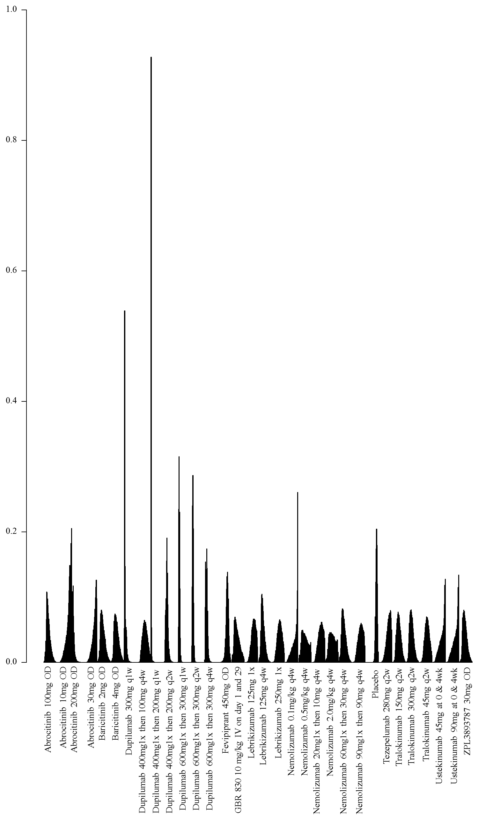
*Note that results for fevripitant are only available in a clinical trial registries. The standard errors given there for the change in EASI score are very small and may be in error. If in fact these are erroneous, this may have changed the precision of the effect estimates for comparisons with fevripirant

2. Network meta-analysis of change in EASI score up to 16 weeks of treatment – analysis including only studies at low risk of bias

- Network plot of arms included in the network meta-analysis of change in EASI score up to 16 weeks of treatment – including only studies at low risk of bias
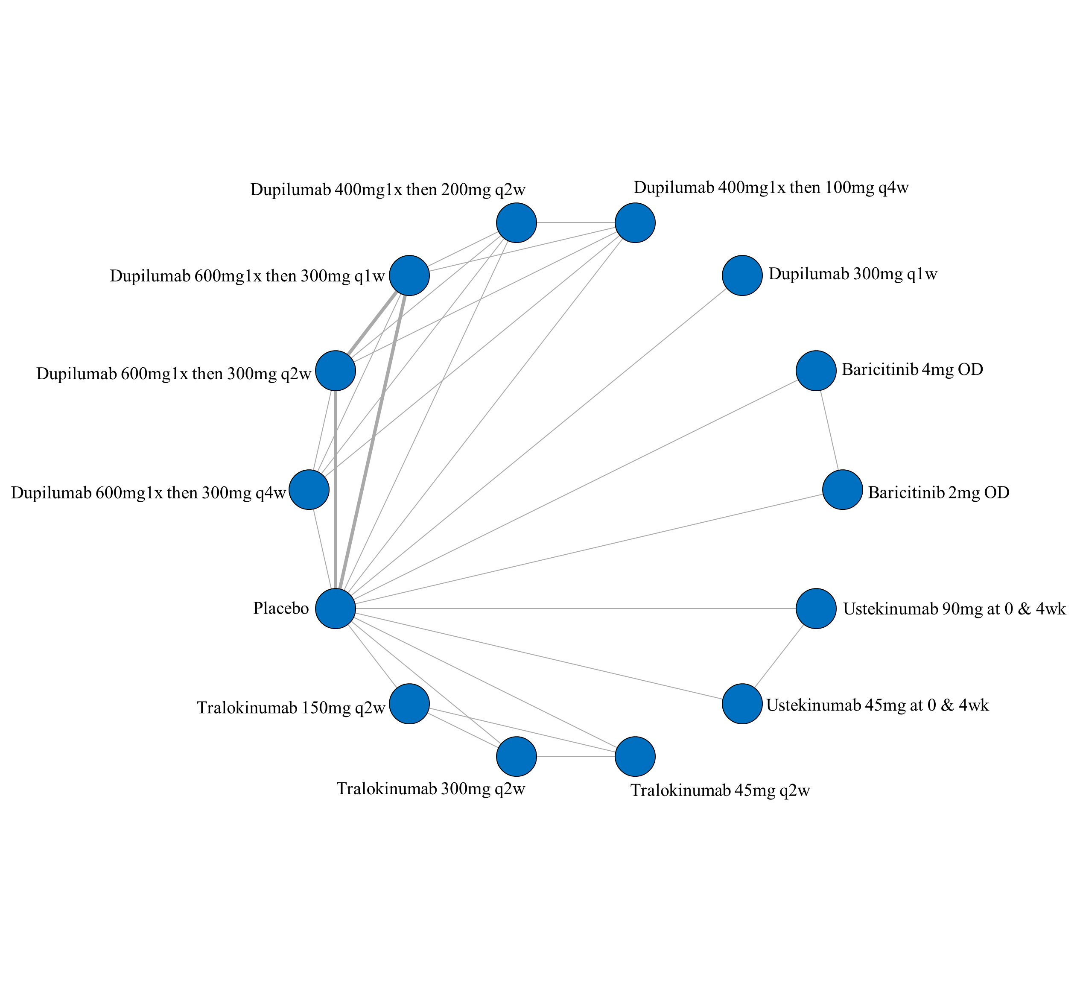

ii. League table of arms included in the network meta-analysis of change in EASI score of the studies at low risk of bias up to 16 weeks of treatment. Results are presented as the mean difference (95% CrI) in EASI score between the two arms. A positive effect estimate in a given cell favors the row-defining treatment. A negative effect estimate in a given cell favors the column-defining treatment.

iii. SUCRA values and ranking for change in EASI score up to 16 weeks of treatment – including only studies at low risk of bias

iv. Rank plot of arms included in the network meta-analysis of change in EASI score of studies at low risk of bias up to 16 weeks of treatment

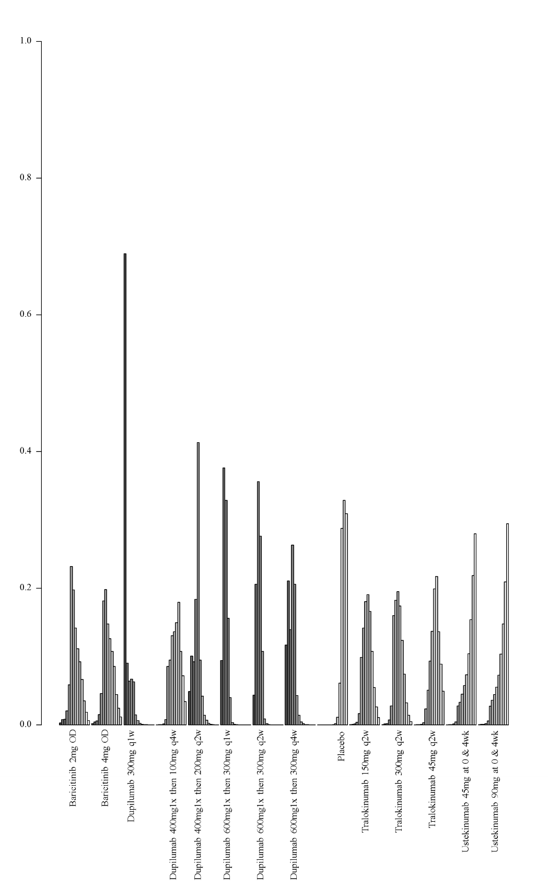

3. Network meta-analysis of change in EASI score up to 16 weeks of treatment – analysis including only studies that did not allow concomitant topical anti-inflammatory treatment

i. Network plot of arms included in the network meta-analysis of change in EASI score – including only studies that did not allow concomitant topical anti-inflammatory treatment
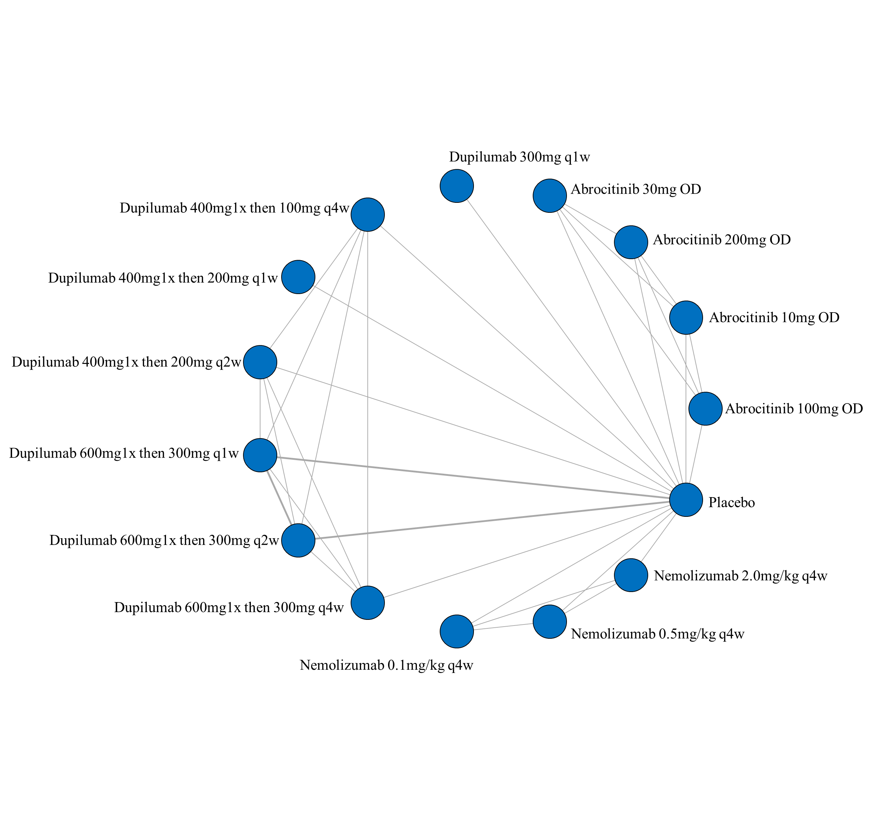

ii. League table of arms included in the network meta-analysis of change in EASI score of the studies that did not allow concomitant topical anti-inflammatory treatment up to 16 weeks of treatment. Results are presented as the mean difference (95% CrI) in EASI score between the two arms. A positive effect estimate in a given cell favors the row-defining treatment. A negative effect estimate in a given cell favors the column-defining treatment.

iii. SUCRA values and ranking for change in EASI score up to 16 weeks of treatment – including only studies that did not allow concomitant topical anti-inflammatory treatment
iv. Rank plot of arms included in the network meta-analysis of change in EASI score – including only studies that did not allow concomitant topical anti-inflammatory treatment up to 16 weeks of treatment
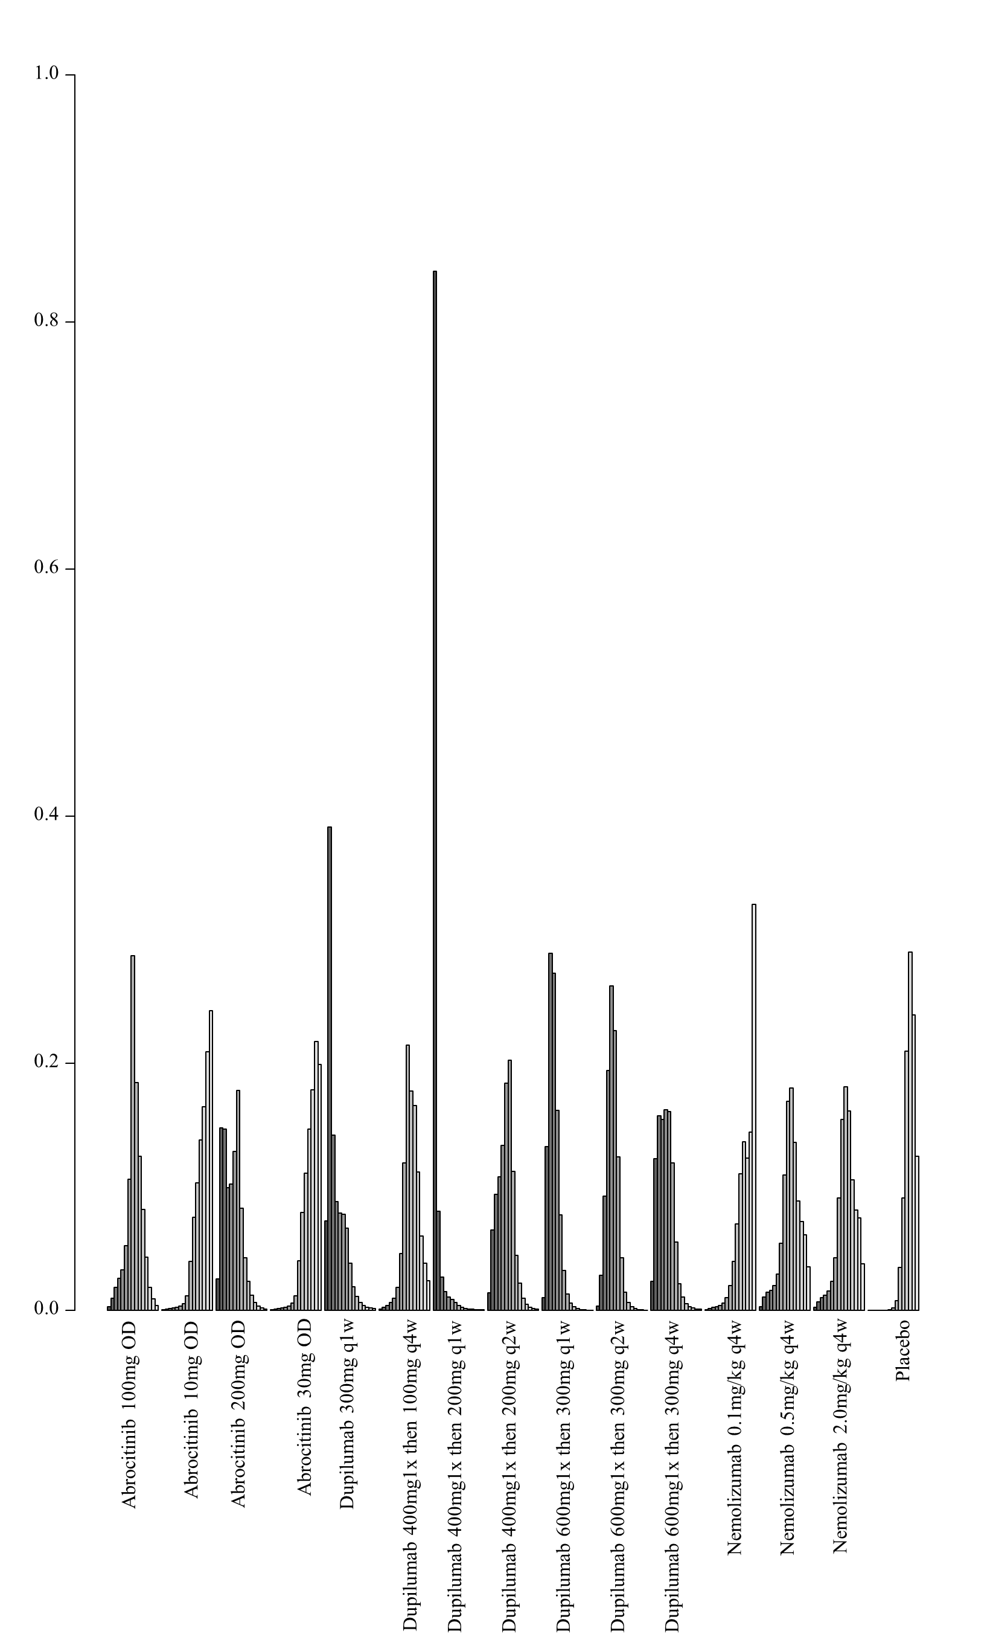

4. Network meta-analysis of change in EASI score up to 16 weeks of treatment – analysis including only studies that allowed concomitant topical anti-inflammatory treatment

i. Network plot of arms included in the network meta-analysis of change in EASI score – including only studies that allowed concomitant topical anti-inflammatory treatment up to 16 weeks of treatment
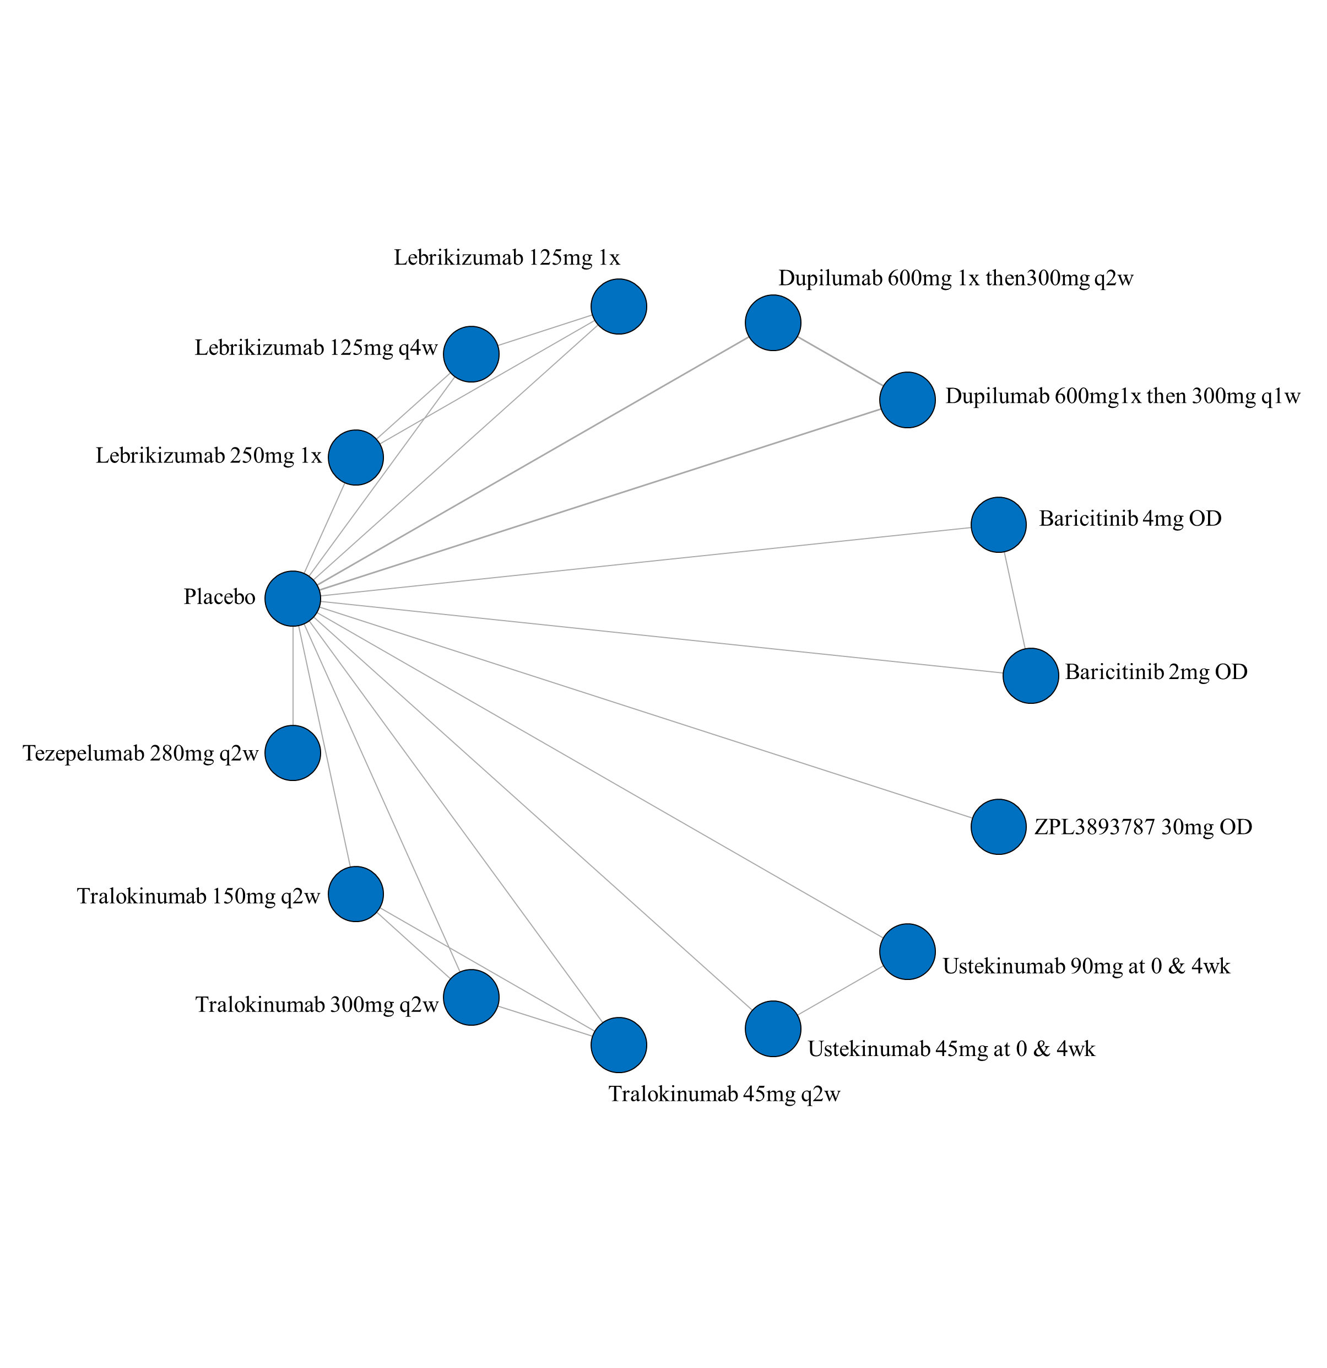
ii. League table of arms included in the network meta-analysis of change in EASI score of the studies that allowed concomitant topical anti-inflammatory treatment up to 16 weeks of treatment. Results are presented as the mean difference (95% CrI) in EASI score between the two arms. A positive effect estimate in a given cell favors the row-defining treatment. A negative effect estimate in a given cell favors the column-defining treatment.

iii. SUCRA values and ranking for change in EASI score up to 16 weeks of treatment – including only studies that allowed concomitant topical anti-inflammatory treatment
iv. Rank plot of arms included in the network meta-analysis of change in EASI score – including only studies that allowed concomitant topical anti-inflammatory treatment up to 16 weeks of treatment

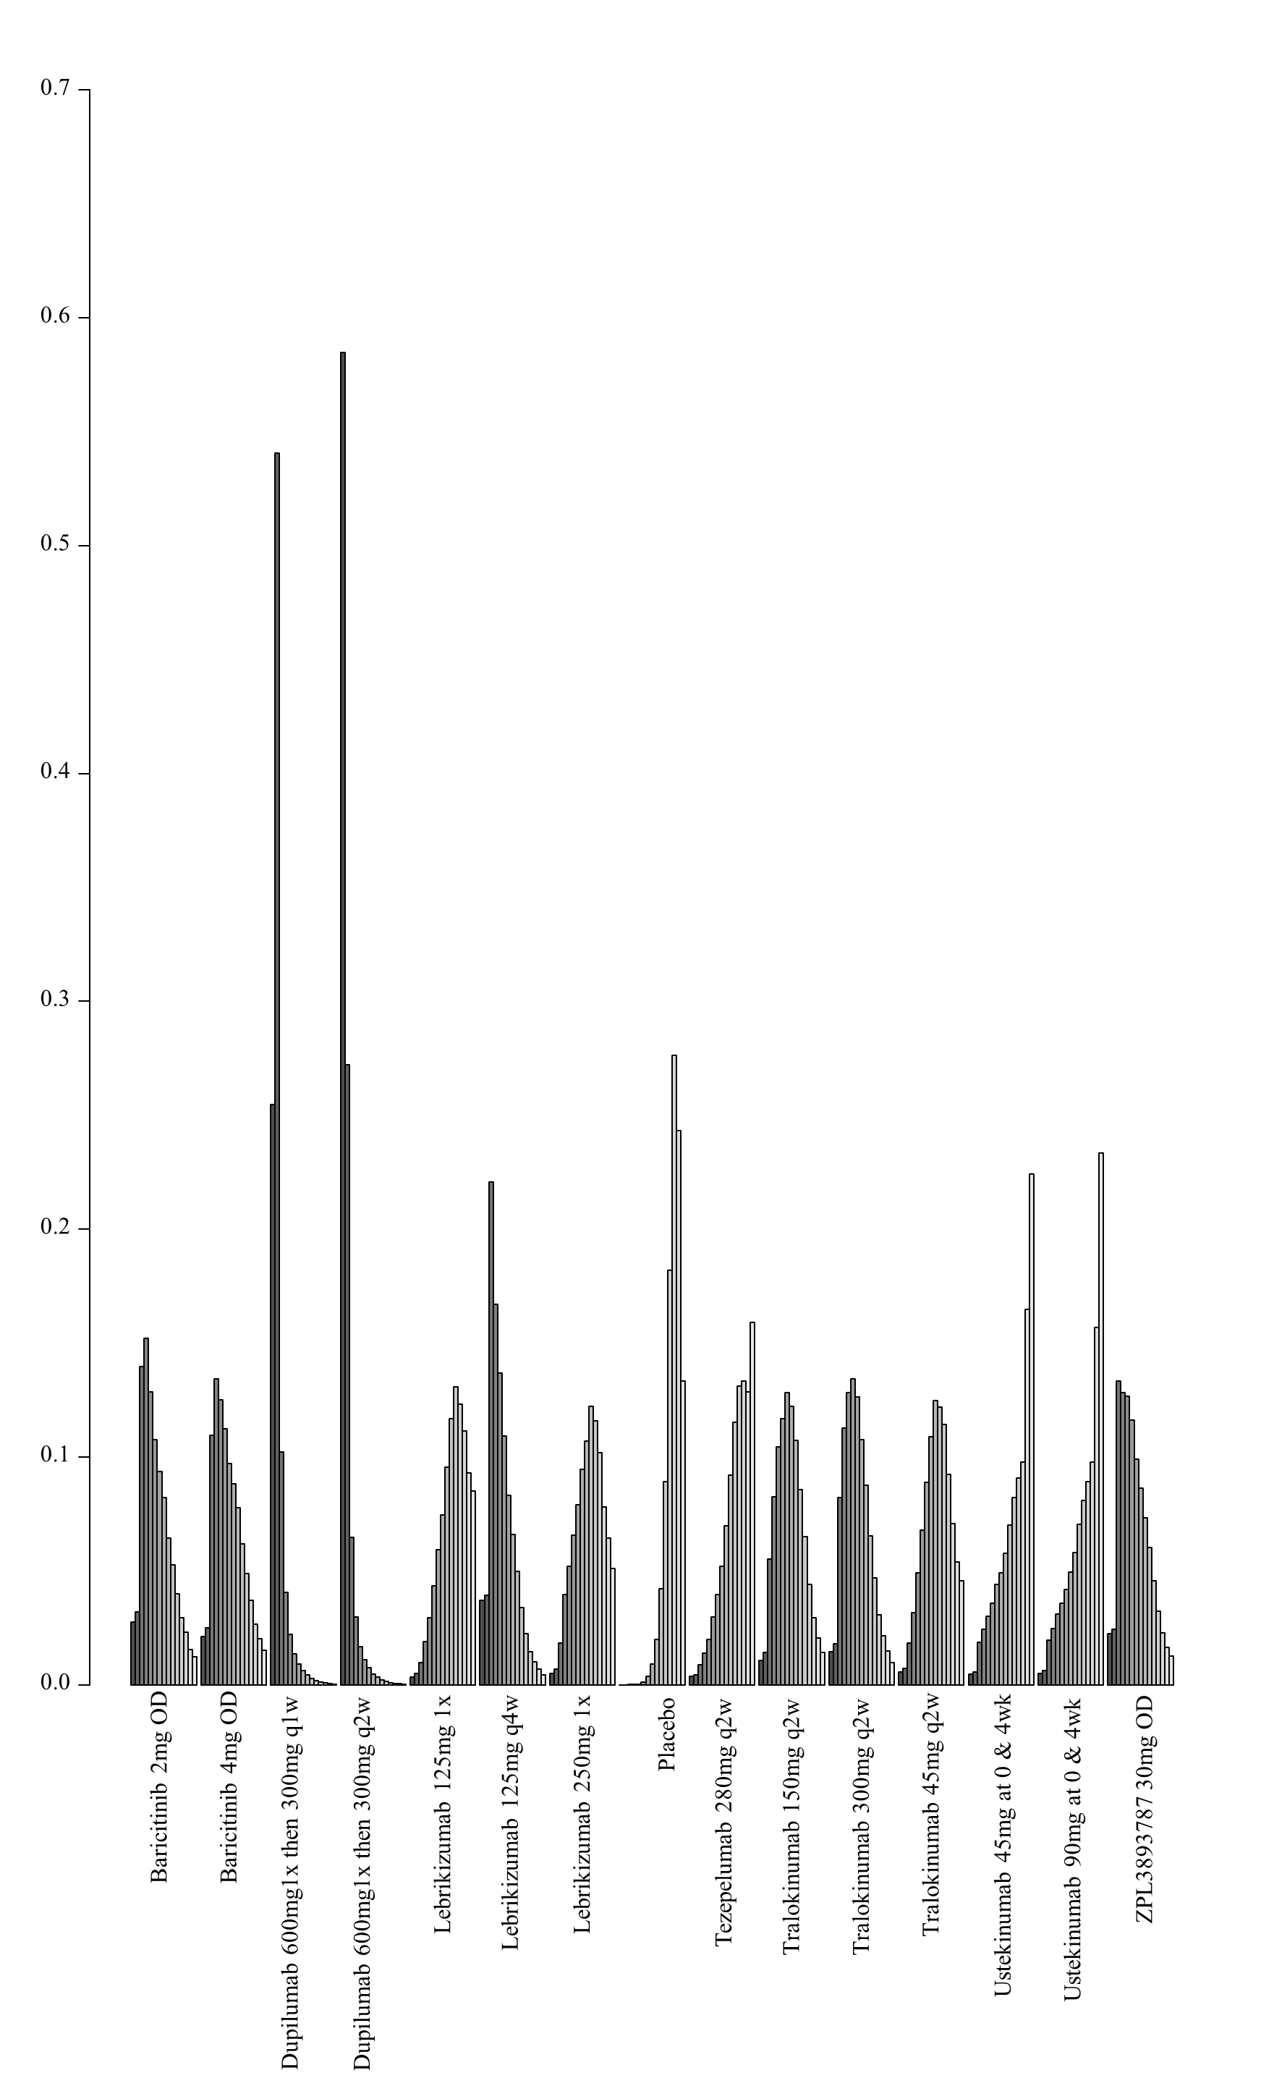

5. Network meta-analysis of change in EASI score up to 16 weeks of treatment – analysis including only studies that report results as change in score from baseline

i. Network plot of arms included in the network meta-analysis of change in EASI score up to 16 weeks of treatment – sensitivity analysis for studies reporting the percent change from baseline
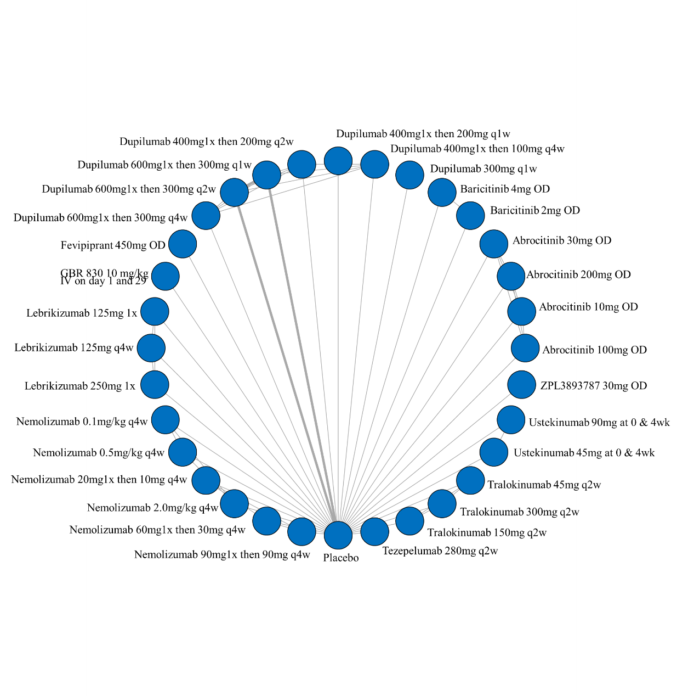

ii. League table of arms included in the network meta-analysis of change in EASI score of all studies that report results up to 16 weeks of treatment (sensitivity analysis for studies reporting the percentage change from baseline). Results are presented as the mean difference (95% CrI) in EASI score between the two arms. A positive effect estimate in a given cell favors the row-defining treatment. A negative effect estimate in a given cell favors the column-defining treatment.

*Note that results for fevipiprant are only available in a clinical trial registries. The standard errors given there for the change in EASI score are very small and may be in error. If in fact these are erroneous, this may have changed the precision of the effect estimates for comparisons with fevipiprant
iii. SUCRA values and ranking for change in EASI score up to 16 weeks of treatment – sensitivity analysis for studies reporting the percent change from baseline

*Note that results for fevipiprant are only available in a clinical trial registries. The standard errors given there for the change in EASI score are very small and may be in error. If in fact these are erroneous, this may have changed the precision of the effect estimates for comparisons with fevipiprant
iv. Rank plot of arms included in the network meta-analysis of change in EASI score up to 16 weeks of treatment – sensitivity analysis for studies reporting the percent change from baseline
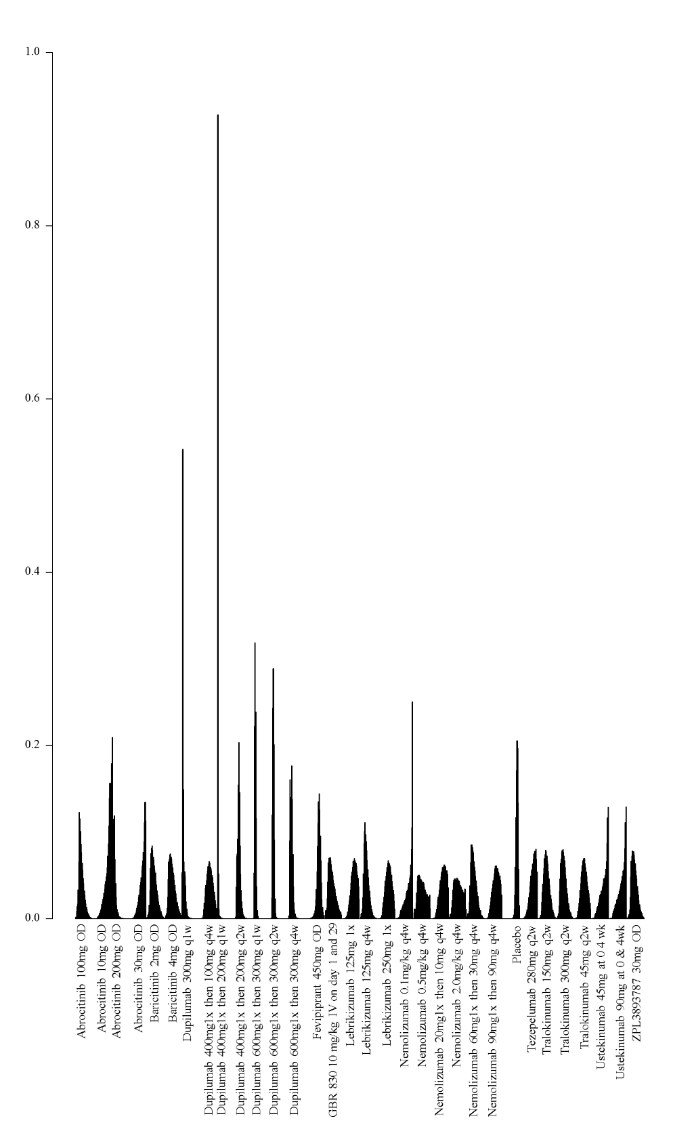
*Note that results for fevipiprant are only available in a clinical trial registries. The standard errors given there for the change in EASI score are very small and may be in error. If in fact these are erroneous, this may have changed the precision of the effect estimates for comparisons with fevipiprant

7B. Network meta-analysis of change in clinical signs on the standardized mean difference scale up to 16 weeks of treatment

1. Network meta-analysis of change in clinical signs on the standardized mean difference scale up to 16 weeks of treatment – main analysis

i. Network plot of arms included in the network meta-analysis of change in clinical signs on the standardized mean difference scale up to 16 weeks of treatment for all medications

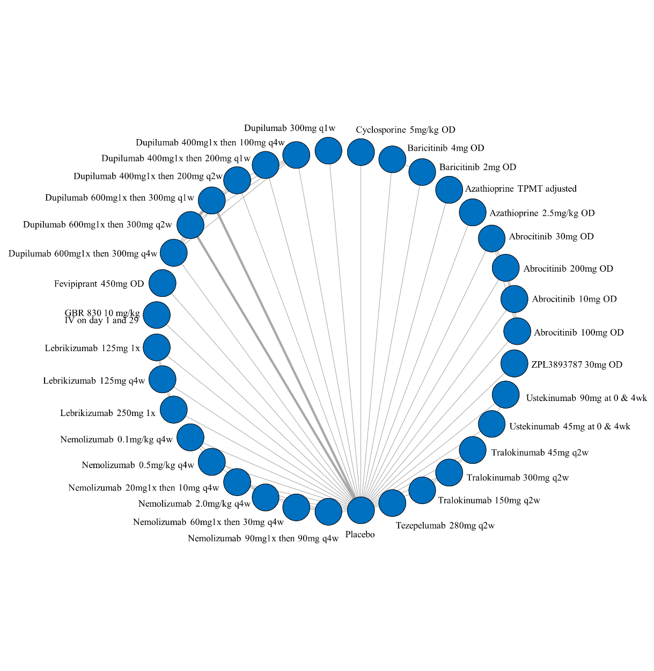

ii. League table of arms included in the network meta-analysis of change in clinical signs on the standardized mean difference scale up to 16 weeks of treatment for all medications. Results are presented as the mean difference (95% CrI) in clinical signs between the two arms. A positive effect estimate in a given cell favors the row-defining treatment. A negative effect estimate in a given cell favors the column-defining treatment.
*Note that results for fevipiprant are only available in a clinical trial registries. The standard errors given there for the change in EASI score are very small and may be in error. If in fact these are erroneous, this would artificially inflate the effect estimate in favor of fevipiprant. The league table on the following page is the analysis with fevipiprant removed.

League table of arms included in the network meta-analysis of change in clinical signs on the standardized mean difference scale up to 16 weeks of treatment for all medications but with fevipiprant removed. Results are presented as the mean difference (95% CrI) in clinical signs between the two arms. A positive effect estimate in a given cell favors the row-defining treatment. A negative effect estimate in a given cell favors the column-defining treatment.

iii. SUCRA values and ranking for change in clinical signs up to 16 weeks of treatment for all medications

*Note that results for fevipiprant are only available in a clinical trial registries. The standard errors given there for the change in EASI score are very small and may be in error. If in fact these are erroneous, this would artificially inflate the effect estimate in favor of fevipiprant. The SUCRA table on the next page is the analysis with fevipiprant removed.

iii. SUCRA values and ranking for change in clinical signs up to 16 weeks of treatment for all medications but with fevipiprant removed

iv. Rank plot of arms included in the network meta-analysis of change in clinical signs on the standardized mean difference scale up to 16 weeks of treatment
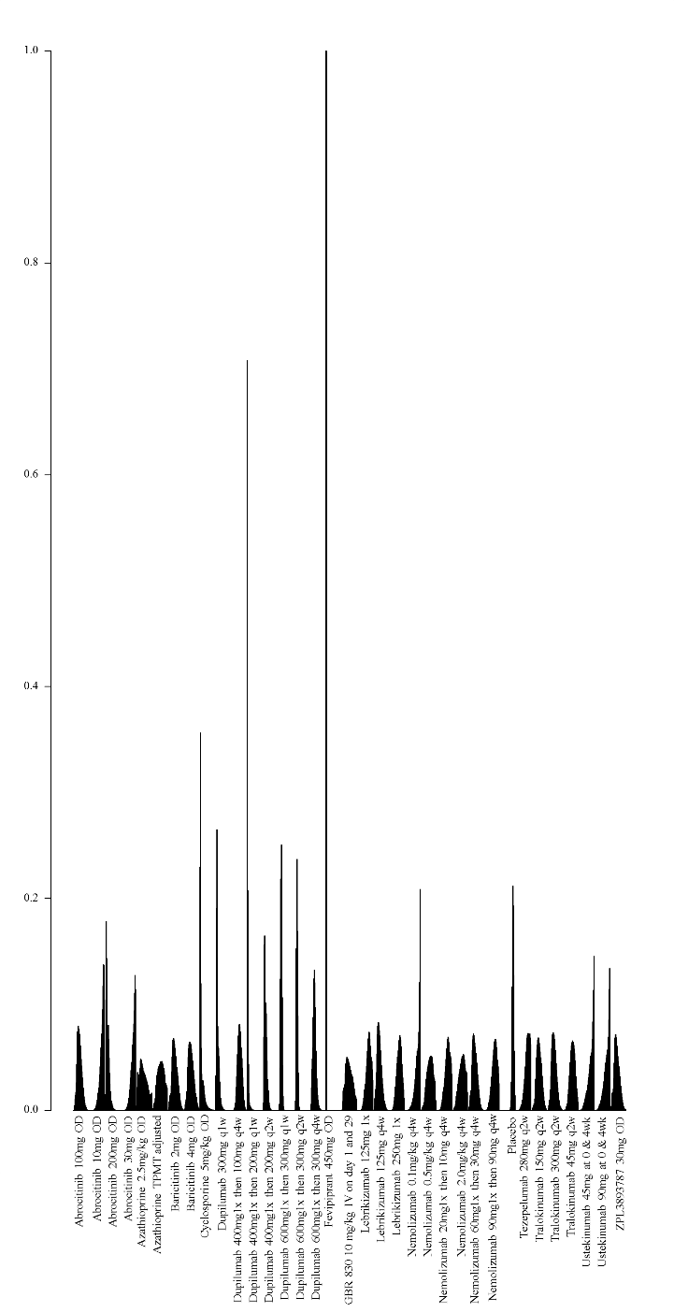
*Note that results for fevripitant are only available in a clinical trial registries. The standard errors given there for the change in EASI score are very small and may be in error. If in fact these are erroneous, this would artificially inflate the effect estimate in favor of fevripitant.

2. Network meta-analysis of change in clinical signs on the standardized mean difference scale up to 16 weeks of treatment – among medications currently in use

i. League table of arms included in the network meta-analysis of change in clinical signs on the standardized mean difference scale up to 16 weeks of treatment – among medications currently in use. Results are presented as the mean difference (95% CrI) in clinical signs between the two arms. A positive effect estimate in a given cell favors the row-defining treatment. A negative effect estimate in a given cell favors the column-defining treatment.

ii. GRADE Assessment for change in clinical signs on the standardized mean difference scale up to 16 weeks of treatment among medications currently in use
Signs SMD
Comparison | GRADE Rating
  Azathioprine vs placebo
  Cyclosporine - higher dose vs placebo
  Cyclosporine - lower dose vs placebo
  Dupilumab 600mg 1x then 300mg q2w vs placebo
  Methotrexate vs placebo
  Methotrexate vs Cyclosporine – higher dose
  Methotrexate vs Cyclosporine – lower dose
  Cyclosporine - higher dose vs Cyclosporine - lower dose
  Dupilumab 600mg 1x then 300mg q2w vs Azathioprine
  Methotrexate vs Azathioprine
  Dupilumab 600mg 1x then 300mg q2w vs Methotrexate
  Dupilumab 600mg 1x then 300mg q2w vs Cyclosporine - higher dose
  Dupilumab 600mg 1x then 300mg q2w vs Cyclosporine – lower dose
  Azathioprine vs Cyclosporine – higher dose
  Azathioprine vs Cyclosporine – lower dose
  Low^{1,2,3}
  Low^{2,3}
  Low⁴
  High
  Low⁴
  Low⁴
  Low^{1,2,3}
  Low^{1,2,3}
  Low⁴
  Low^{1,2,3}
  Low⁵
  Low⁴
  Low⁵
  Low⁴
  Low⁴
1 – NMA estimate imprecise and would suggest different conclusions at either end of the 95% Credible Intervals
2 – Number of patients included in analysis below optimal information size
3 – significant issues related to risk of bias from included trials
4 – no direct estimate, first-order indirect loop includes low certainty evidence and therefore NMA estimate is low certainty
5 – no direct estimate, no first-order indirect loop, 2nd-order loop includes low certainty evidence and therefore NMA estimate is low certainty

iii. SUCRA values and ranking for change in clinical signs up to 16 weeks of treatment among medications currently in use

iv. Rank plot of arms included in the network meta-analysis of change in clinical signs on the standardized mean difference scale up to 16 weeks of treatment among medications currently in use
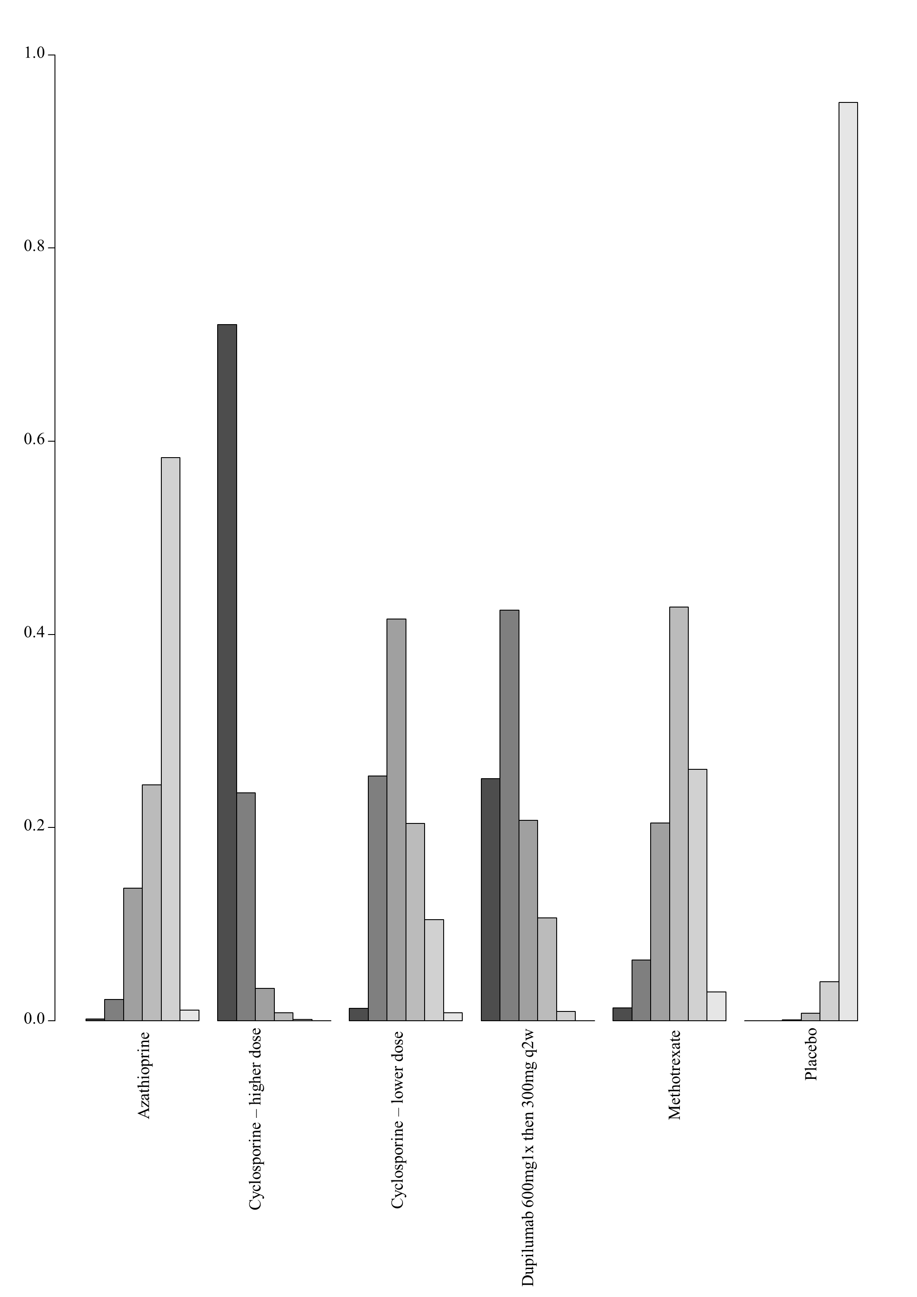

7C. Network meta-analysis of change in POEM scores up to 16 weeks of treatment

1. Network meta-analysis of change in POEM score up to 16 weeks of treatment – main analysis

i. Network plot of arms included in the network meta-analysis of change in POEM score up to 16 weeks of treatment

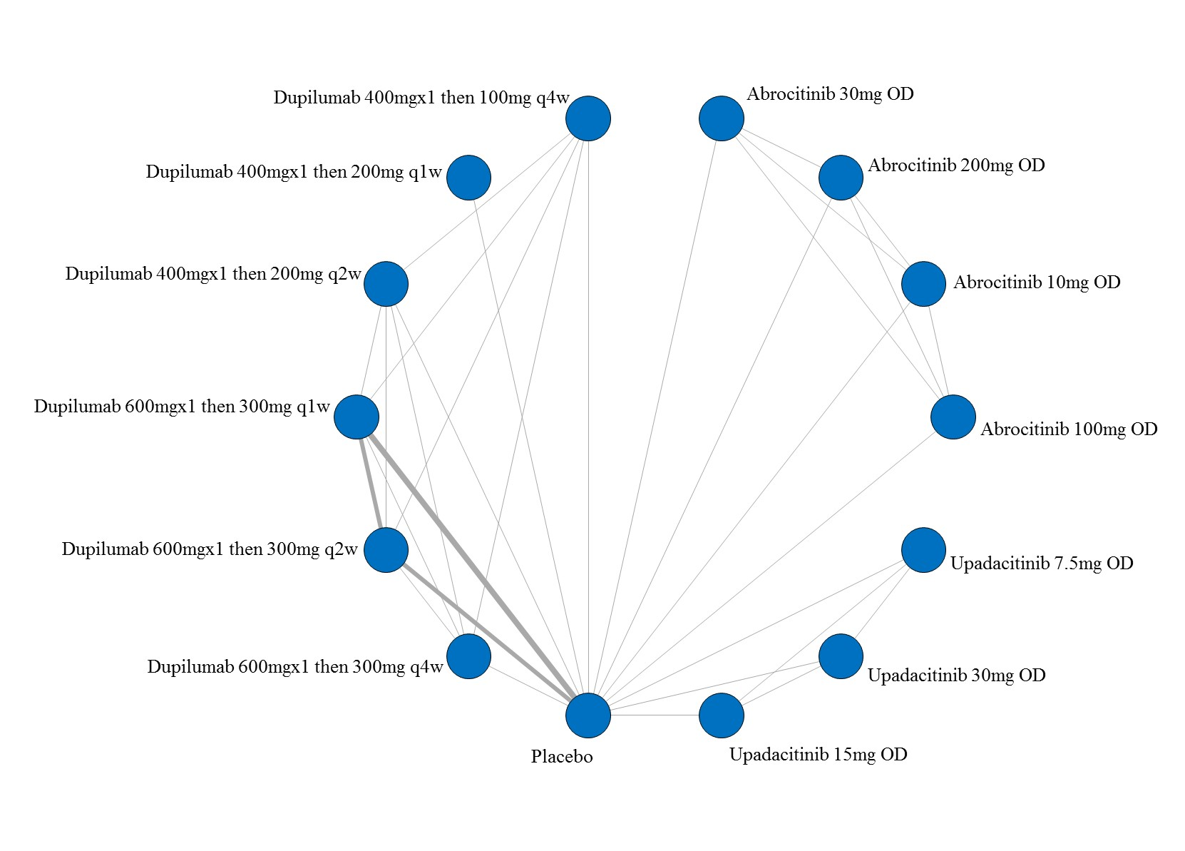

ii. League table of arms included in the network meta-analysis of change in POEM score up to 16 weeks of treatment. Results are presented as the mean difference (95% CrI) in POEM score between the two arms. A positive effect estimate in a given cell favors the row-defining treatment. A negative effect estimate in a given cell favors the column-defining treatment.

iii. GRADE assessment of change in POEM scores up to 16 weeks of treatment
POEM Score
All versus Placebo
Drug | GRADE Rating
  Abrocitinib 10mg OD
  Abrocitinib 30mg OD
  Abrocitinib 100mg OD
  Abrocitinib 200mg OD
  Dupilumab 400mg1x then 100mg q4w
  Dupilumab 400mg1x then 200mg q1w
  Dupilumab 400mg1x then 200mg q2w
  Dupilumab 600mg1x then 300mg q1w
  Dupilumab 600mg1x then 300mg q2w
  Dupilumab 600mg1x then 300mg q4w
  Upadacitinib 15mg OD
  Upadacitinib 30mg OD
  Upadacitinib 7.5mg OD
  Low^{1,2,3}
  Low^{1,2,3}
  Low^{2,3}
  Low^{2,3}
  Moderate²
  Moderate²
  Moderate²
  High
  High
  Moderate²
  Low^{1,2,3}
  Low^{2,3}
  Low^{1,2,3}
1 – NMA estimate imprecise and would suggest different conclusions at either end of the 95% Credible Intervals
2 – Number of patients included in analysis below optimal information size
3 – significant issues related to risk of bias from included trials
Given the exclusive hub and spoke arrangement, any head to head comparison will be the lowest rated of the two interventions as compared to placebo.

iv. SUCRA values and ranking for change in POEM score up to 16 weeks of treatment – main analysis

v. Rank plot of arms included in the network meta-analysis of change in POEM score up to 16 weeks of treatment
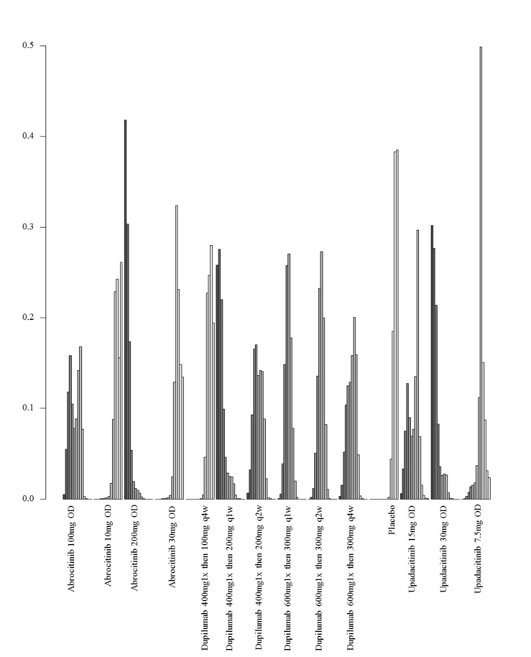

2. Network meta-analysis of change in POEM score up to 16 weeks of treatment – analysis including only studies at low risk of bias

i. Network plot of arms included in the network meta-analysis of change in POEM score – including only studies at low risk of bias up to 16 weeks of treatment
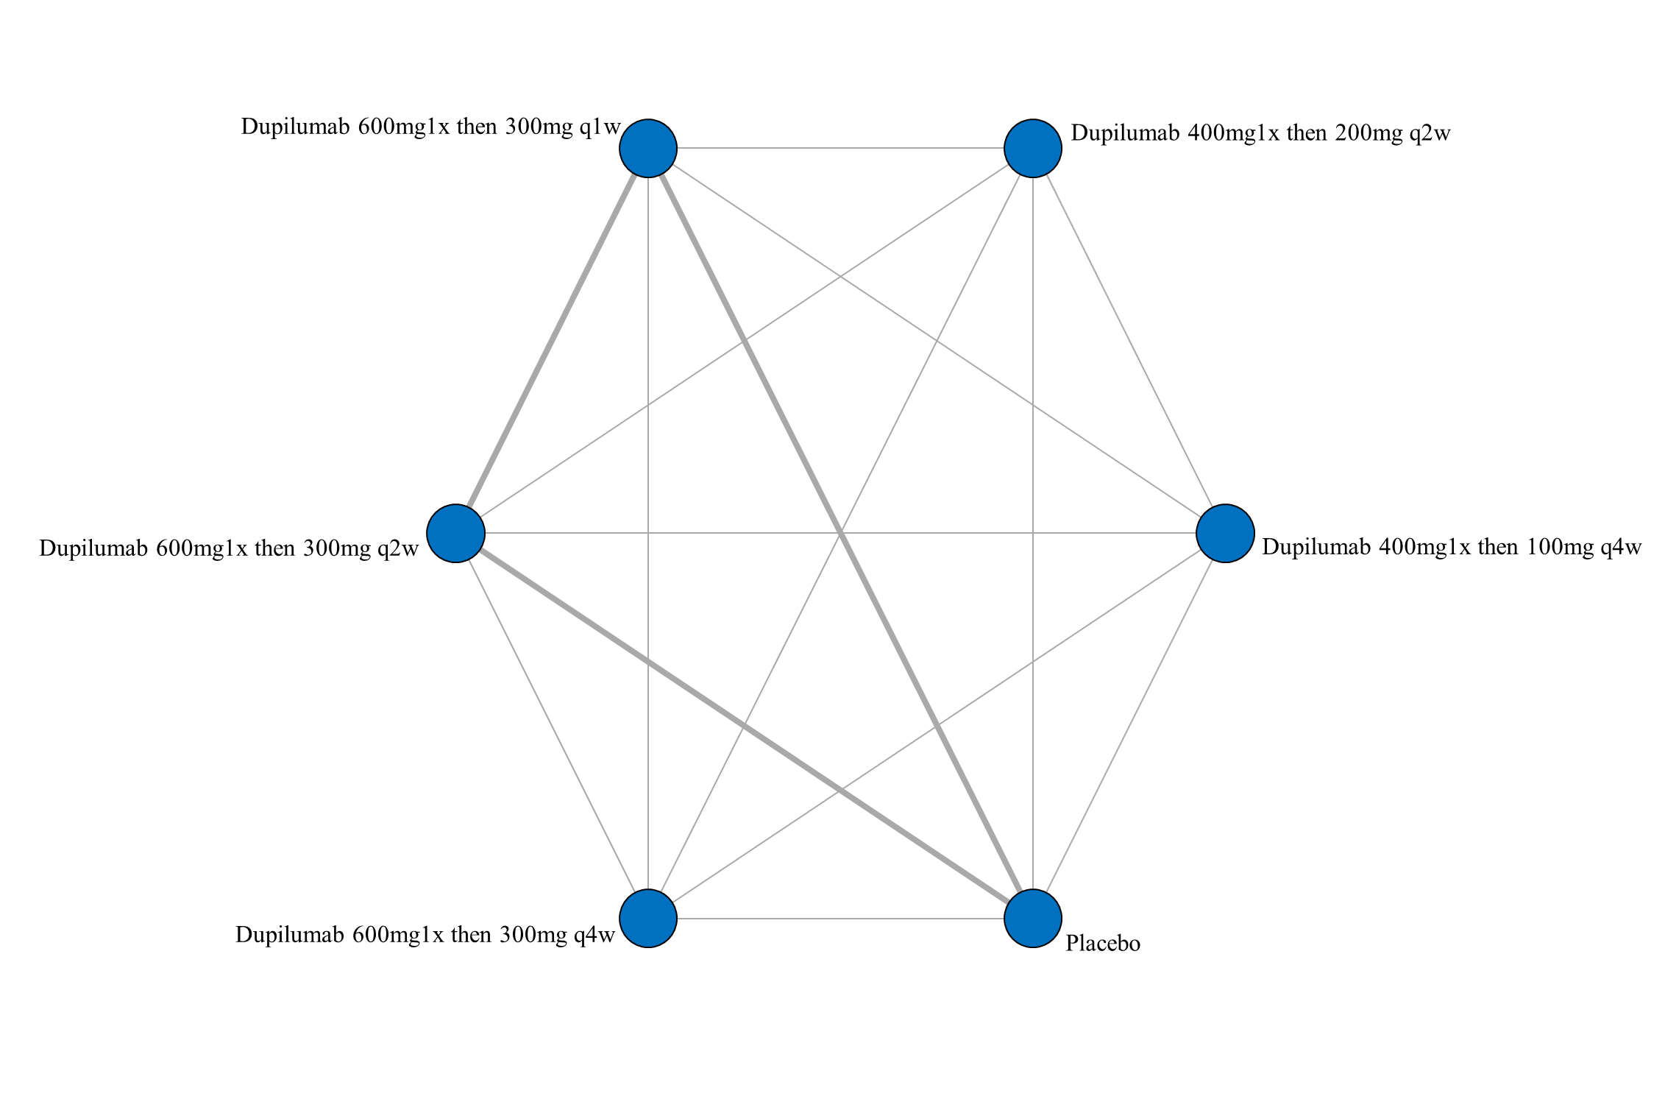

ii. League table of arms included in the network meta-analysis of change in POEM score of the studies at low risk of bias up to 16 weeks of treatment. Results are presented as the mean difference (95% CrI) in POEM score between the two arms. A positive effect estimate in a given cell favors the row-defining treatment. A negative effect estimate in a given cell favors the column-defining treatment.

iii. SUCRA values and ranking for change in POEM score up to 16 weeks of treatment – including only studies at low risk of bias

iv. Rank plot of arms included in the network meta-analysis of change in POEM score up to 16 weeks of treatment – including only studies at low risk of bias
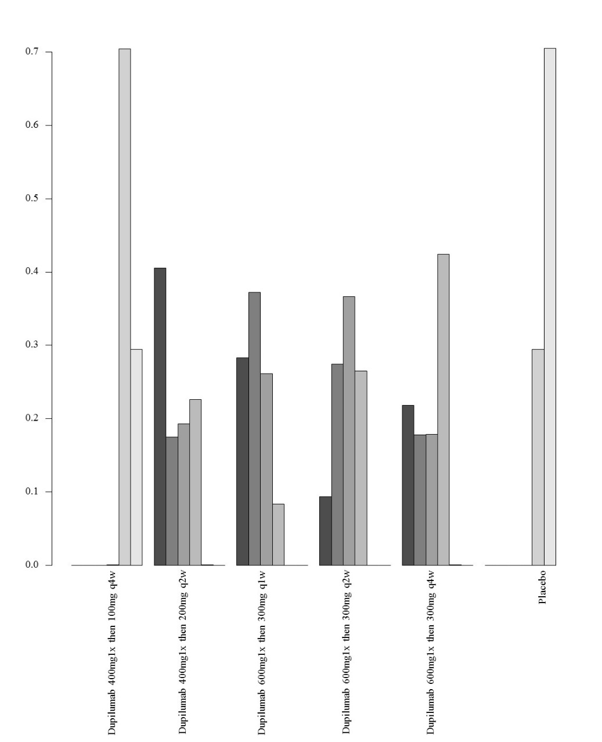

3. Network meta-analysis of change in POEM score up to 16 weeks of treatment – analysis including only studies that did not allow concomitant topical anti-inflammatory treatment

- Network plot of arms included in the network meta-analysis of change in POEM score up to 16 weeks of treatment – including only studies that did not allow concomitant topical anti-inflammatory treatment

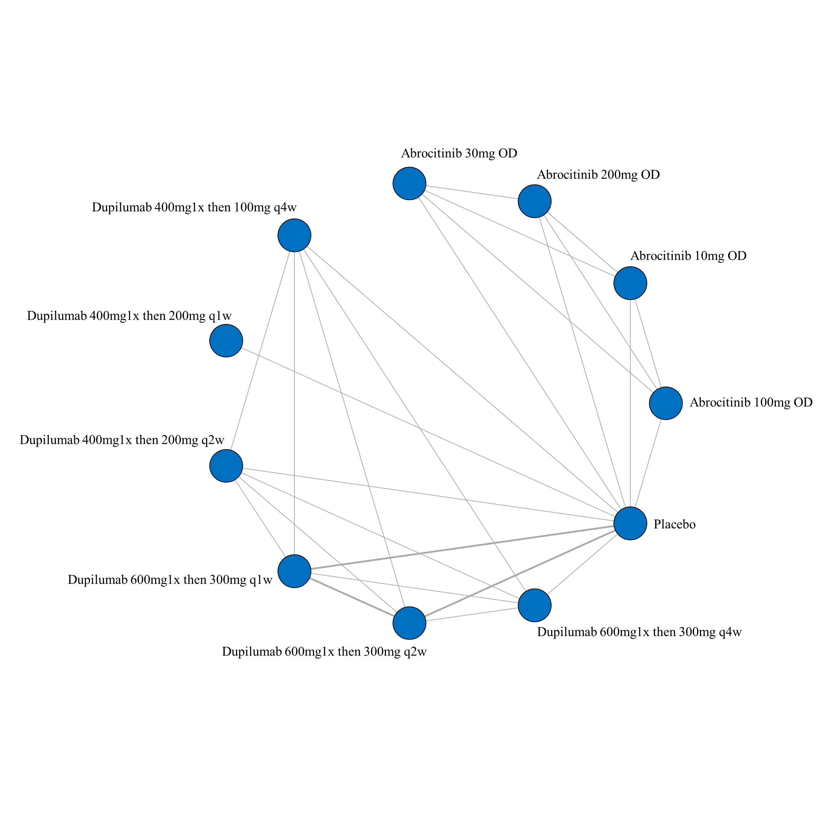

- League table of arms included in the network meta-analysis of change in POEM score of the studies that did not allow concomitant topical anti-inflammatory treatment up to 16 weeks of treatment. Results are presented as the mean difference (95% CrI) in POEM score between the two arms. A positive effect estimate in a given cell favors the row-defining treatment. A negative effect estimate in a given cell favors the column-defining treatment.

iii. SUCRA values and ranking for change in POEM score up to 16 weeks of treatment – including only studies that did not allow concomitant topical anti-inflammatory treatment

iv. Rank plot of arms included in the network meta-analysis of change in POEM score up to 16 weeks of treatment – including only studies that did not allow concomitant topical anti-inflammatory treatment
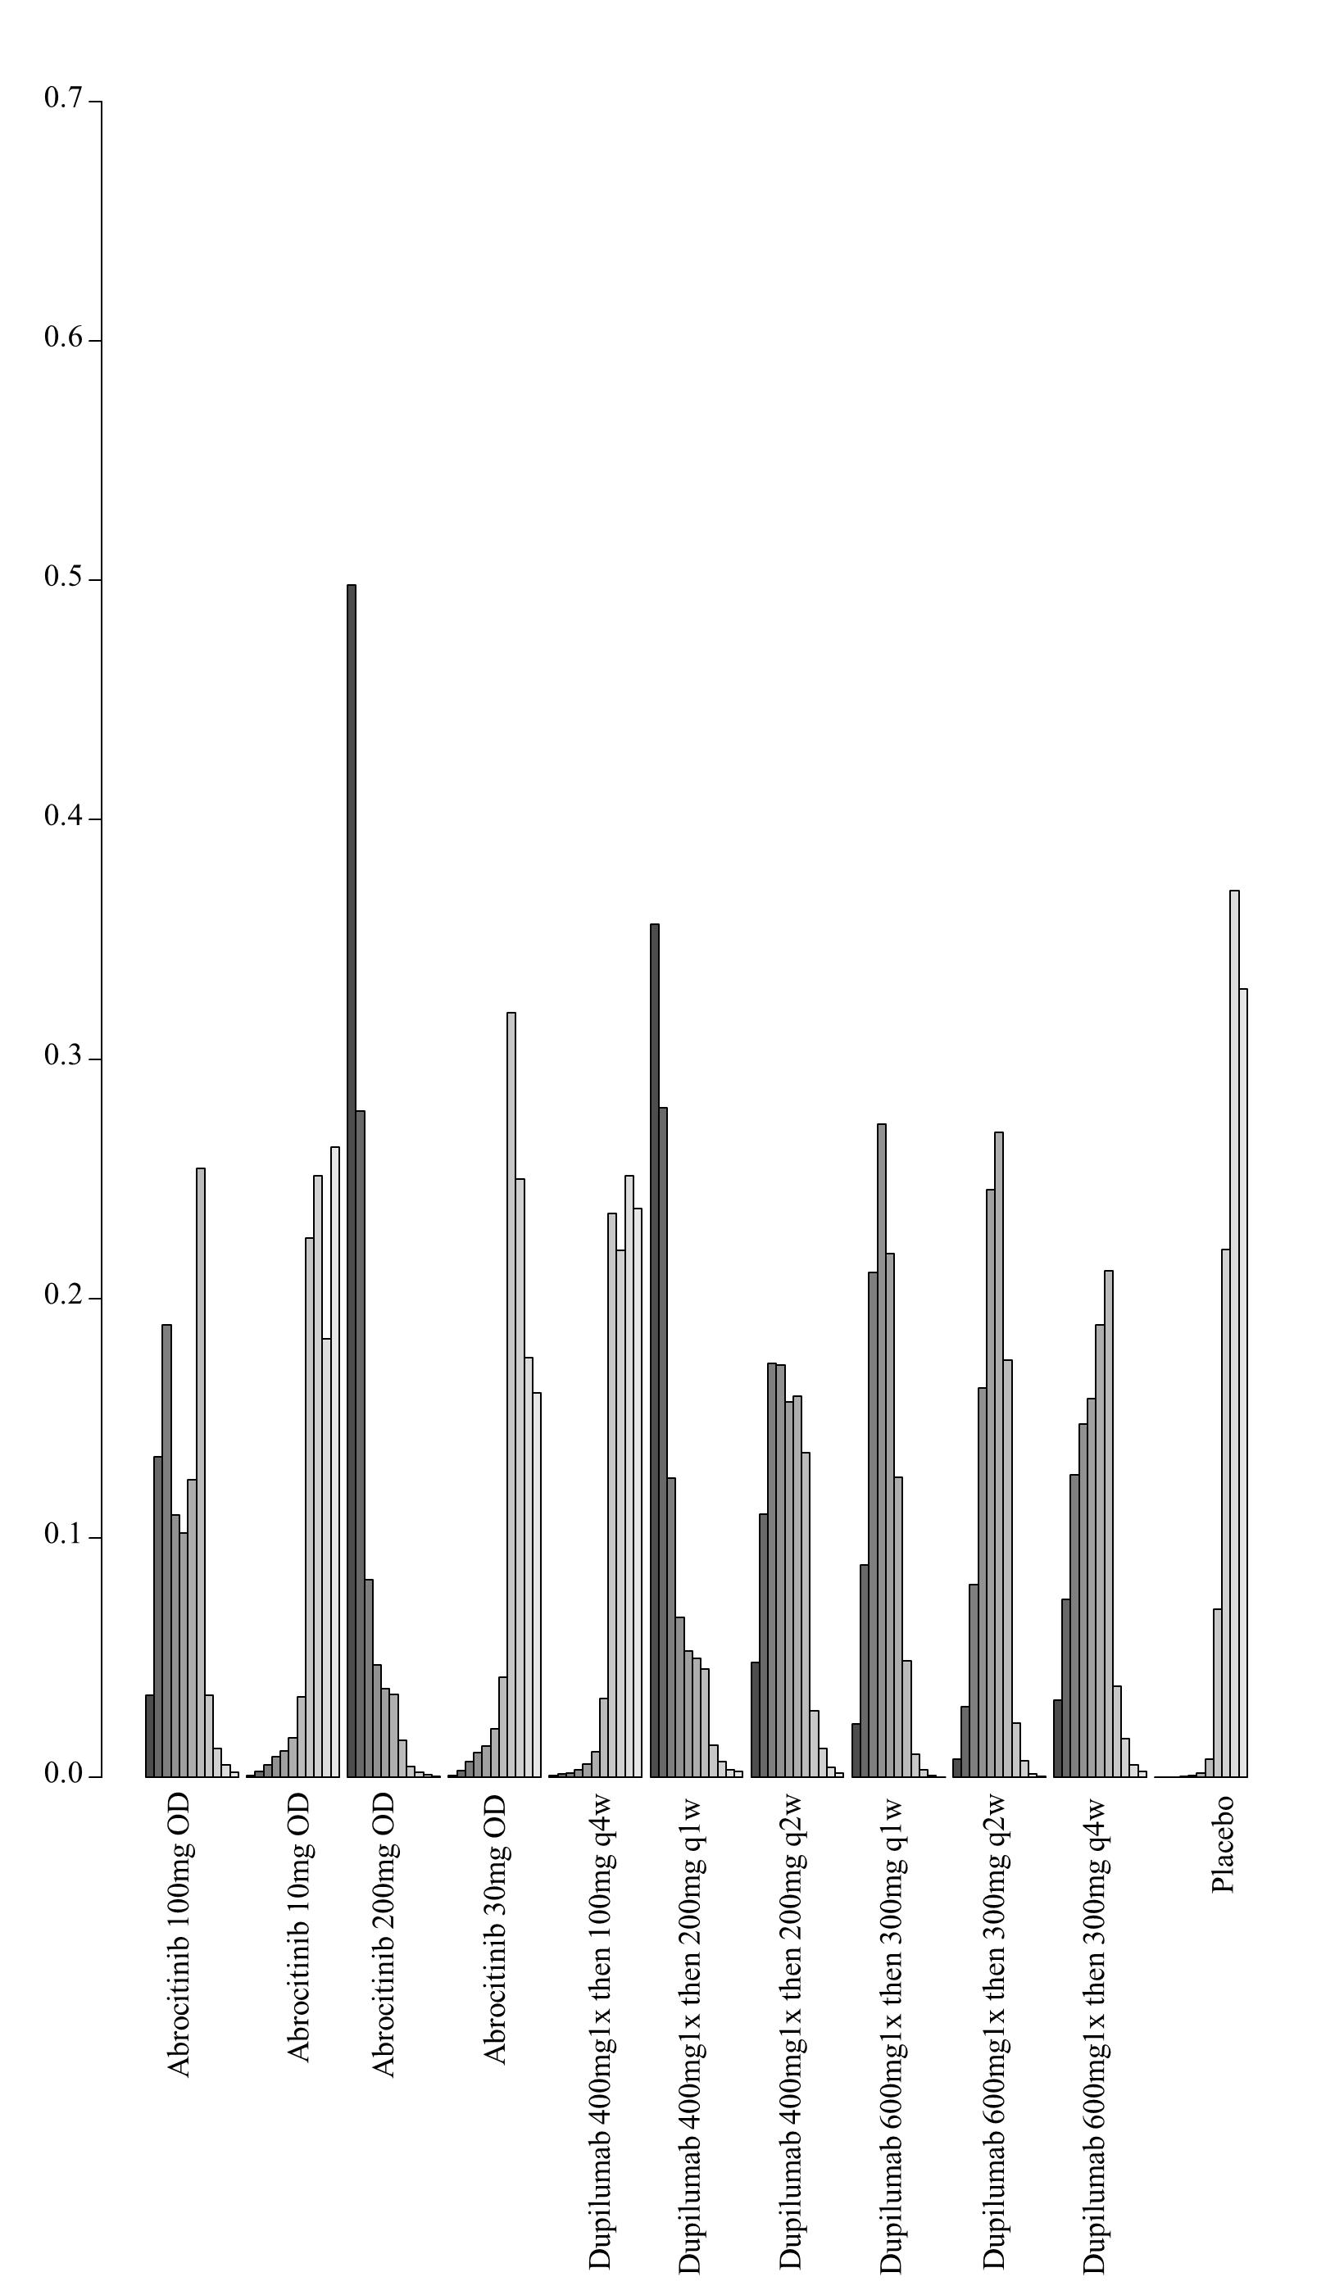

4. Network meta-analysis of change in POEM score – analysis including only studies that allowed concomitant topical anti-inflammatory treatment up to 16 weeks of treatment

i. Network plot of arms included in the network meta-analysis of change in POEM score – including only studies that allowed concomitant topical anti-inflammatory treatment up to 16 weeks of treatment

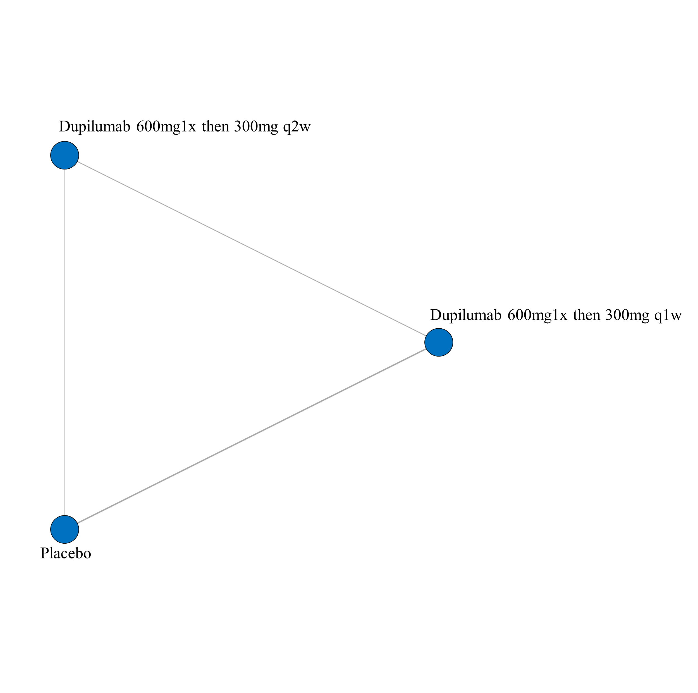

ii. League table of arms included in the network meta-analysis of change in POEM score of studies that allowed concomitant topical anti-inflammatory treatment up to 16 weeks of treatment. Results are presented as the mean difference (95% CrI) in POEM score between the two arms. A positive effect estimate in a given cell favors the row-defining treatment. A negative effect estimate in a given cell favors the column-defining treatment.

iii. SUCRA values and ranking for change in POEM score up to 16 weeks of treatment – including only studies that allowed concomitant topical anti-inflammatory treatment
iv. Rank plot of arms included in the network meta-analysis of change in POEM score up to 16 weeks of treatment – including only studies that allowed concomitant topical anti-inflammatory treatment
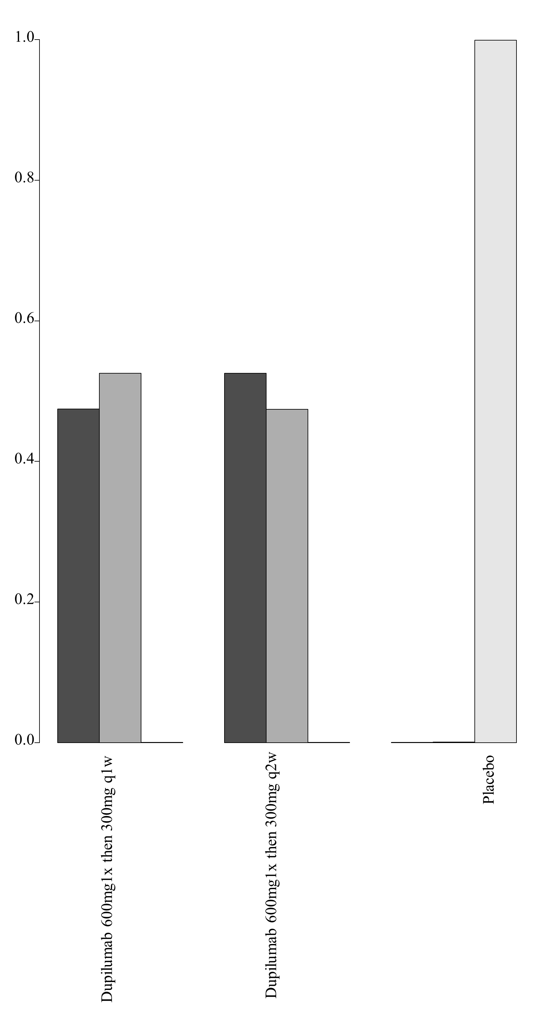

7D. Network meta-analysis of withdrawal due to adverse event up to 16 weeks of treatment

1. Network meta-analysis of withdrawal due to adverse event up to 16 weeks of treatment – main analysis

i. League table of arms included in the network meta-analysis of withdrawal due to adverse events up to 16 weeks of treatment. Results are presented as odds ratios (95% CrI) for withdrawals due to adverse event between the two arms. An effect estimate greater than 1 in a given cell favors the row-defining treatment. An effect estimate less than 1 in a given cell favors the column-defining treatment.

ii. GRADE assessment of withdrawal due to adverse event up to 16 weeks of treatment

Withdrawals due to adverse event
All versus Placebo
Drug | GRADE Rating
  Abrocitinib 100mg OD
  Abrocitinib 10mg OD
  Abrocitinib 200mg OD
  Abrocitinib 30mg OD
  Apremilast 30mg BID
  Apremilast 40mg BID
  Azathioprine TPMT adjusted
  Baricitninib 2mg OD
  Baricitinib 4mg OD
  Dupilumab 300mg q1w
  Dupilumab 400mg1x then 100mg q4w
  Dupilumab 400mg1x then 200mg q1w
  Dupilumab 400mg1x then 200mg q2w
  Dupilumab 600mg1x then 300mg q1w
  Dupilumab 600mg1x then 300mg q2w
  Dupilumab 600mg1x then 300mg q4w
  GBR 830 10mg/kg IV on day 1 and 29
  INF-y 50ug/m2 OD
  Lebrikizumab 125mg 1x
  Lebrikizumab 125mg q4w
  Nemolizumab 0.1mg/kg q4w
  Nemolizumab 0.5mg/kg q4w
  Nemolizumab 2.0mg/kg q4w
  Nemolizumab 2.0mg/kg q8w
  Tezepelumab 280mg q2w
  Tralokinumab 150mg q2w
  Tralokinumab 45mg q2w
  Low^{1,2,3}
  Low^{1,2,3}
  Low^{1,2,3}
  Low^{1,2,3}
  Low^{1,2,3}
  Low^{2,3}
  Low^{1,2,3}
  Low^{2,4}
  Moderate^{1,2}
  Low^{2,4}
  Moderate²
  Moderate^{1,2}
  Moderate^{1,2}
  High
  Moderate^{1,2}
  Moderate^{1,2}
  Very Low^{2,3,4}
  Very Low^{1,2,5}
  Very Low^{2,3,4}
  Low^{1,2,3}
  Low^{1,2,3}
  Low^{1,2,3}
  Low^{1,2,3}
  Low^{1,2,3}
  Very Low^{2,3,4}
  Moderate^{1,2}
  Low^{2,3,4}
1 – NMA estimate imprecise and would suggest different conclusions at either end of the 95% Credible Intervals
2 – Number of patients included in analysis below optimal information size
3 – significant issues related to risk of bias from included trials
4 – very serious imprecision (lowered 2 levels) for very imprecise NMA estimate
5 – very serious risk of bias issues (lowered 2 levels) from included trials
Given the exclusive hub and spoke arrangement, any head to head comparison will be the lowest rated of the two interventions as compared to placebo.

2. Network meta-analysis of withdrawal due to adverse event up to 16 weeks of treatment - analyses using restrictive priors on treatment effects and heterogeneity parameters (all medications)

i. League table of arms included in the network meta-analysis of withdrawal due to adverse events up to 16 weeks of treatment – analyses using restrictive priors on treatment effects and heterogeneity parameters (all medications). Results are presented as odds ratios (95% CrI) for withdrawals due to adverse event between the two arms. An effect estimate greater than 1 in a given cell favors the row-defining treatment. An effect estimate less than 1 in a given cell favors the column-defining treatment.

ii. SUCRA values and ranking for change in withdrawal due to adverse event up to 16 weeks of treatment – analyses using restrictive priors on treatment effects and heterogeneity parameters (all medications)

iii. Rank plot of arms included in the network meta-analysis of withdrawal due to adverse event up to 16 weeks of treatment - analyses using restrictive priors on treatment effects and heterogeneity parameters (all medications)
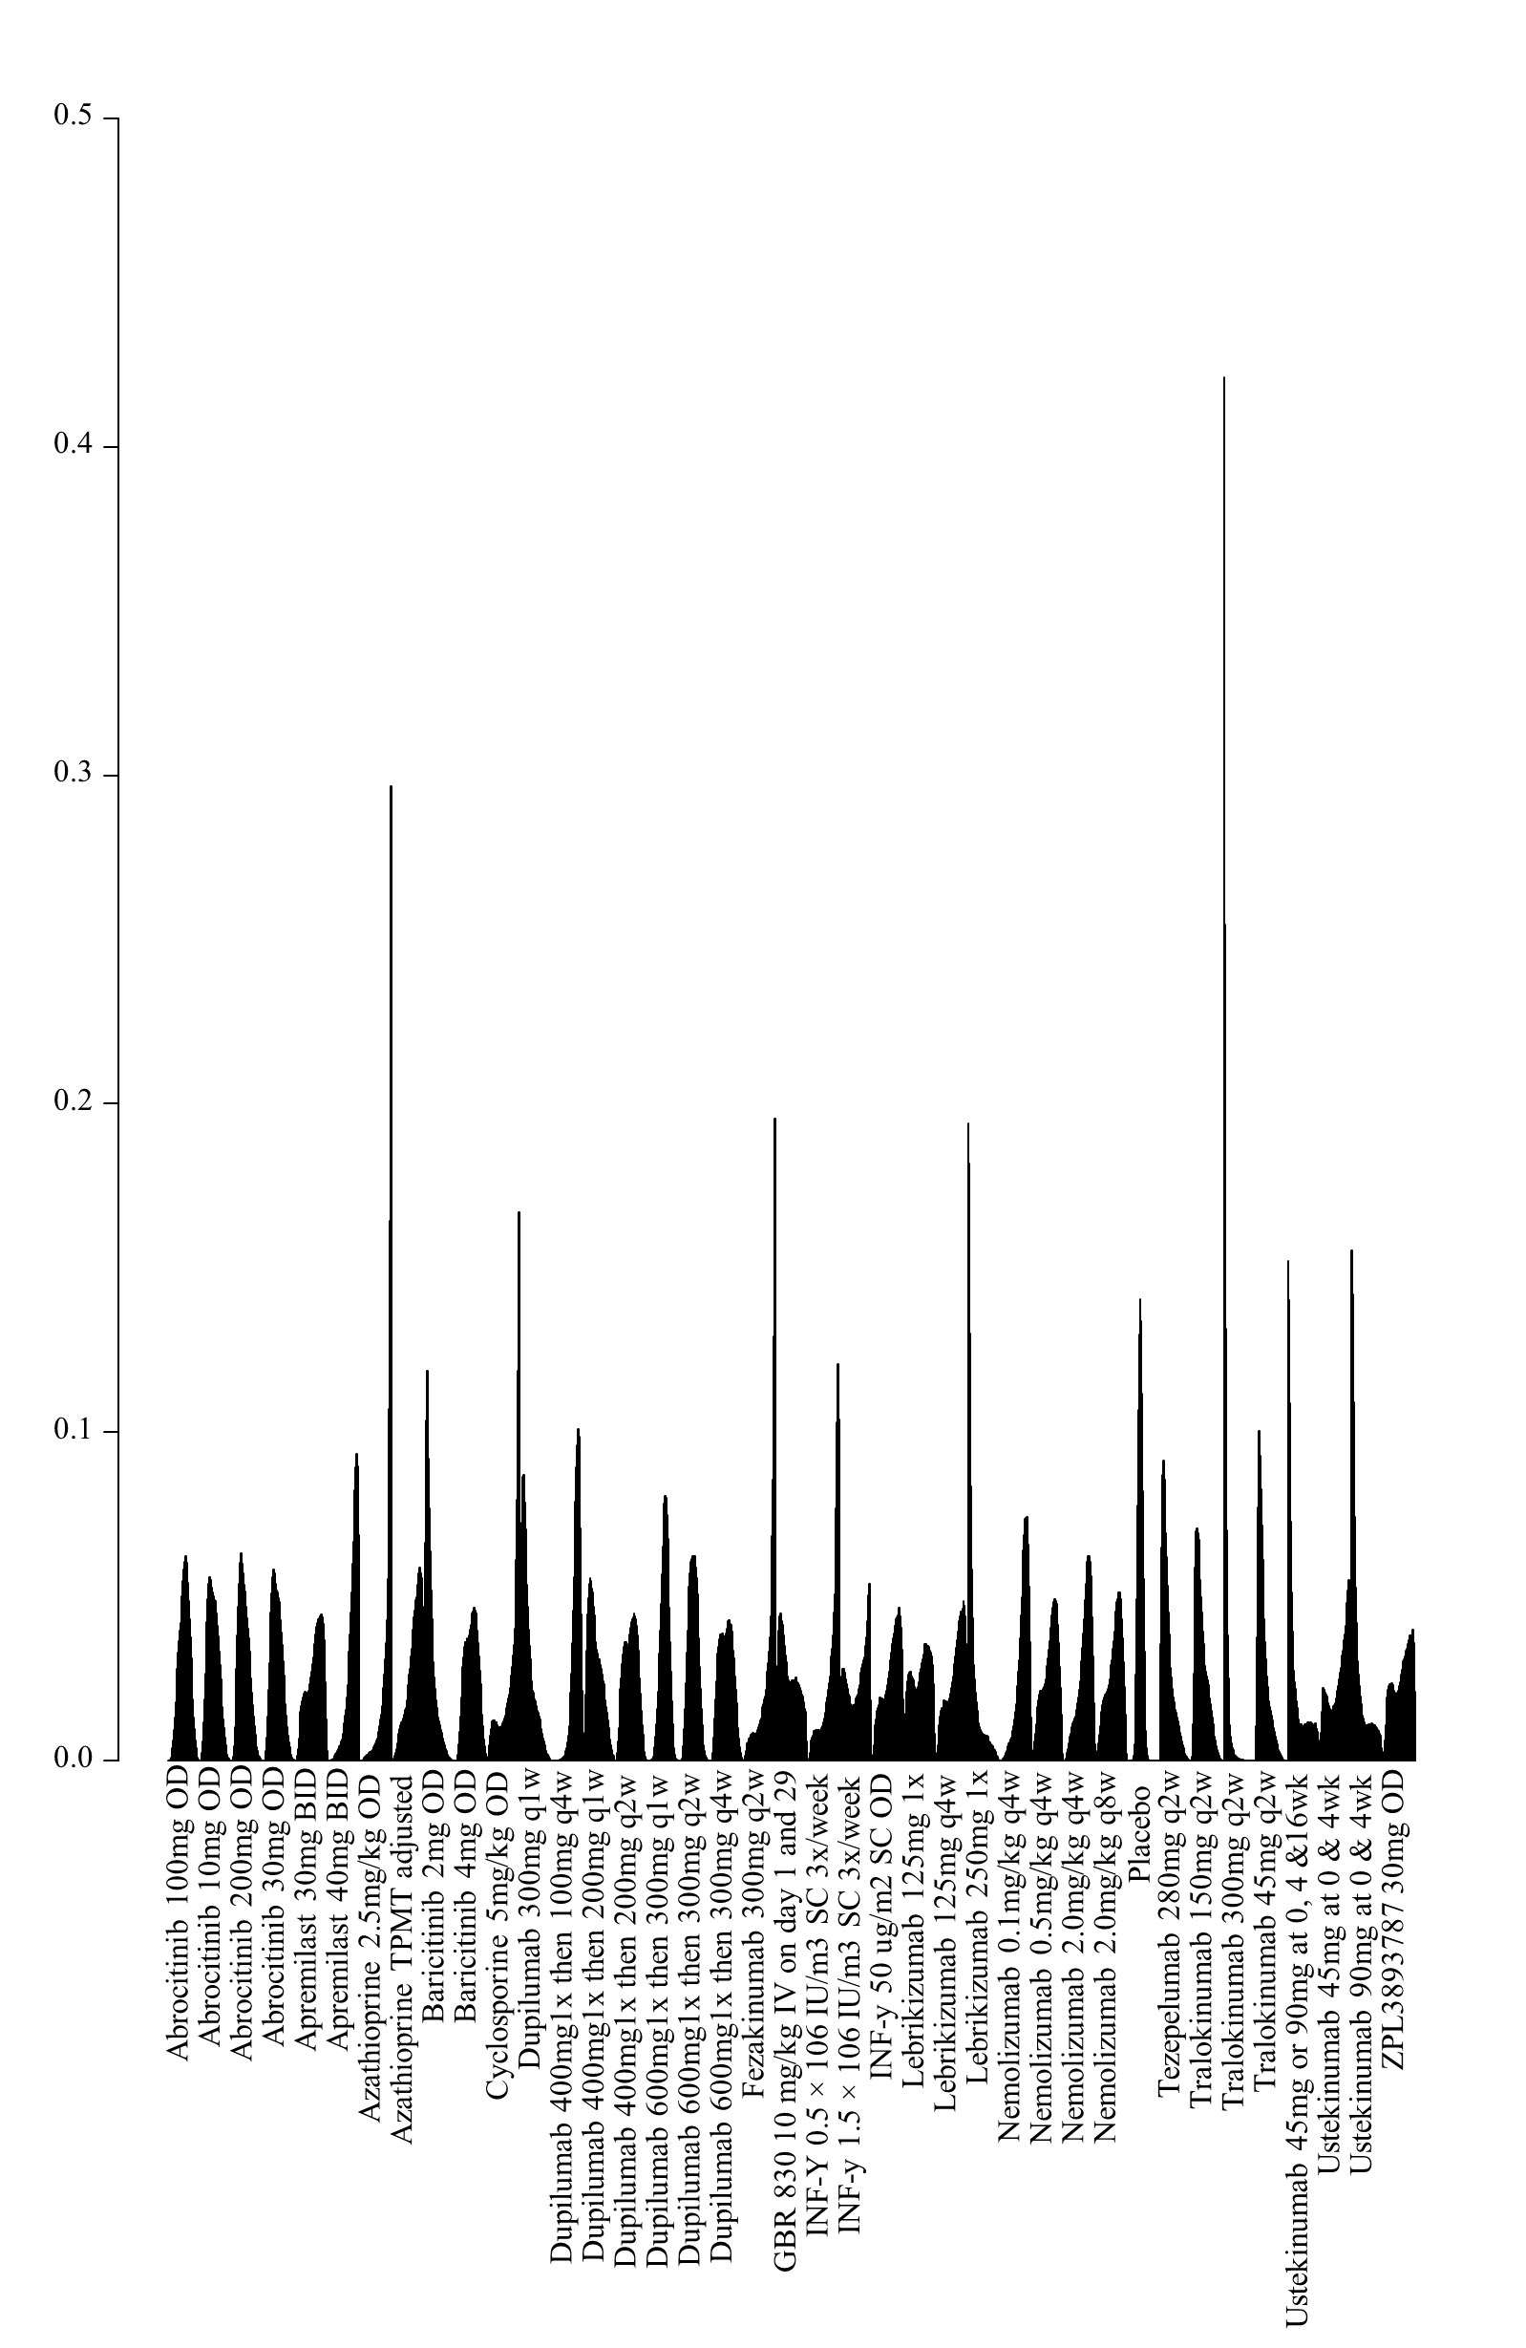

3. Network meta-analysis of withdrawal due to adverse event up to 16 weeks of treatment - analyses using restrictive priors on treatment effects and heterogeneity parameters (including only medications currently in use)

i. League table of arms included in the network meta-analysis of withdrawal due to adverse events up to 16 weeks of treatment – analyses using restrictive priors on treatment effects and heterogeneity parameters (including only medications currently in use). Results are presented as odds ratios (95% CrI) for withdrawals due to adverse event between the two arms. An effect estimate greater than 1 in a given cell favors the row-defining treatment. An effect estimate less than 1 in a given cell favors the column-defining treatment.

ii. SUCRA values and ranking for change in withdrawal due to adverse event up to 16 weeks of treatment – analyses using restrictive priors on treatment effects and heterogeneity parameters (including only medications currently in use)

iii. Rank plot of arms included in the network meta-analysis of withdrawal due to adverse event up to 16 weeks of treatment - analyses using restrictive priors on treatment effects and heterogeneity parameters (including only medications currently in use)

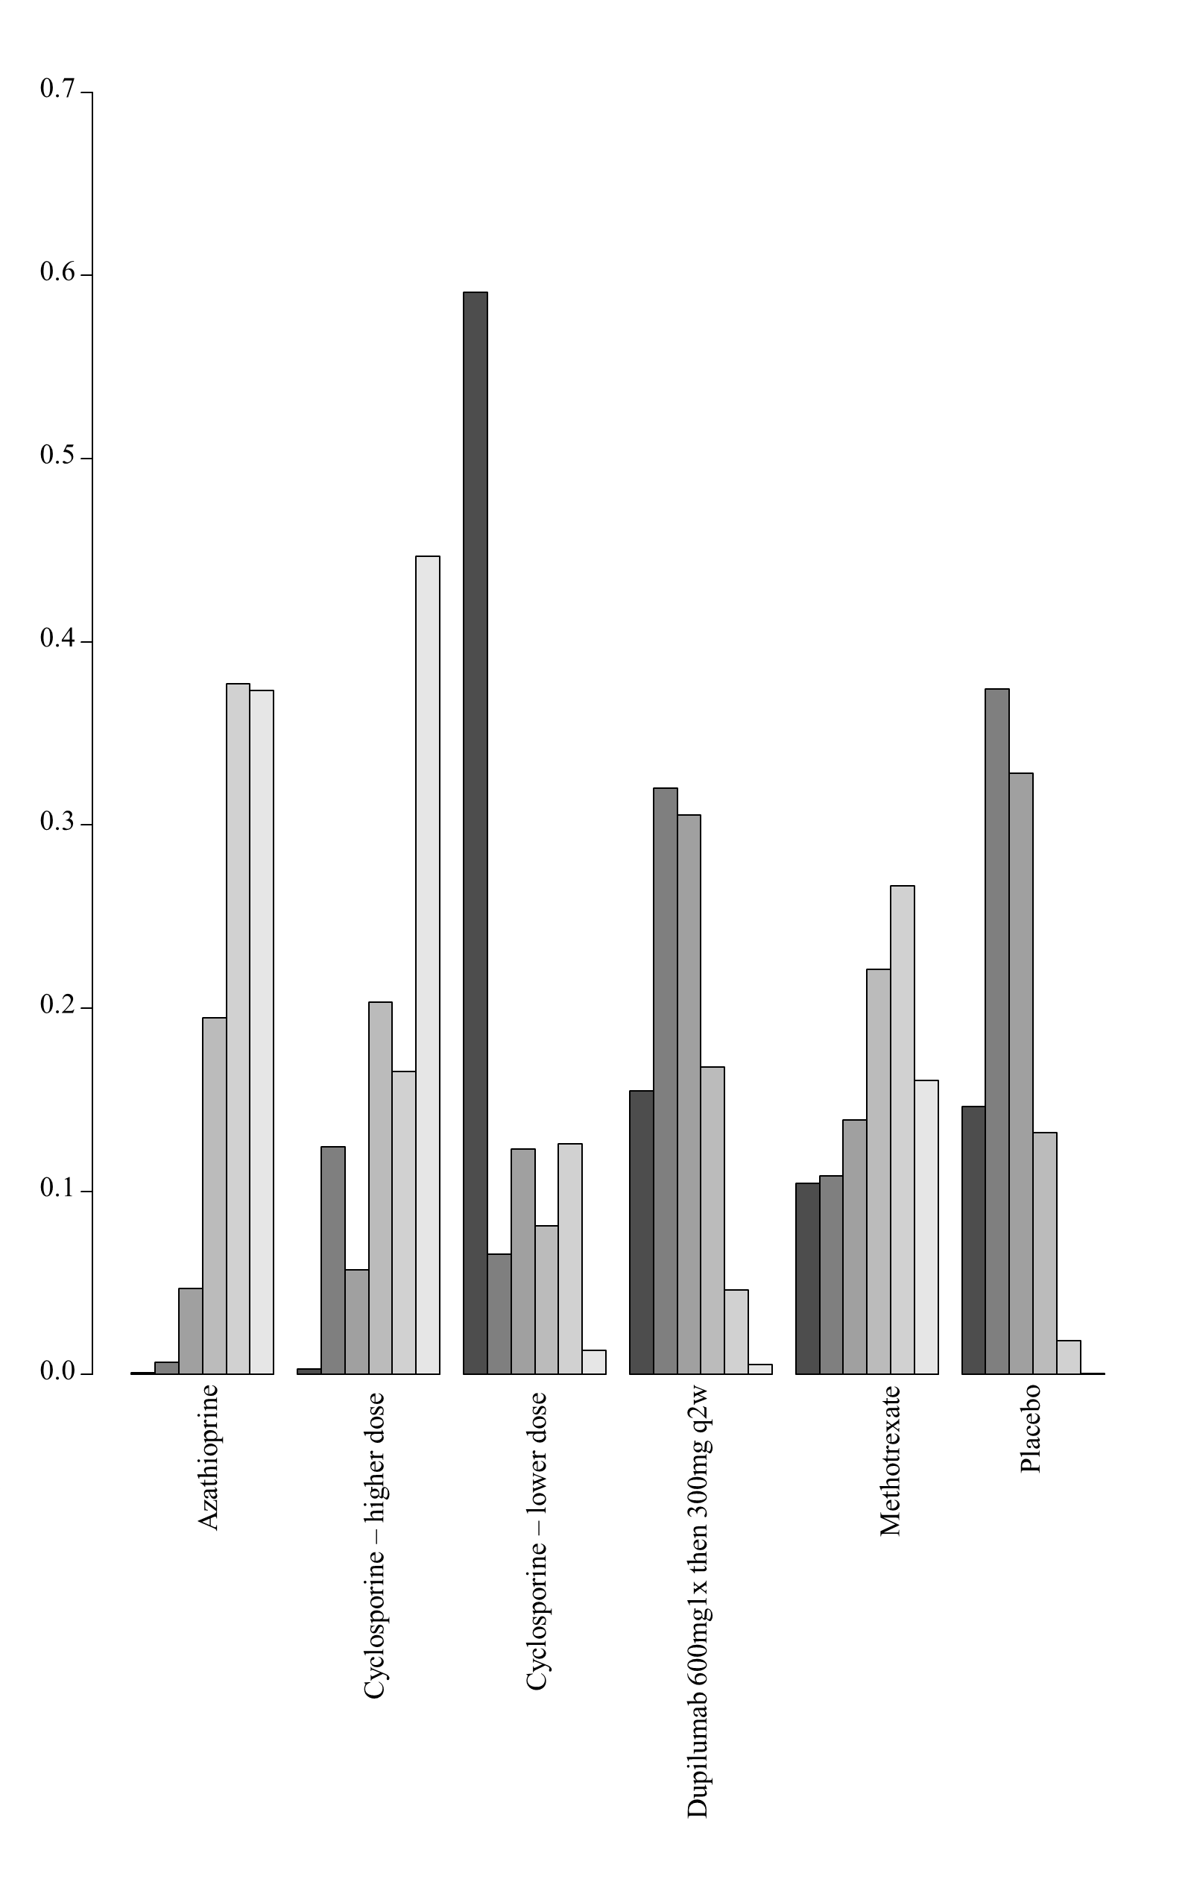

7E. Network meta-analysis of serious adverse events up to 16 weeks of treatment

1. Network meta-analysis of serious adverse events up to 16 weeks of treatment – main analysis

i. Network plot of arms included in the network meta-analysis of difference in serious adverse events up to 16 weeks of treatment
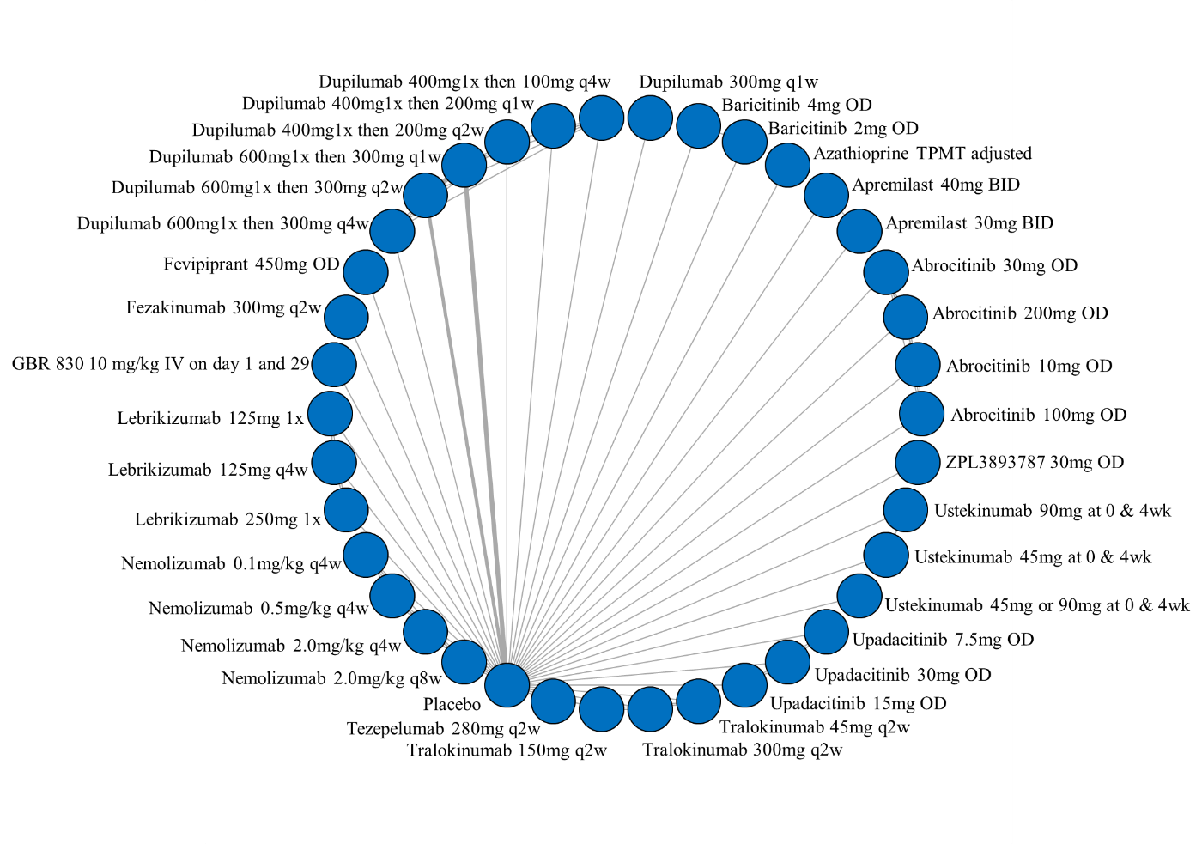

ii. League table of arms included in the network meta-analysis of serious adverse events up to 16 weeks of treatment. Results are presented as odds ratios (95% CrI) for serious adverse events between the two arms. An effect estimate greater than 1 in a given cell favors the row-defining treatment. An effect estimate less than 1 in a given cell favors the column-defining treatment.

iii. GRADE assessment of serious adverse events up to 16 weeks of treatment
Serious Adverse Event
All versus Placebo
Drug | GRADE Rating
  Abrocitinib 100mg OD
  Abrocitinib 10mg OD
  Abrocitinib 200mg OD
  Abrocitinib 30mg OD
  Apremilast 30mg PO BID
  Apremilast 40mg PO BID
  Azathrioprine TPMT adjusted
  Baricitninib 2mg OD
  Baricitinib 4mg OD
  Dupilumab 300mg q1w
  Dupilumab 400mg1x then 100mg q4w
  Dupilumab 400mg1x then 200mg q1w
  Dupilumab 400mg1x then 200mg q2w
  Dupilumab 600mg1x then 300mg q1w
  Dupilumab 600mg1x then 300mg q2w
  Dupilumab 600mg1x then 300mg q4w
  Fevipiprant 450mg OD
  Fezakinumab 300mg q2w
  GBR 830 10mg/kg IV on day 1 and 29
  Lebrikizumab 125mg 1x
  Lebrikizumab 125mg q4w
  Lebrikizumab 250mg 1x
  Nemolizumab 0.1mg/kg q4w
  Nemolizumab 0.5mg/kg q4w
  Nemolizumab 2.0mg/kg q4w
  Nemolizumab 2.0mg/kg q8w
  Tezepelumab 280mg q2w
  Tralokinumab 150mg q2w
  Tralokinumab 300mg q2w
  Tralokinumab 45mg q2w
  Upadacitinib 15mg OD
  Upadacitinib 30mg OD
  Upadacitinib 75mg OD
  Ustekinumab 45mg or 90mg at 0, 4 or 16wk
  Ustekinumab 45mg at 0 and 4wk
  Ustekinumab 90mg at 0 and 4wk
  ZPL3893787 30mg OD
  Low^{1,2,3}
  Low^{1,2,3}
  Low^{1,2,3}
  Very Low^{2,3,4}
  Low^{2,3}
  Low^{2,3}
  Low^{2,3}
  Moderate²
  Low^{2,4}
  Low^{2,4}
  Moderate²
  Low^{2,4}
  Low^{2,4}
  Moderate¹
  Moderate¹
  Moderate^{1,2}
  Very Low^{2,3,4}
  Low^{2,3}
  Very Low^{2,3,4}
  Low^{1,2,3}
  Very Low^{2,3,4}
  Very Low^{2,3,4}
  Very Low^{2,3,4}
  Very Low^{2,3,4}
  Low^{1,2,3}
  Low^{1,2,3}
  Very Low^{2,3,4}
  Moderate²
  Low^{2,4}
  Moderate²
  Very Low^{2,3,4}
  Very Low^{2,3,4}
  Very Low^{2,3,4}
  Low^{2,4}
  Low^{2,4}
  Low^{2,4}
  Very Low^{2,3,4}
1 – NMA estimate imprecise and would suggest different conclusions at either end of the 95% Credible Intervals
2 – Number of patients included in analysis below optimal information size
3 – significant issues related to risk of bias from included trials
4 – very serious imprecision (lowered 2 levels) for very imprecise NMA estimate
Given the exclusive hub and spoke arrangement, any head to head comparison will be the lowest rated of the two interventions as compared to placebo.

2. Network meta-analysis of serious adverse events up to 16 weeks of treatment - analyses using restrictive priors on treatment effects and heterogeneity parameters (all medications)

i. League table of arms included in the network meta-analysis of serious adverse events up to 16 weeks of treatment – analyses using restrictive priors on treatment effects and heterogeneity parameters (all medications). Results are presented as odds ratios (95% CrI) for serious adverse events between the two arms. An effect estimate greater than 1 in a given cell favors the row-defining treatment. An effect estimate less than 1 in a given cell favors the column-defining treatment.

ii. SUCRA values and ranking for change in serious adverse events up to 16 weeks of treatment – analyses using restrictive priors on treatment effects and heterogeneity parameters (all medications)

iii. Rank plot of arms included in the network meta-analysis of serious adverse events up to 16 weeks of treatment - analyses using restrictive priors on treatment effects and heterogeneity parameters (all medications)

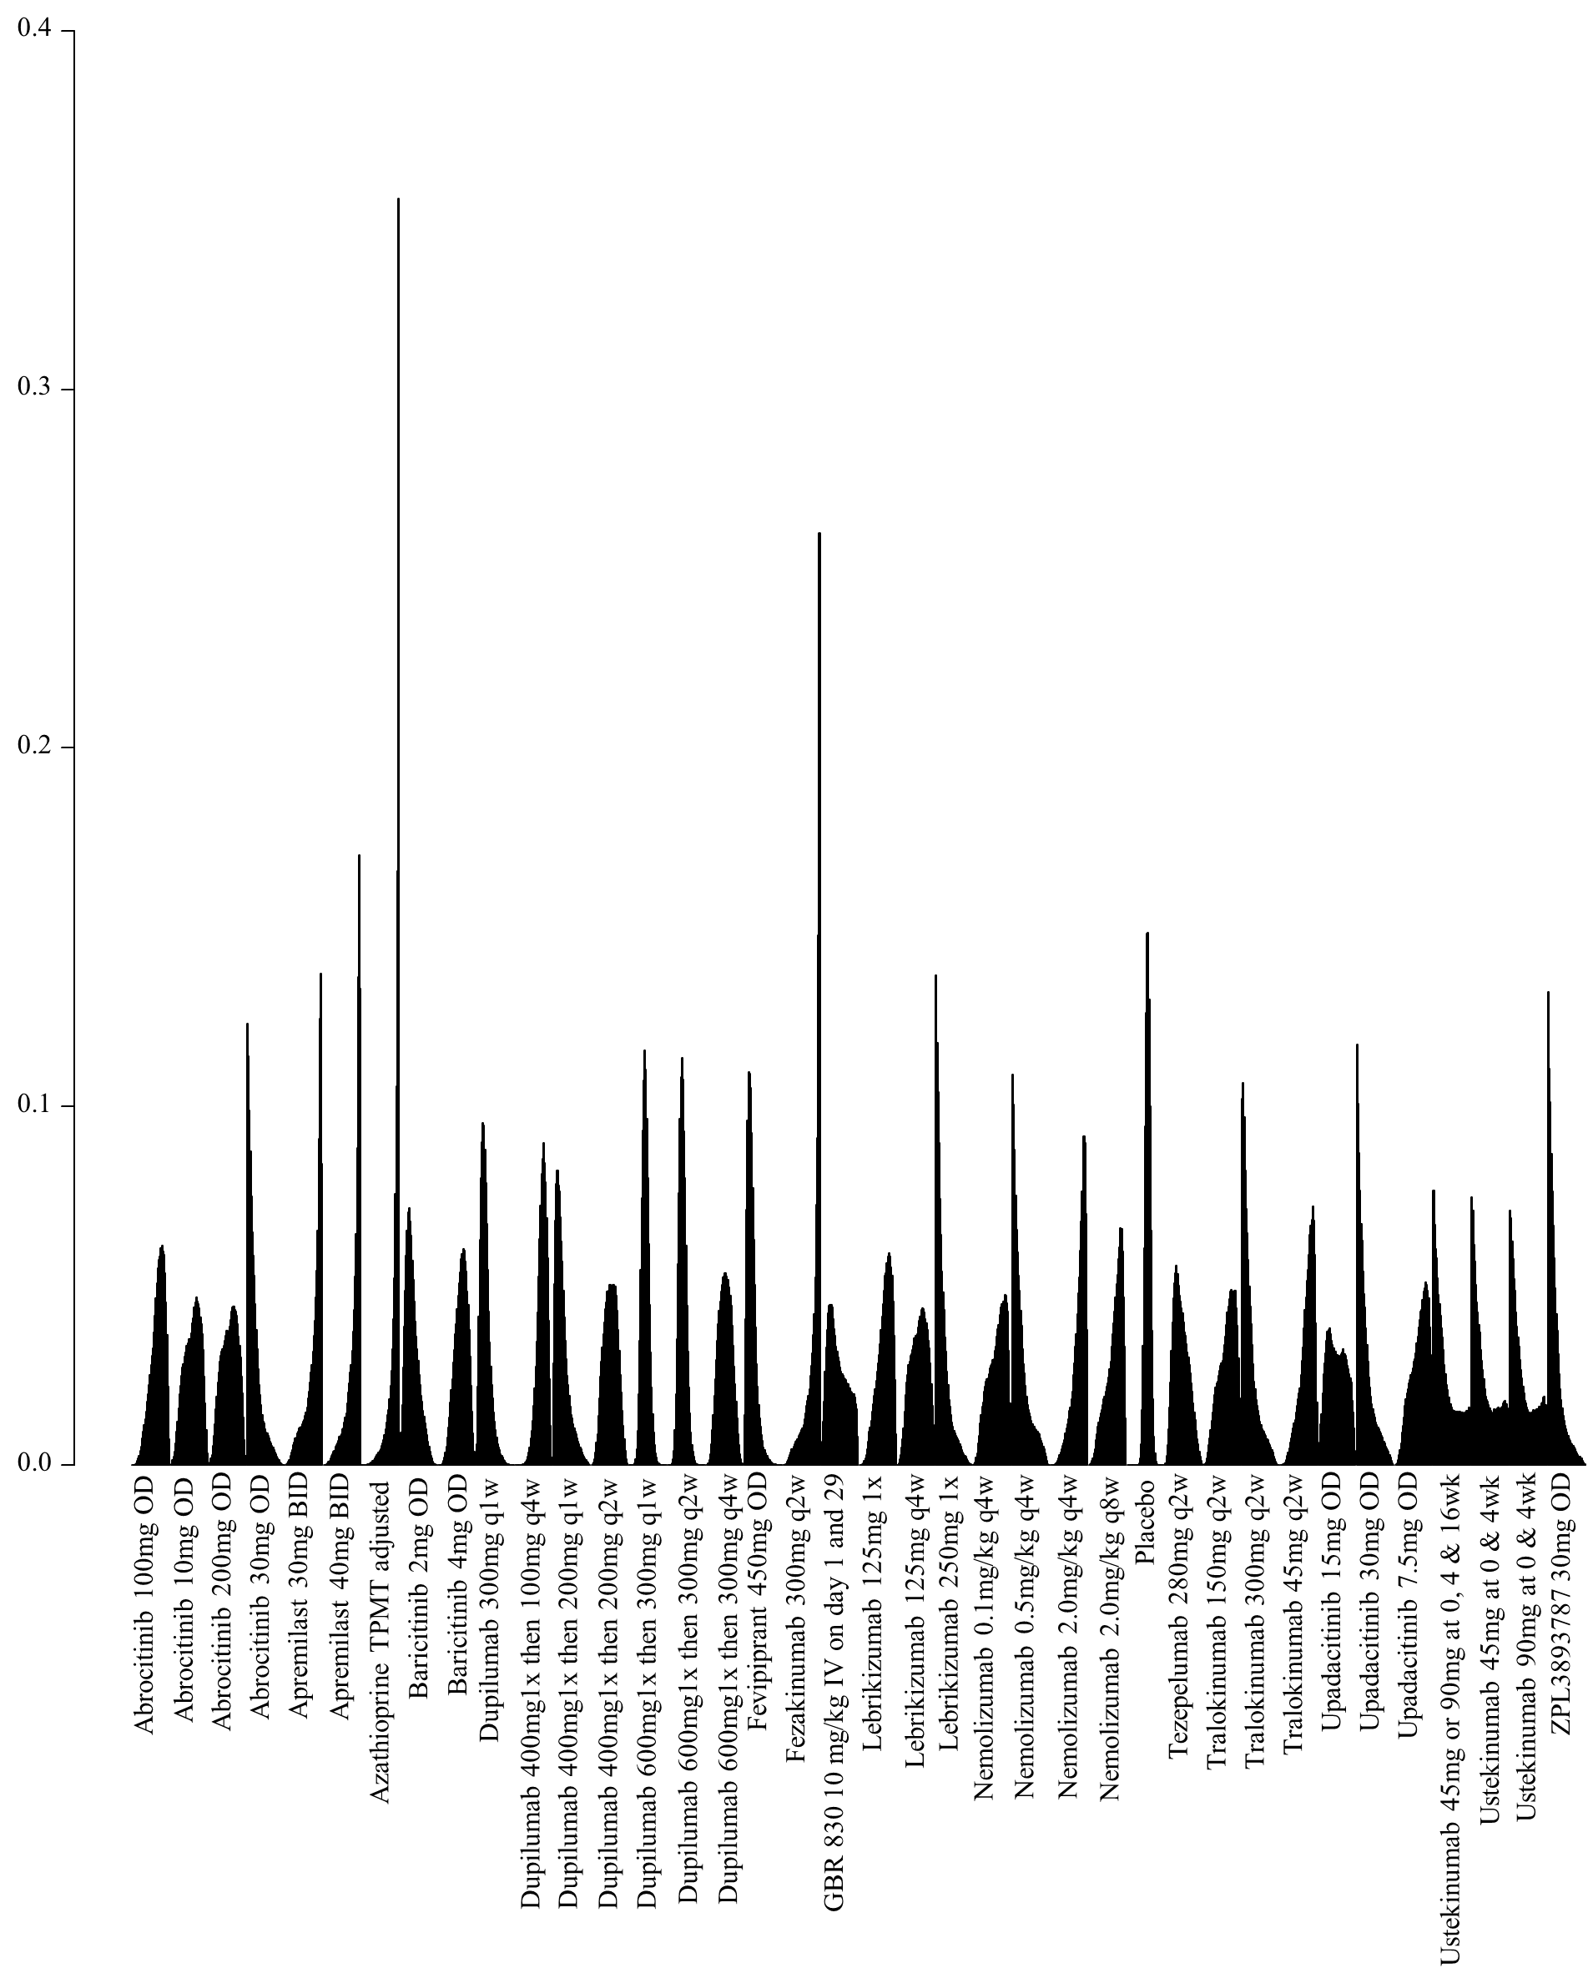

3. Network meta-analysis of serious adverse events up to 16 weeks of treatment - analyses using restrictive priors on treatment effects and heterogeneity parameters (including only medications currently in use)

i. League table of arms included in the network meta-analysis of serious adverse events up to 16 weeks of treatment – analyses using restrictive priors on treatment effects and heterogeneity parameters (including only medications currently in use). Results are presented as odds ratios (95% CrI) for serious adverse events between the two arms. An effect estimate greater than 1 in a given cell favors the row-defining treatment. An effect estimate less than 1 in a given cell favors the column-defining treatment.

ii. SUCRA values and ranking for change in serious adverse events up to 16 weeks of treatment – analyses using restrictive priors on treatment effects and heterogeneity parameters (including only medications currently in use)

iii. Rank plot of arms included in the network meta-analysis of serious adverse events up to 16 weeks of treatment - analyses using restrictive priors on treatment effects and heterogeneity parameters (including only medications currently in use)

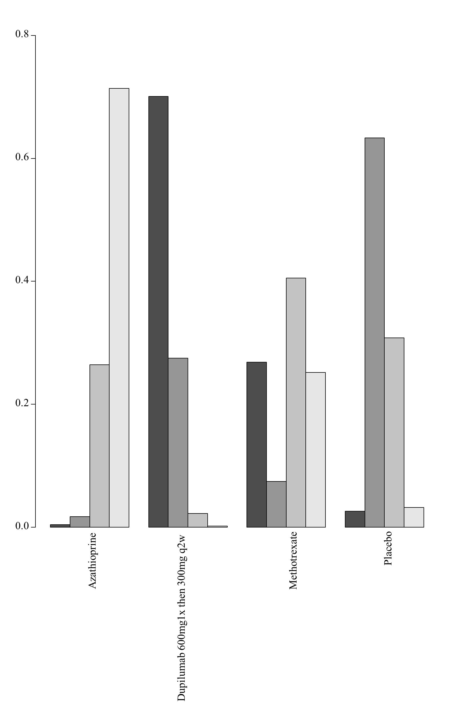

7F. Network meta-analysis of change in DLQI scores up to 16 weeks of treatment

1. Network meta-analysis of change in DLQI score up to 16 weeks of treatment – main analysis

i. Network plot of arms included in the network meta-analysis of change in DLQI score up to 16 weeks of treatment
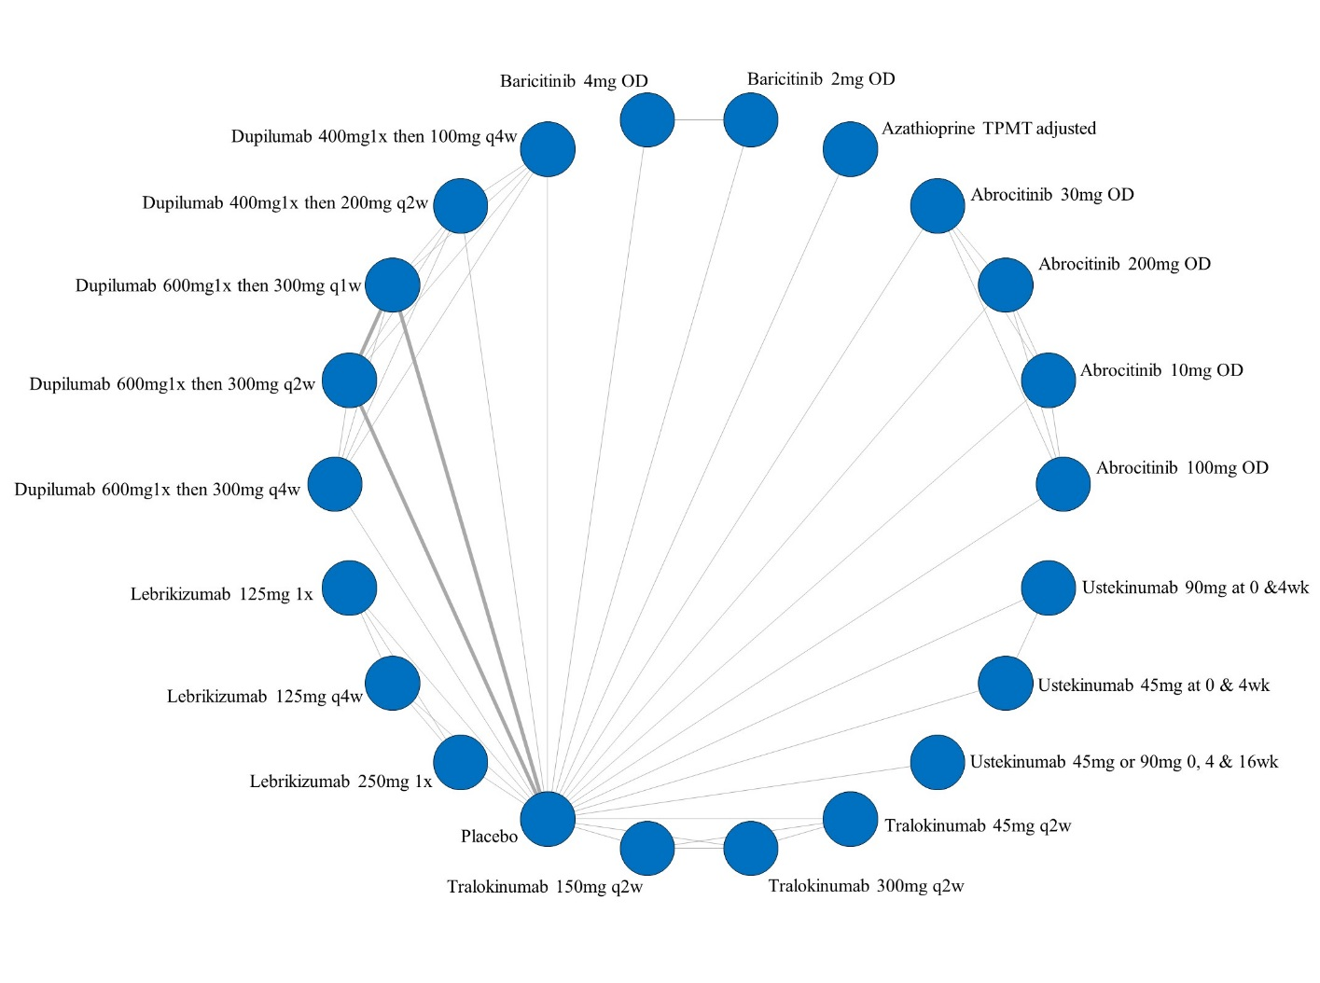

- League table of arms included in the network meta-analysis of change in DLQI score up to 16 weeks of treatment. Results are presented as the mean difference (95% CrI) in DLQI score between the two arms. A positive effect estimate in a given cell favors the row-defining treatment. A negative effect estimate in a given cell favors the column-defining treatment.

iii. GRADE assessment of change in DLQI scores up to 16 weeks of treatment
DLQI
All versus Placebo
Drug | GRADE Rating
  Abrocitinib 100mg OD
  Abrocitinib 10mg OD
  Abrocitinib 200mg OD
  Abrocitinib 30mg OD
  Azathioprine TPMT adjusted
  Baricitninib 2mg OD
  Baricitinib 4mg OD
  Dupilumab 400mg1x then 100mg q4w
  Dupilumab 400mg1x then 200mg q2w
  Dupilumab 600mg1x then 300mg q1w
  Dupilumab 600mg1x then 300mg q2w
  Dupilumab 600mg1x then 300mg q4w
  Lebrikizumab 125mg 1x
  Lebrikizumab 125mg q4w
  Lebrikizumab 250mg 1x
  Tralokinumab 150mg q2w
  Tralokinumab 300mg q2w
  Tralokinumab 45mg q2w
  Ustekinumab 45mg or 90mg at 0,4 & 16 wk
  Ustekinumab 45mg at 0 and 4wk
  Ustekinumab 90mg at 0 and 4wk
  Low^{1,2,3}
  Low^{1,2,3}
  Low^{1,2,3}
  Low^{1,2,3}
  Low^{1,2,3}
  Moderate^{1,2}
  Moderate^{1,2}
  Moderate^{1,2}
  Moderate^{1,2}
  High
  High
  Moderate^{1,2}
  Low^{1,2,3}
  Low^{1,2,3}
  Low^{1,2,3}
  Moderate^{1,2}
  Moderate^{1,2}
  Moderate^{1,2}
  Low^{2,4}
  Moderate^{1,2}
  Moderate^{1,2}
1 – NMA estimate imprecise and would suggest different conclusions at either end of the 95% Credible Intervals
2 – Number of patients included in analysis below optimal information size
3 – significant issues related to risk of bias from included trials
4 – very serious imprecision (lowered 2 levels) for very imprecise NMA estimate
Given the exclusive hub and spoke arrangement, any head to head comparison will be the lowest rated of the two interventions as compared to placebo.

iv. SUCRA values and ranking for change in DLQI score up to 16 weeks of treatment – main analyses
v. Rank plot of arms included in the network meta-analysis of change in DLQI score up to 16 weeks of treatment
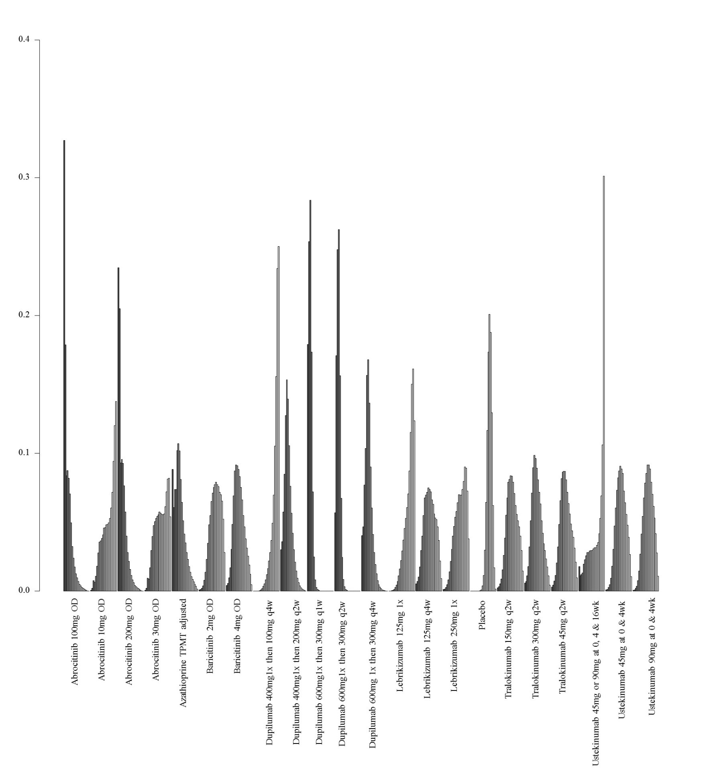

2. Network meta-analysis of change in DLQI score up to 16 weeks of treatment – analysis including only studies at low risk of bias

i. Network plot of arms included in the network meta-analysis of change in DLQI score up to 16 weeks of treatment – including only studies at low risk of bias
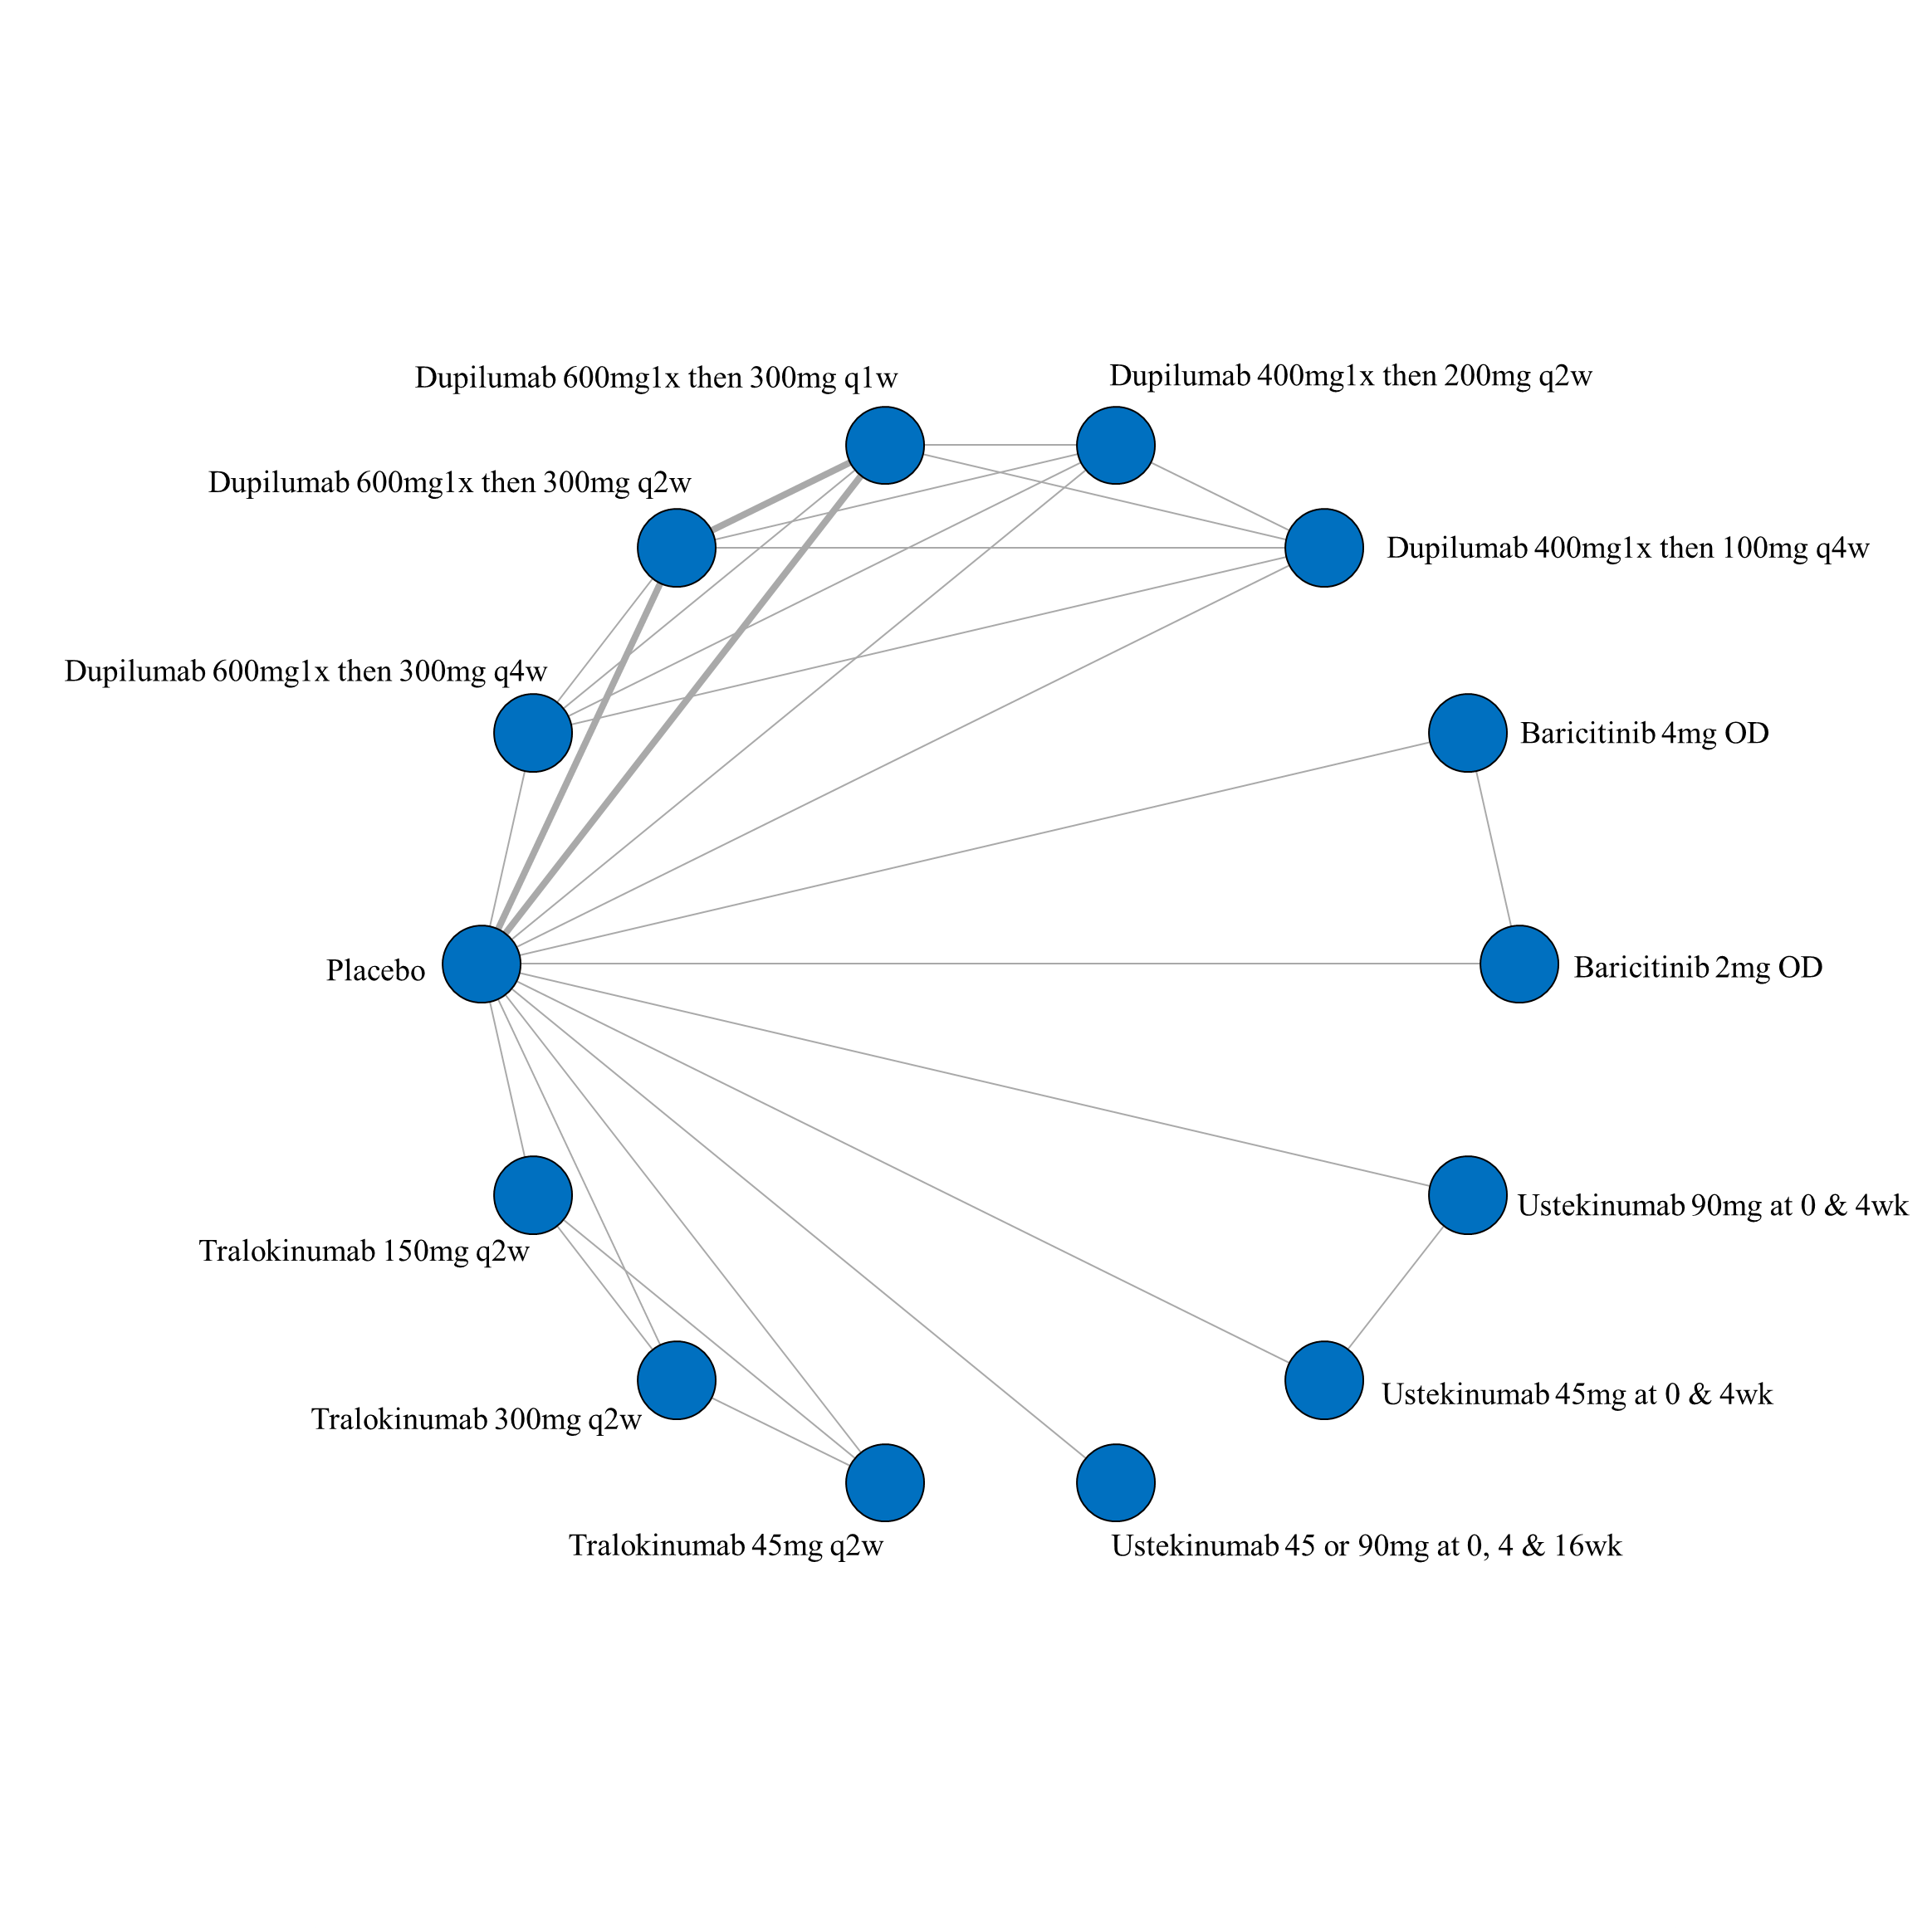

- League table of arms included in the network meta-analysis of change in DLQI score of studies at low risk of bias up to 16 weeks of treatment. Results are presented as the mean difference (95% CrI) in DLQI score between the two arms. A positive effect estimate in a given cell favors the row-defining treatment. A negative effect estimate in a given cell favors the column-defining treatment.

iii. SUCRA values and ranking for change in DLQI score up to 16 weeks of treatment – including only studies at low risk of bias
iv. Rank plot of arms included in the network meta-analysis of change in DLQI score up to 16 weeks of treatment – including only studies at low risk of bias
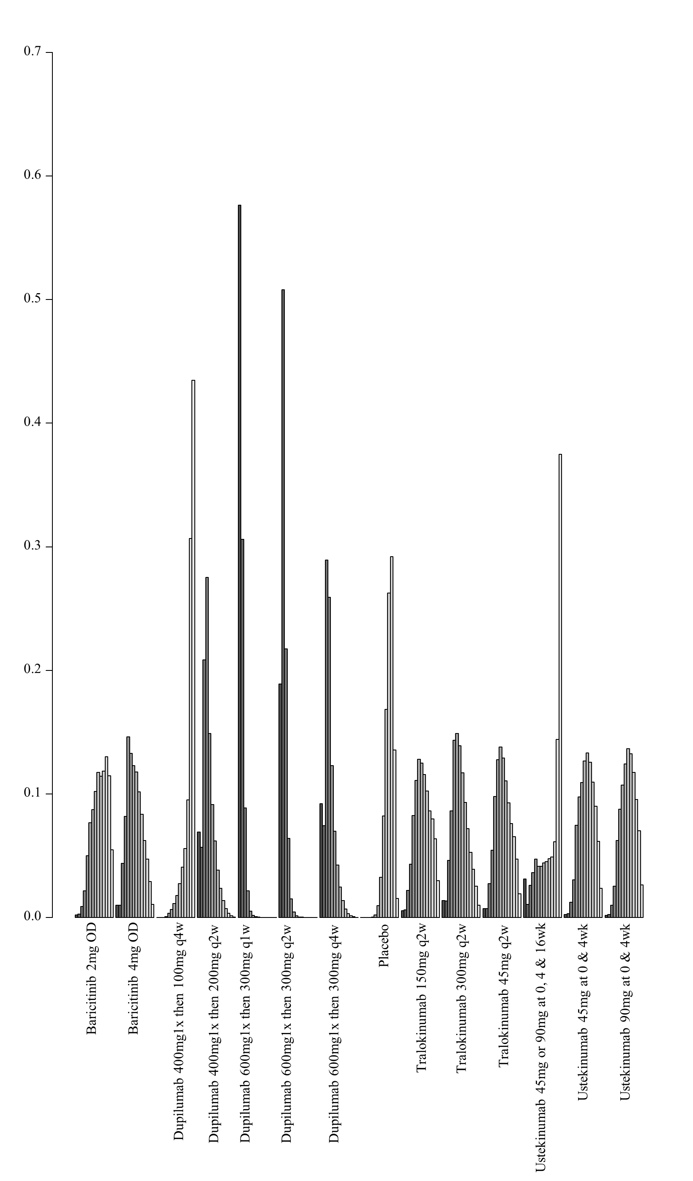

3. Network meta-analysis of change in DLQI score up to 16 weeks of treatment – analysis including only studies that did not allow concomitant topical anti-inflammatory treatment

i. Network plot of arms included in the network meta-analysis of change in DLQI score up to 16 weeks of treatment – including only studies that did not allow concomitant topical anti-inflammatory treatment

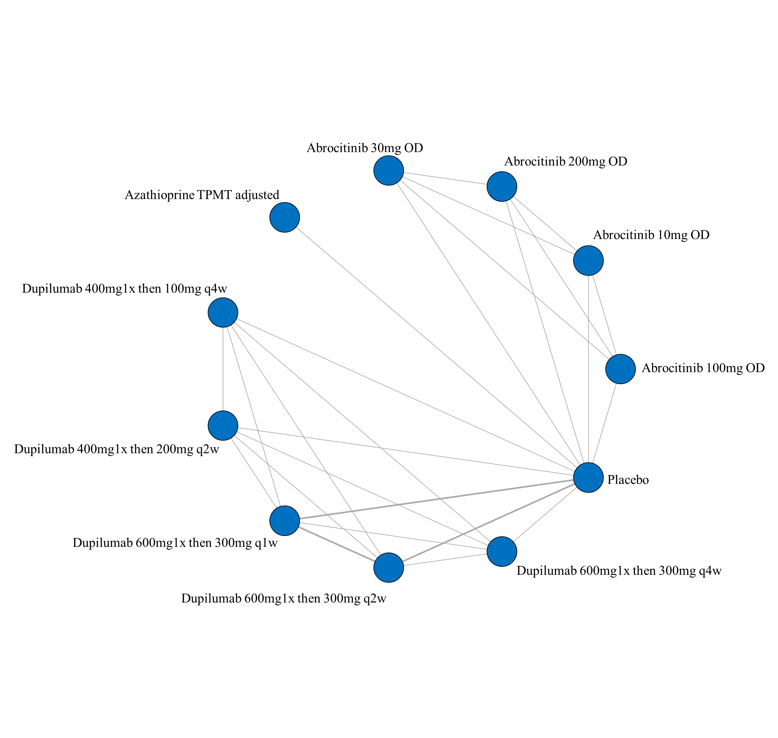

ii. League table of arms included in the network meta-analysis of change in DLQI score of studies that did not allow concomitant topical anti-inflammatory treatment up to 16 weeks of treatment. Results are presented as the mean difference (95% CrI) in DLQI score between the two arms. A positive effect estimate in a given cell favors the row-defining treatment. A negative effect estimate in a given cell favors the column-defining treatment.

iii. SUCRA values and ranking for change in DLQI score up to 16 weeks of treatment – including only studies that did not allow concomitant topical anti-inflammatory treatment

iv. Rank plot of arms included in the network meta-analysis of change in DLQI score up to 16 weeks of treatment – including only studies at that did not allow concomitant topical anti-inflammatory treatment

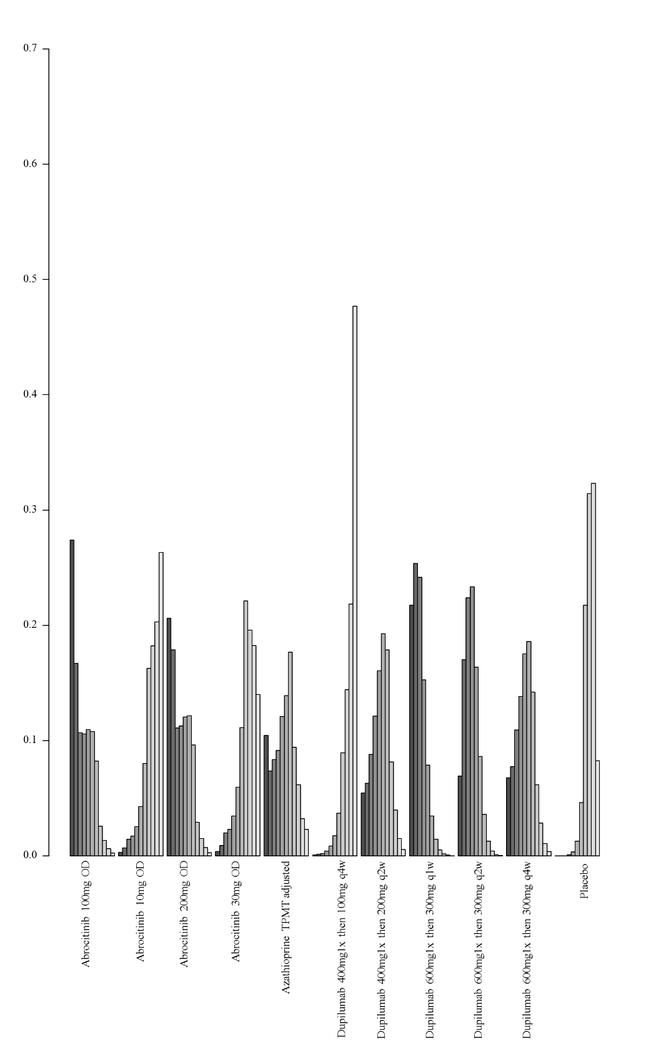

4. Network meta-analysis of change in DLQI score up to 16 weeks of treatment – analysis including only studies that allowed concomitant topical anti-inflammatory treatment
i. Network plot of arms included in the network meta-analysis of change in DLQI score up to 16 weeks of treatment – including only studies that allowed concomitant topical anti-inflammatory treatment
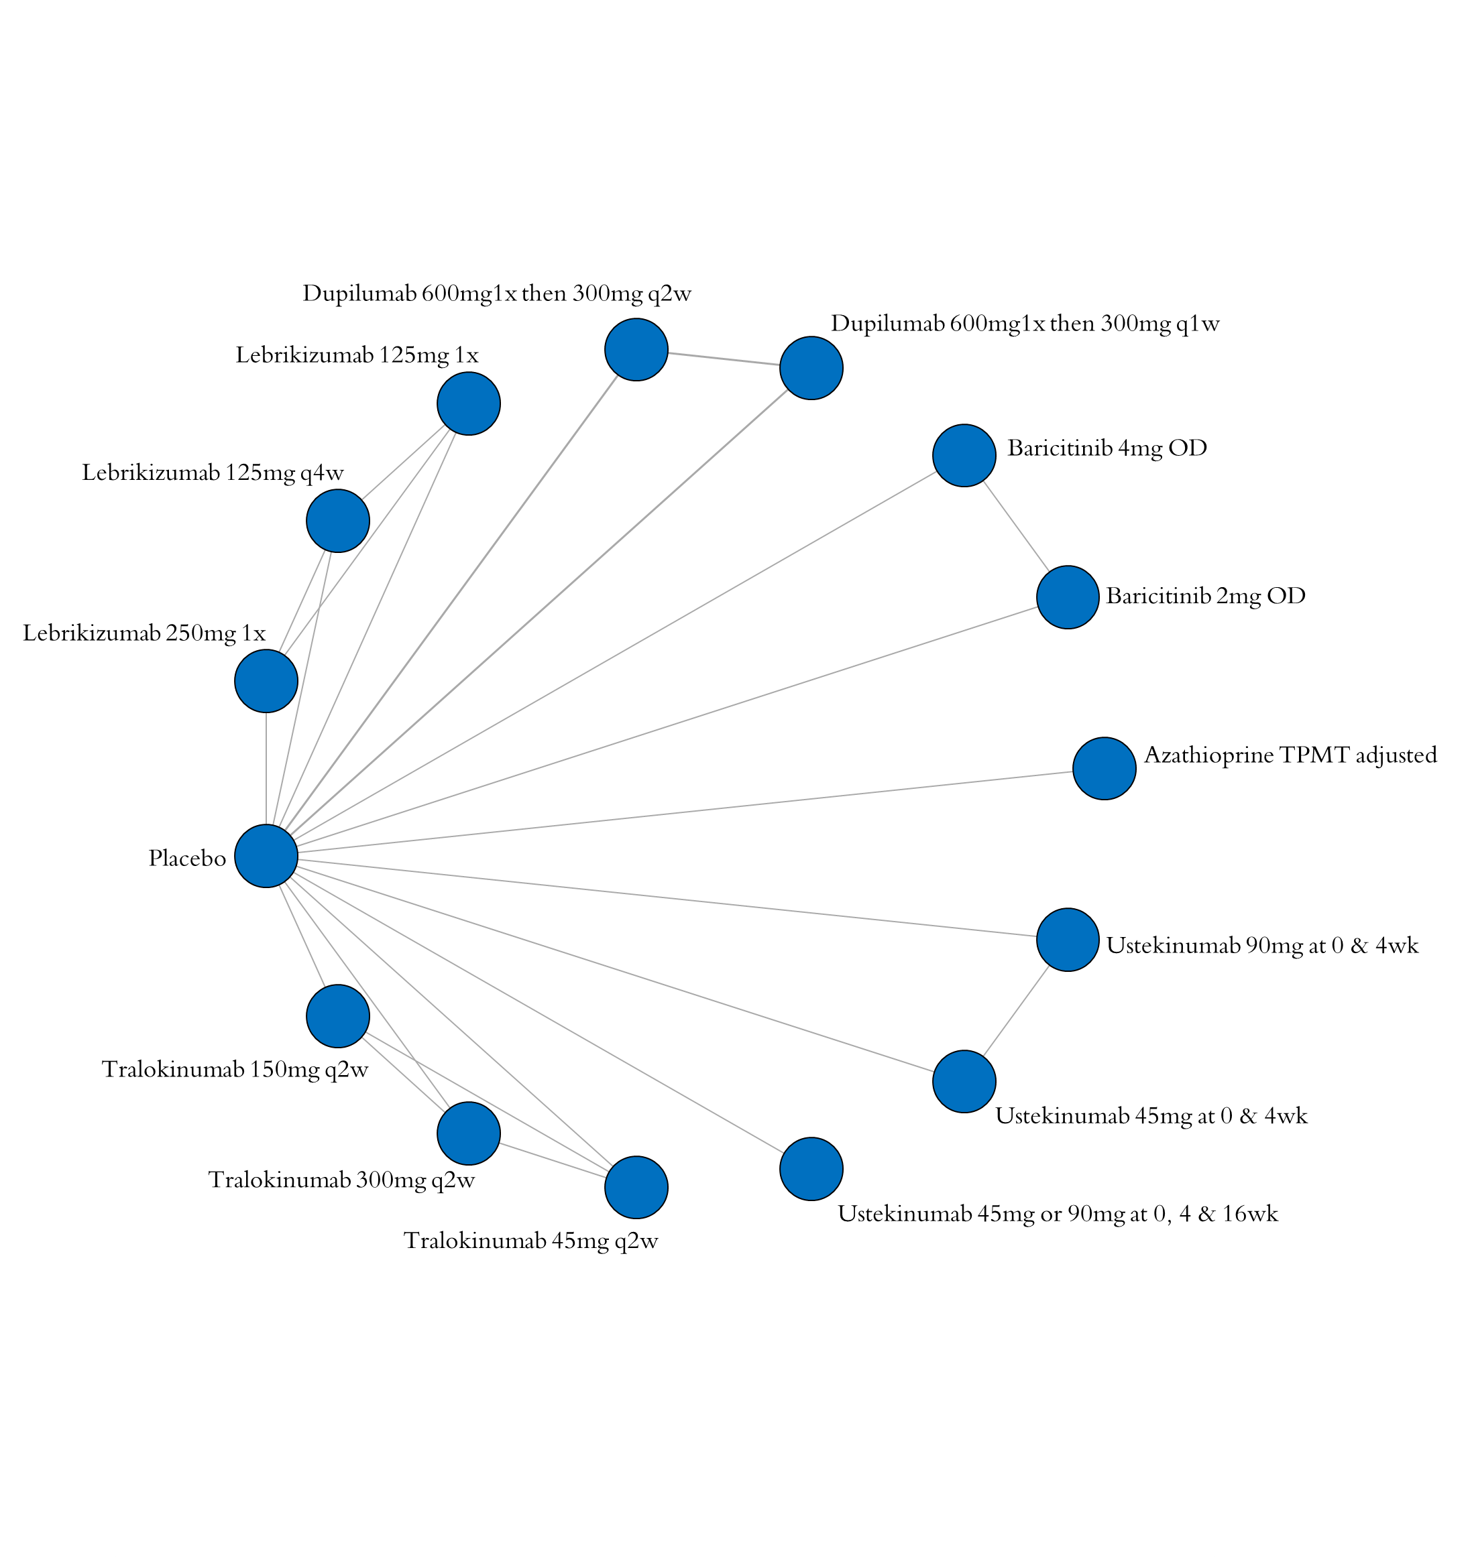

- League table of arms included in the network meta-analysis of change in DLQI score of studies that allowed concomitant topical anti-inflammatory treatment up to 16 weeks of treatment. Results are presented as the mean difference (95% CrI) in DLQI score between the two arms. A positive effect estimate in a given cell favors the row-defining treatment. A negative effect estimate in a given cell favors the column-defining treatment.

iii. SUCRA values and ranking for change in DLQI score up to 16 weeks of treatment – including only studies that allowed concomitant topical anti-inflammatory treatment
iv. Rank plot of arms included in the network meta-analysis of change in DLQI score up to 16 weeks of treatment – including only studies that allowed concomitant topical anti-inflammatory treatment
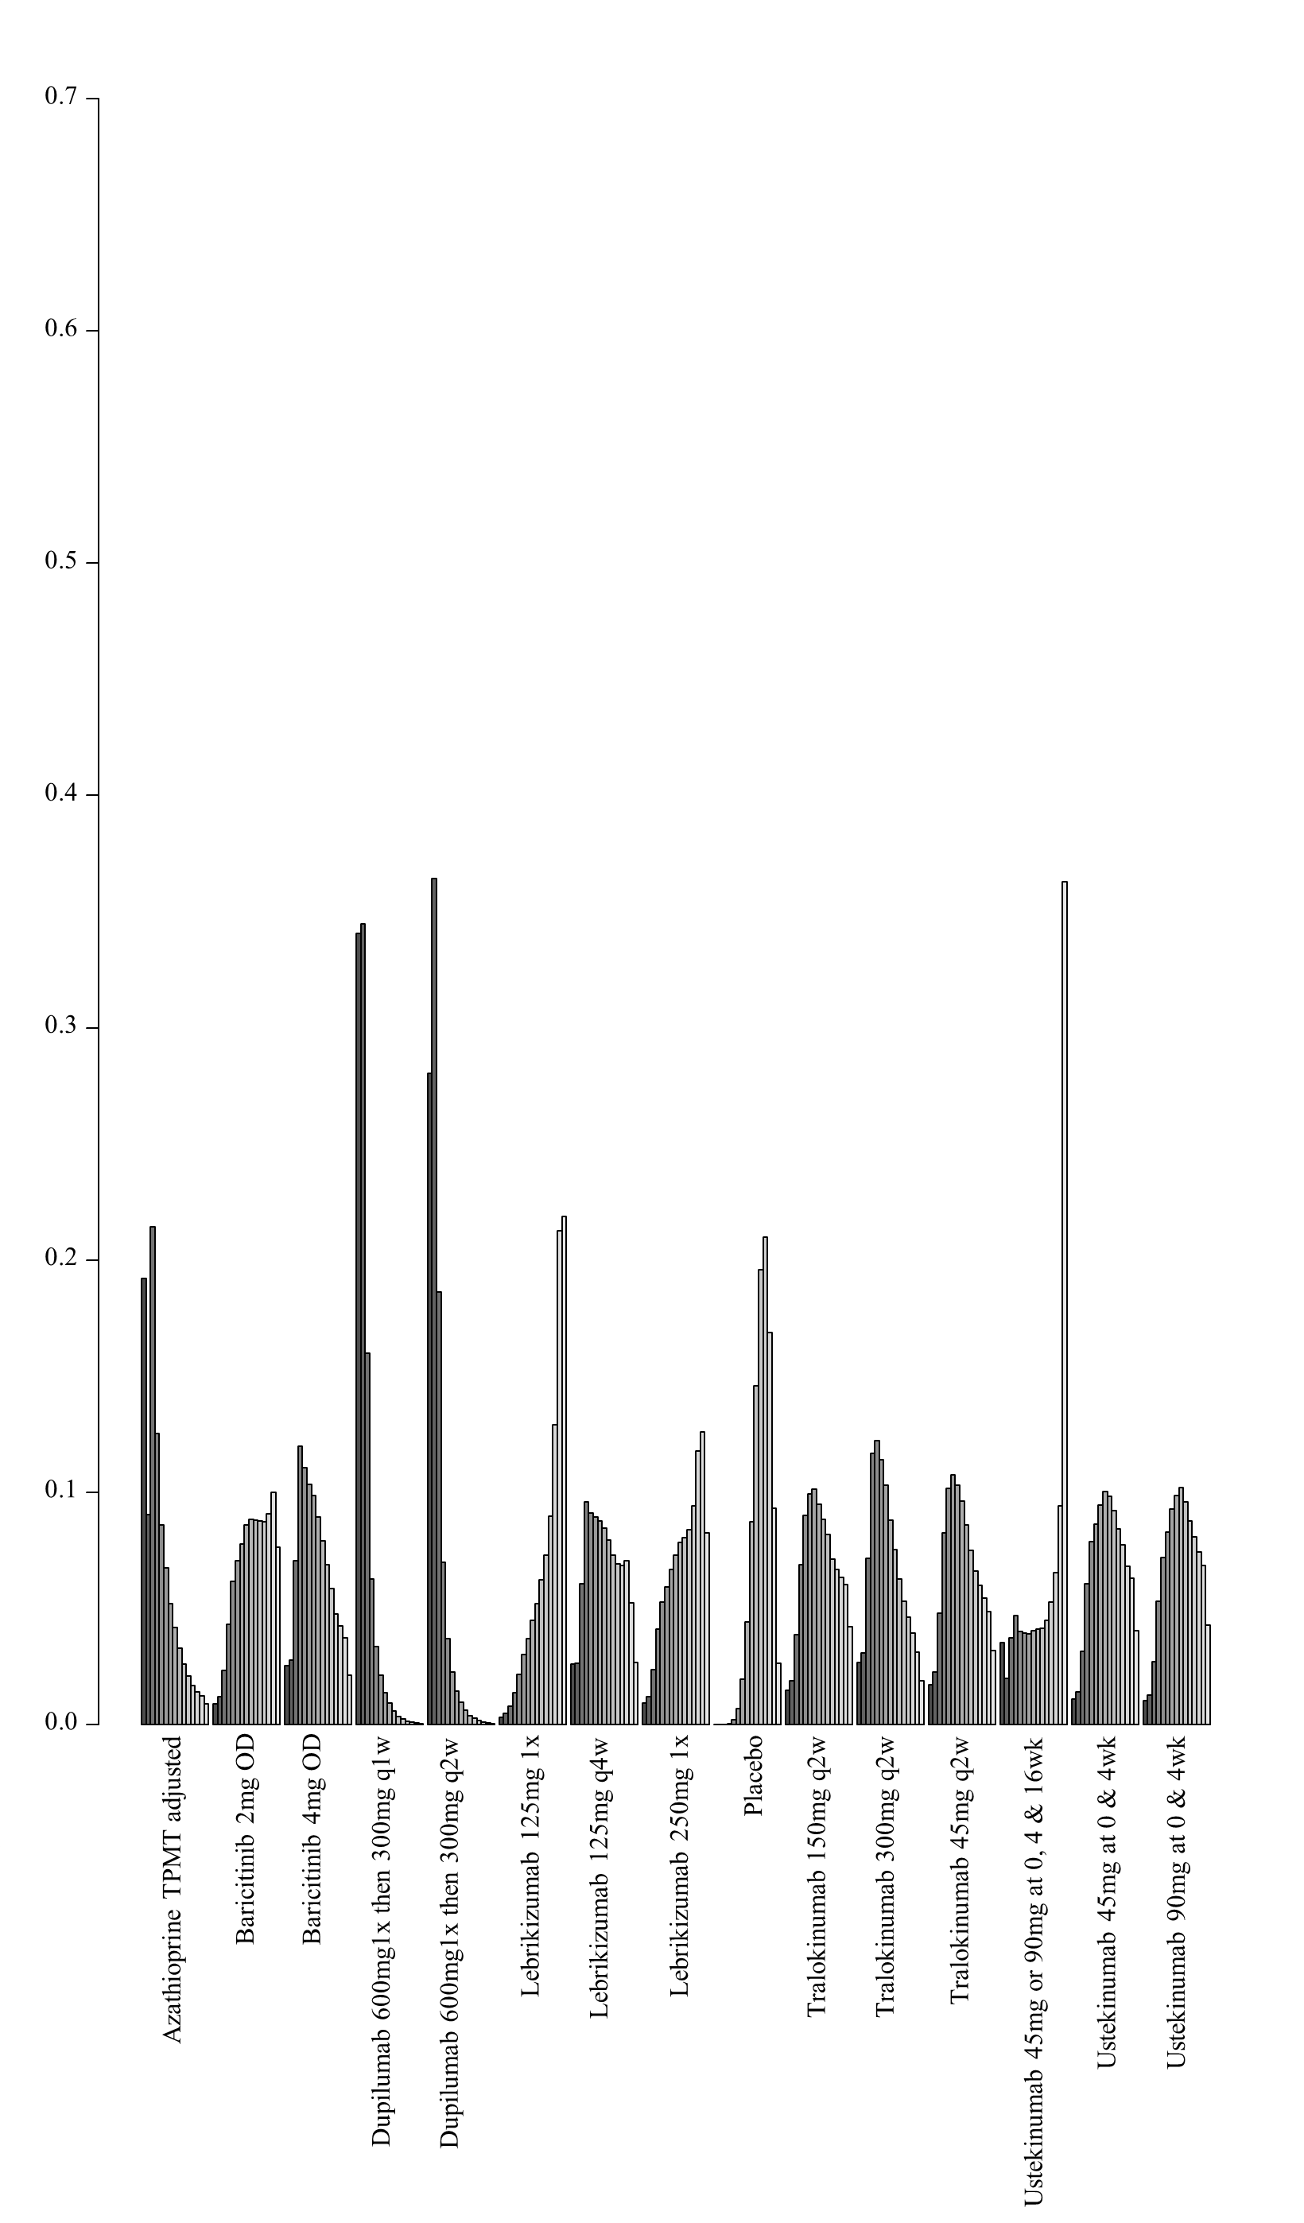

5. Network meta-analysis of change in DLQI score up to 16 weeks of treatment – including only studies that reported change from baseline scores

i. Network plot of arms included in the network meta-analysis of change in DLQI score up to 16 weeks of treatment – including only studies that reported the change from baseline scores
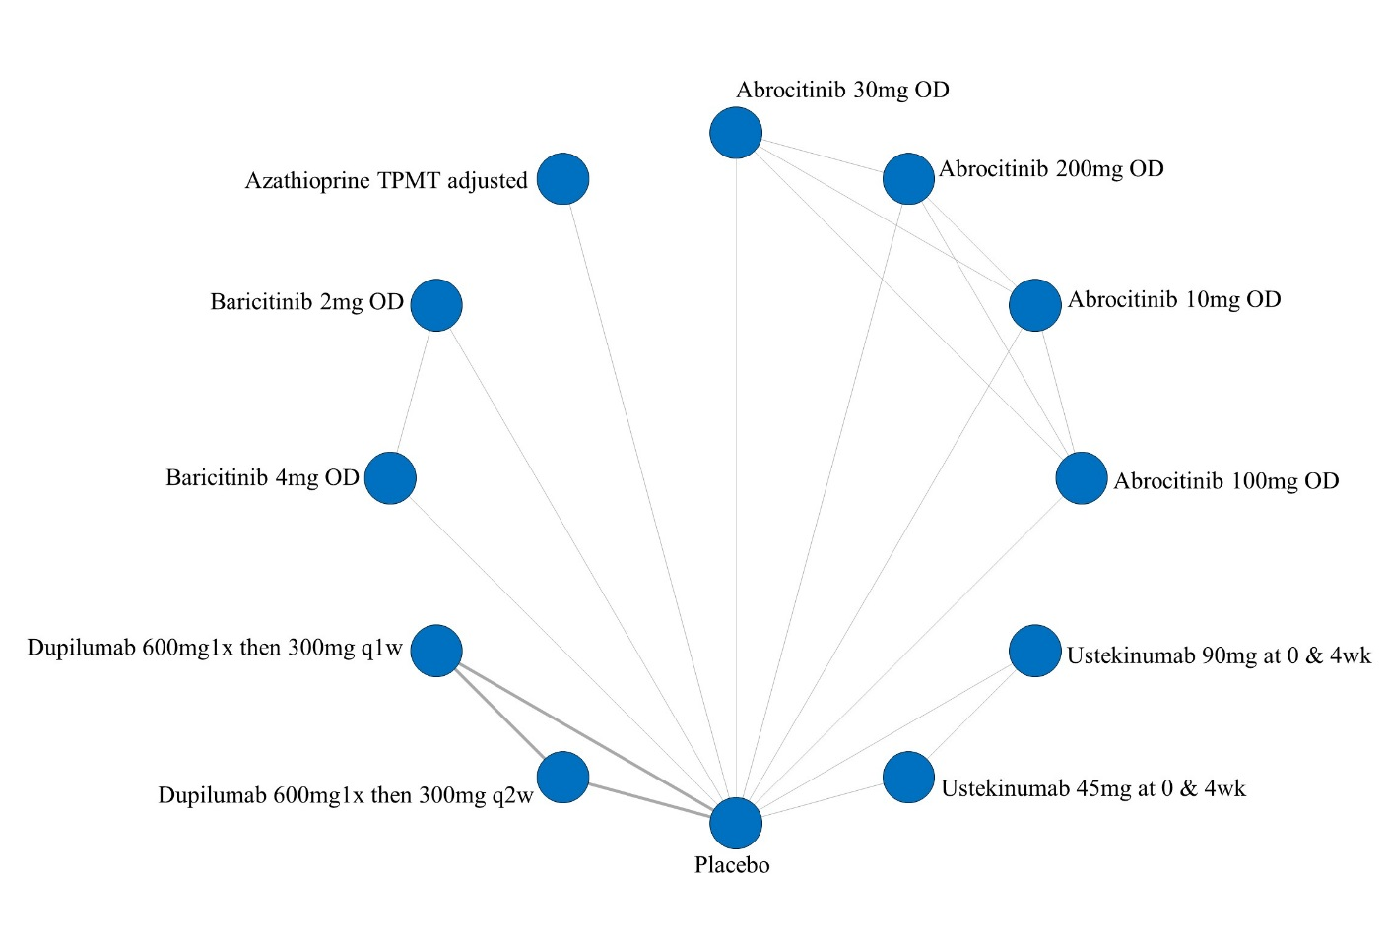

ii. League table of arms included in the network meta-analysis of change in DLQI score of the studies that reported the change from baseline scores. Results are presented as the mean difference (95% CrI) in DLQI score between the two arms. A positive effect estimate in a given cell favors the row-defining treatment. A negative effect estimate in a given cell favors the column-defining treatment.

iii. SUCRA values and ranking for change in DLQI score up to 16 weeks of treatment – including only studies that reported change from baseline scores

iv. Rank plot of arms included in the network meta-analysis of change in DLQI score – including only studies that report results as change in scores from baseline
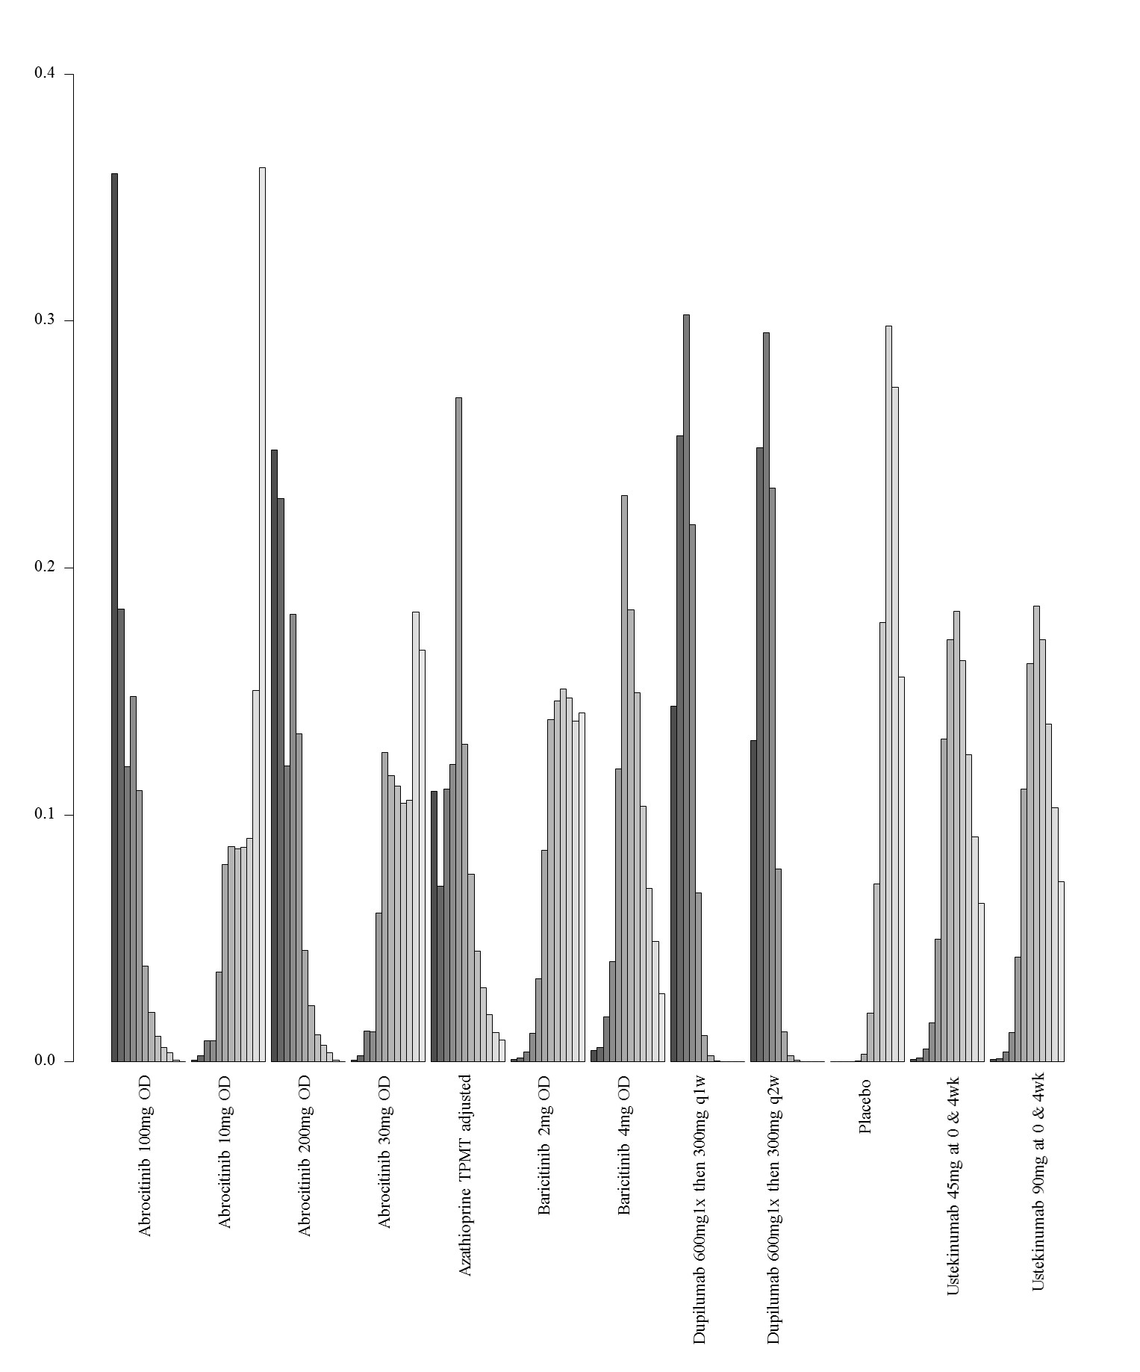

6. Network meta-analysis of change in DLQI score up to 16 weeks of treatment– analysis including studies that report results as change from baseline and were at low risk of bias

i. Network plot of arms included in the network meta-analysis of change in DLQI score up to 16 weeks of treatment – including only studies that report results as change in score from baseline and were at low risk of bias
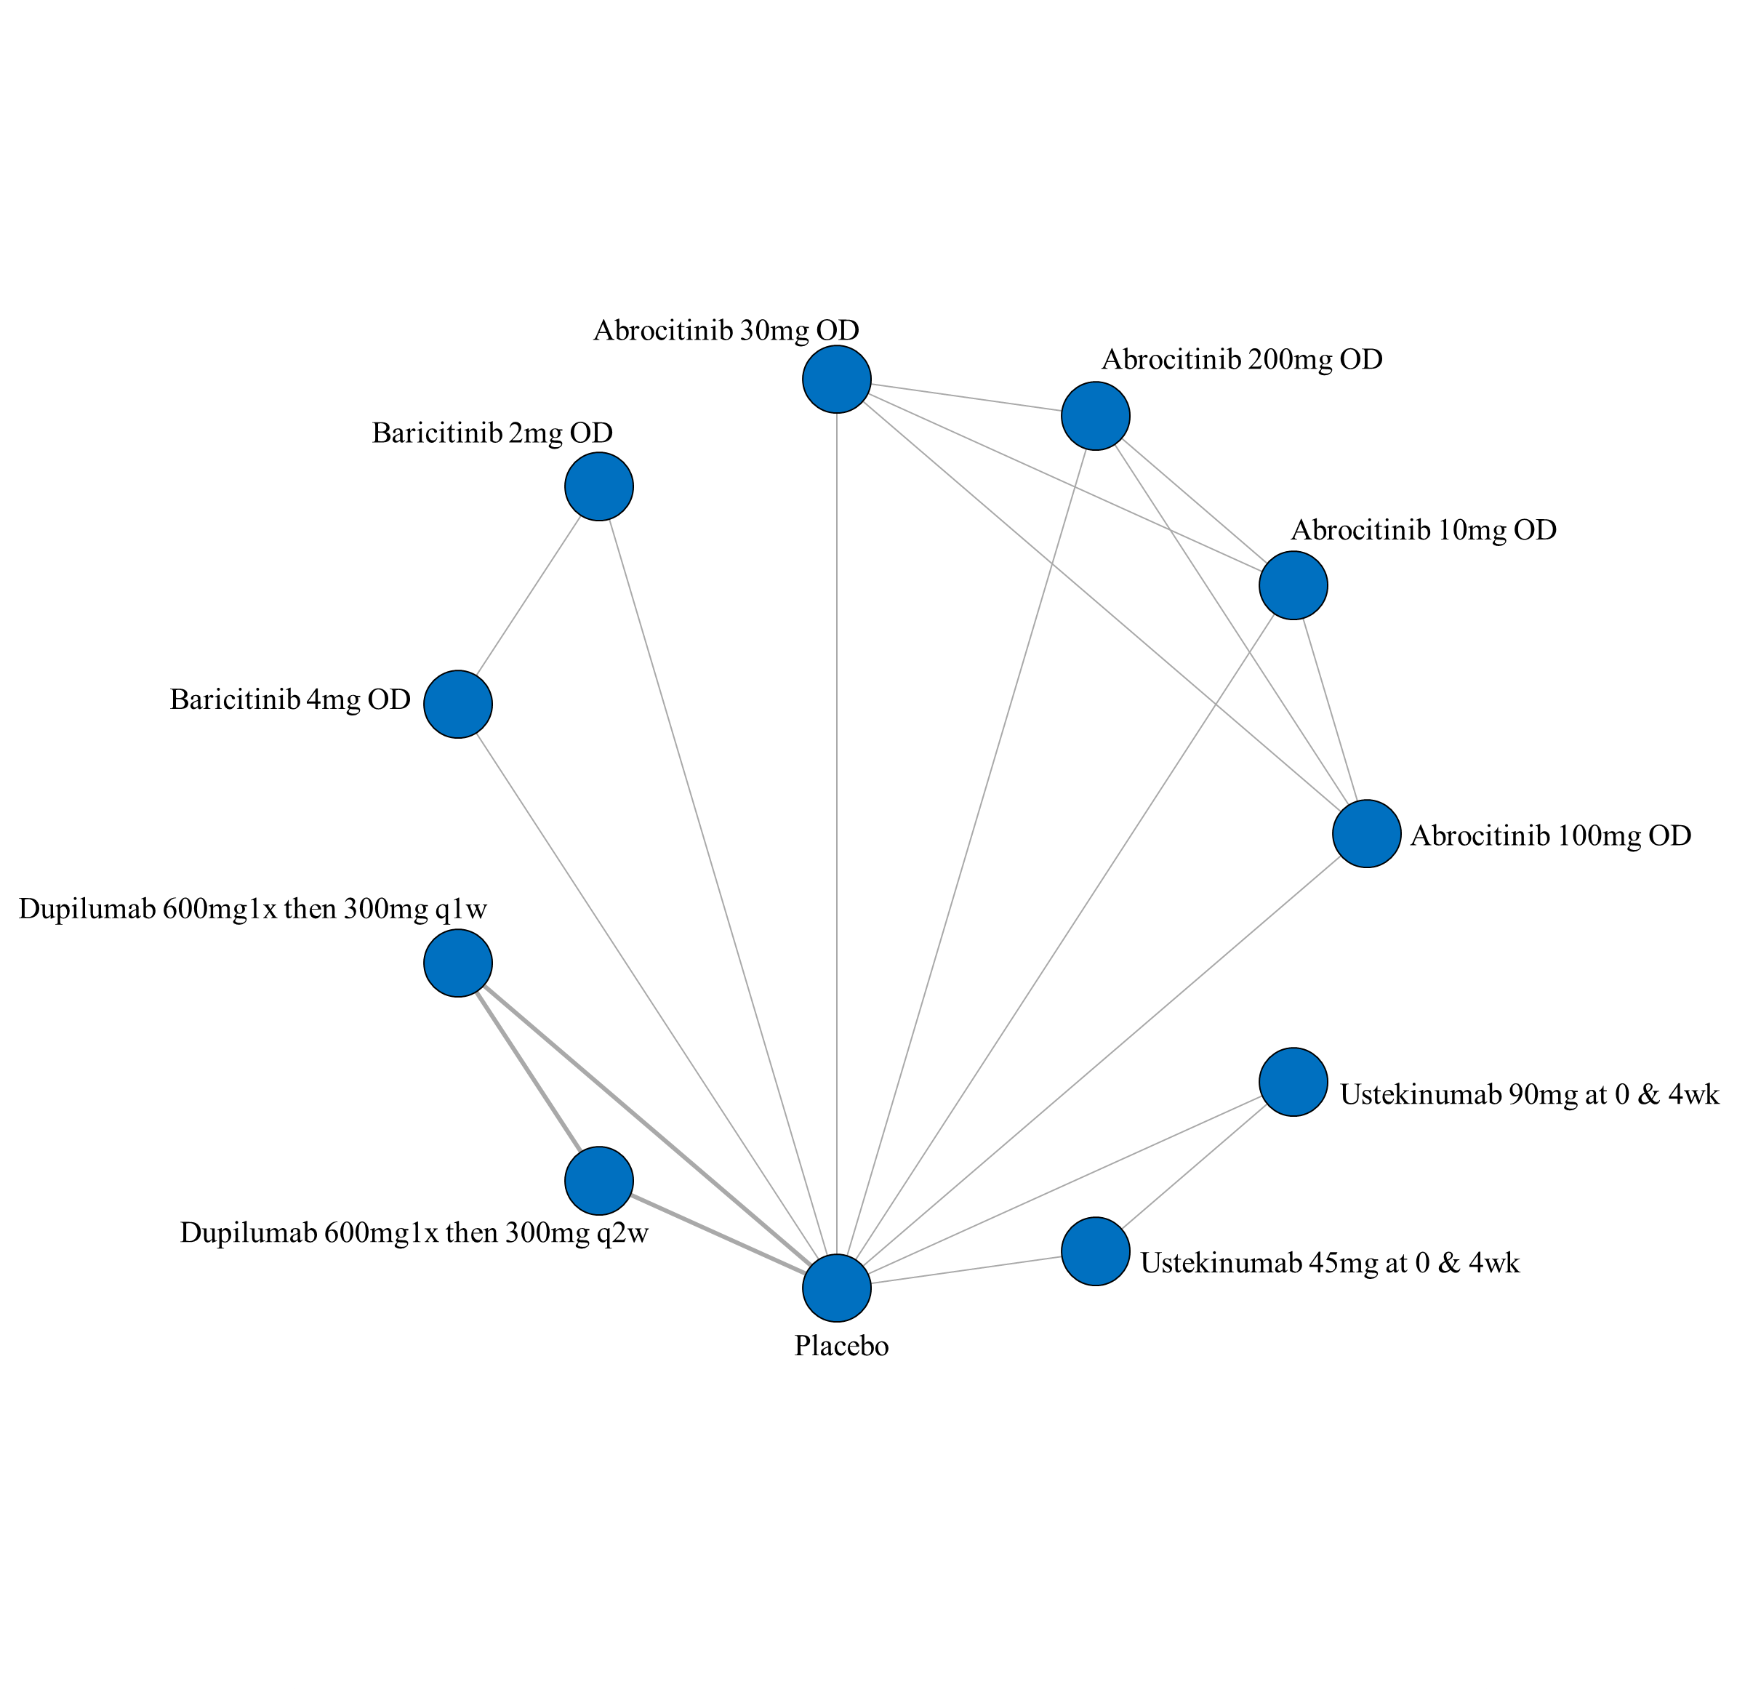

ii. League table of arms included in the network meta-analysis of change in DLQI score of the studies that report results as change from baseline and were at low risk of bias up to 16 weeks of treatment. Results are presented as the mean difference (95% CrI) in DLQI score between the two arms. A positive effect estimate in a given cell favors the row-defining treatment. A negative effect estimate in a given cell favors the column-defining treatment.

iii. SUCRA values and ranking for change in DLQI score up to 16 weeks of treatment – including only studies that report results as change from baseline and were at low risk of bias

iv. Rank plot of arms included in the network meta-analysis of change in DLQI score up to 16 weeks of treatment – including only studies that report results as change from baseline and were at low risk of bias
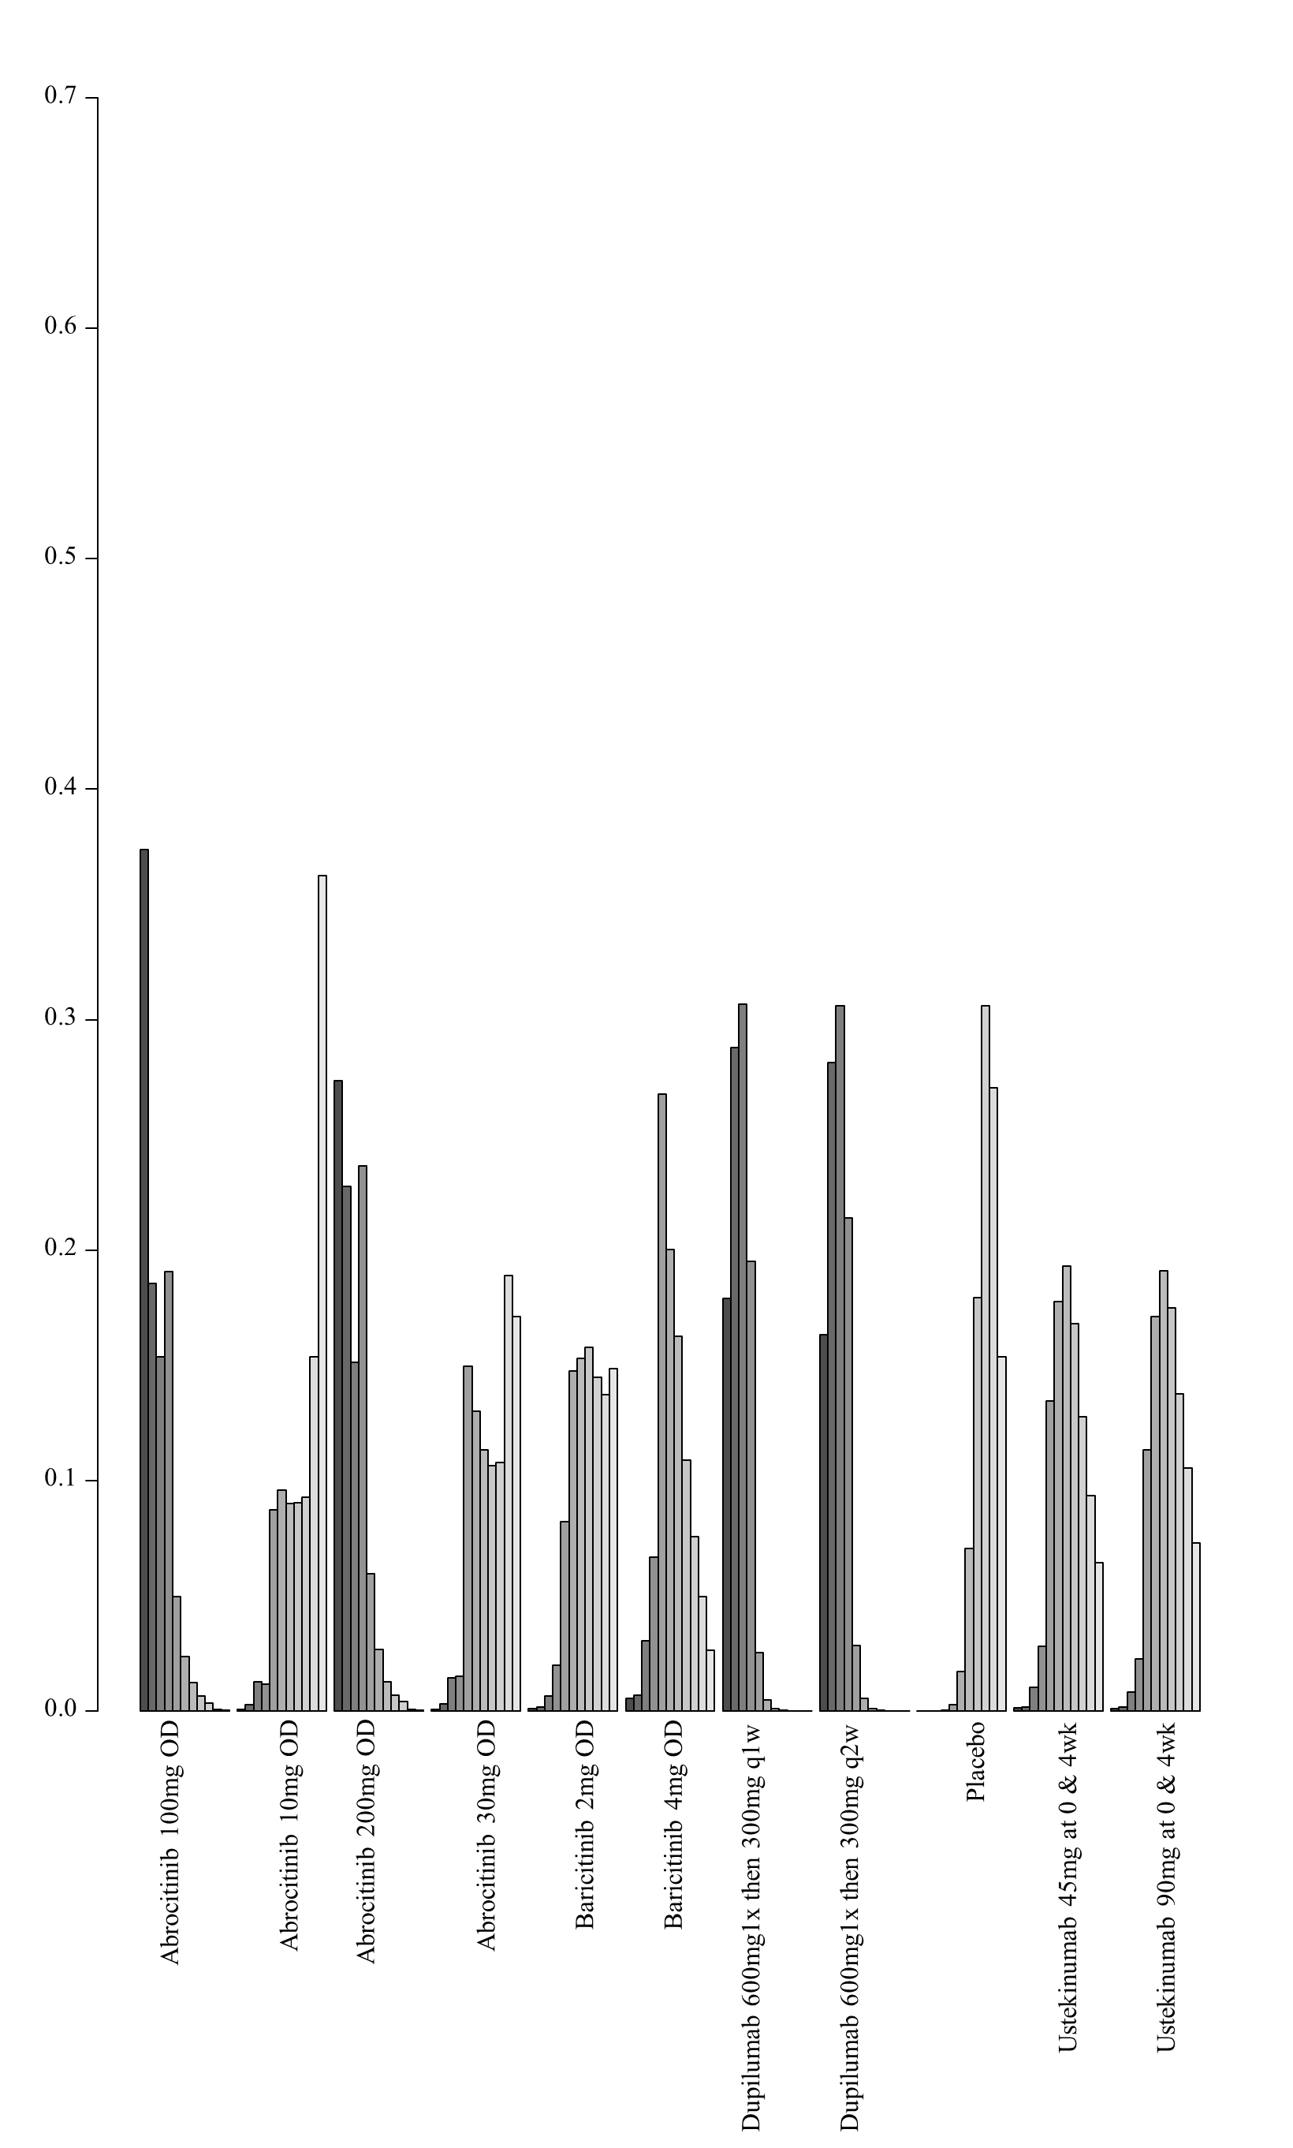

7. Network meta-analysis of change in DLQI score up to 16 weeks of treatment – analysis including studies that report results as change from baseline and did not allow concomitant topical anti-inflammatory treatment

i. Network plot of arms included in the network meta-analysis of change in DLQI score up to 16 weeks of treatment – including only studies that report results as change from baseline and did not allow concomitant topical anti-inflammatory treatment

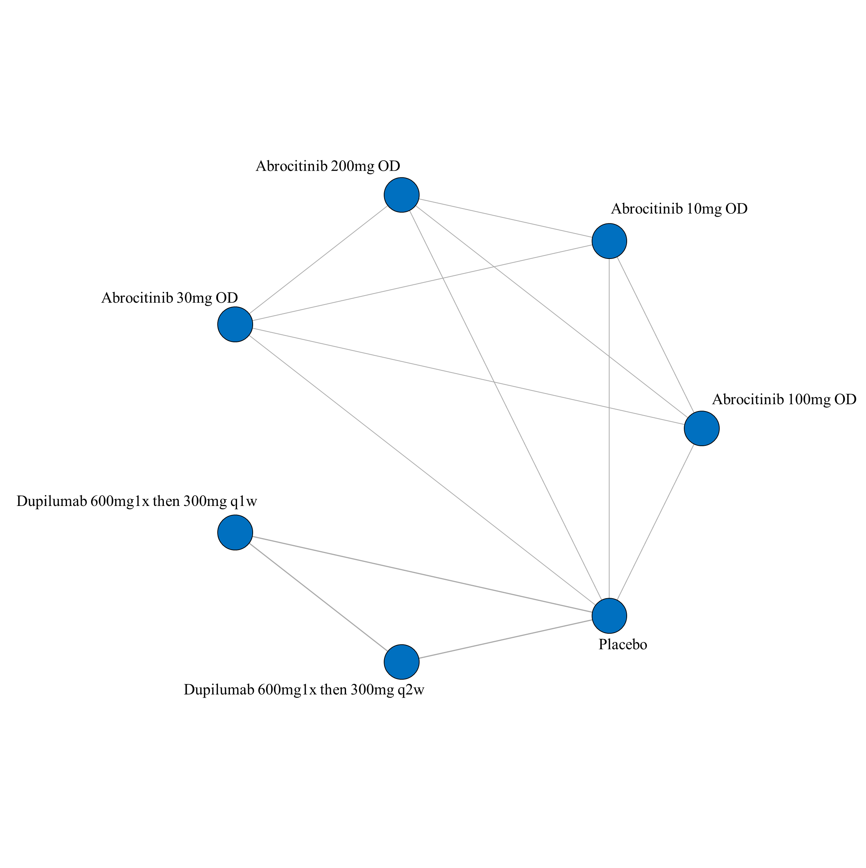
ii. League table of arms included in the network meta-analysis of change in DLQI score of the studies that report results as change from baseline and did not allow concomitant topical anti-inflammatory treatment up to 16 weeks of treatment. Results are presented as the mean difference (95% CrI) in DLQI score between the two arms. A positive effect estimate in a given cell favors the row-defining treatment. A negative effect estimate in a given cell favors the column-defining treatment.

iii. SUCRA values and ranking for change in DLQI score up to 16 weeks of treatment – including only studies that report results as change from baseline and did not allow concomitant topical anti-inflammatory treatment

iv. Rank plot of arms included in the network meta-analysis of change in DLQI score up to 16 weeks of treatment – including only studies that report results as change from baseline and did not allow concomitant topical anti-inflammatory treatment

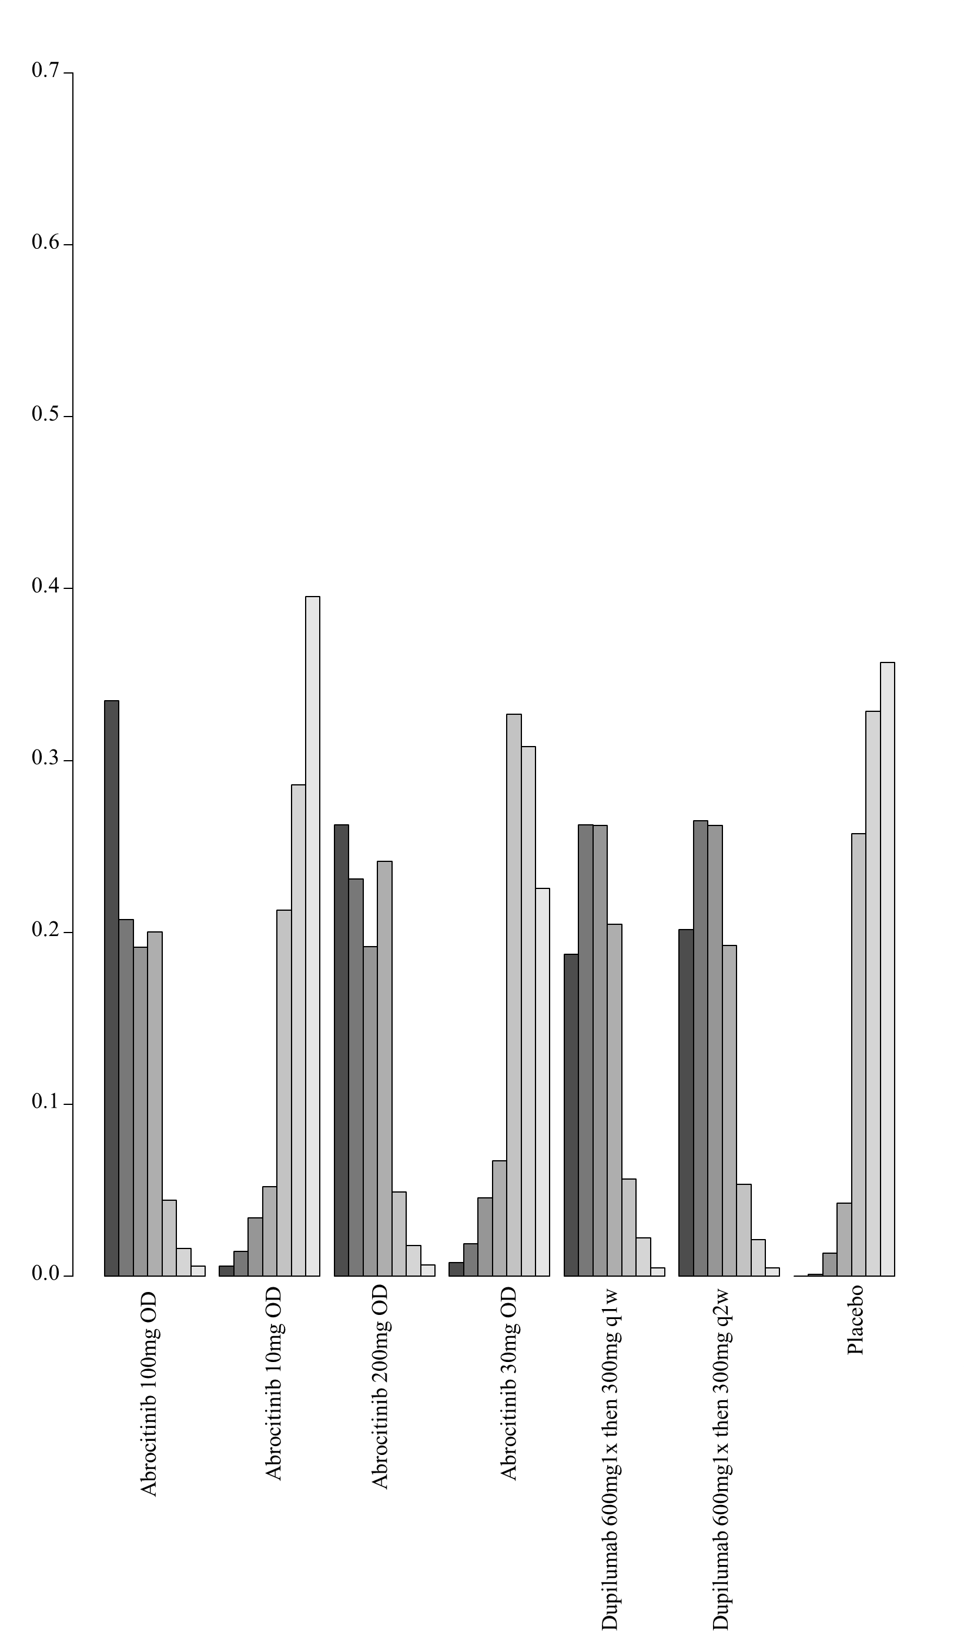

8. Network meta-analysis of change in DLQI score up to 16 weeks of treatment – analysis including studies that report results as change from baseline and allowed concomitant topical anti-inflammatory treatment

i. Network plot of arms included in the network meta-analysis of change in DLQI score up to 16 weeks of treatment – including only studies that report results as change from baseline and allowed concomitant topical anti-inflammatory treatment
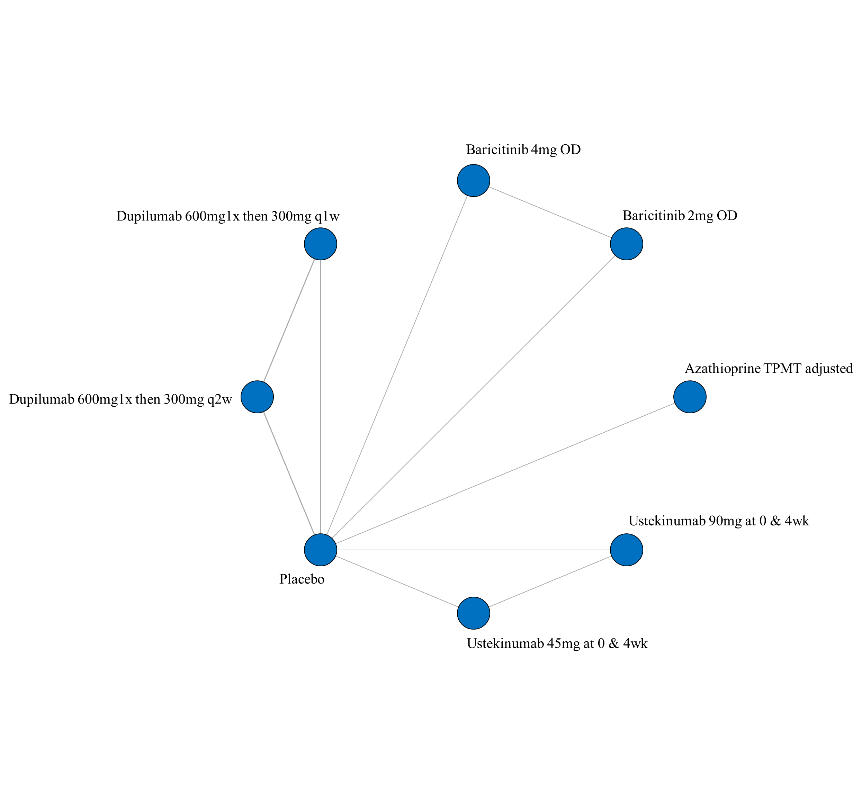

- League table of arms included in the network meta-analysis of change in DLQI score of the studies that report results as change from baseline and allowed concomitant topical anti-inflammatory treatment up to 16 weeks of treatment. Results are presented as the mean difference (95% CrI) in DLQI score between the two arms. A positive effect estimate in a given cell favors the row-defining treatment. A negative effect estimate in a given cell favors the column-defining treatment.

iii. SUCRA values and ranking for change in DLQI score up to 16 weeks of treatment – including only studies that report results as change from baseline and allowed concomitant topical anti-inflammatory treatment
iv. Rank plot of arms included in the network meta-analysis of change in DLQI score up to 16 weeks of treatment – including only studies that report results as change from baseline and allowed concomitant topical anti-inflammatory treatment
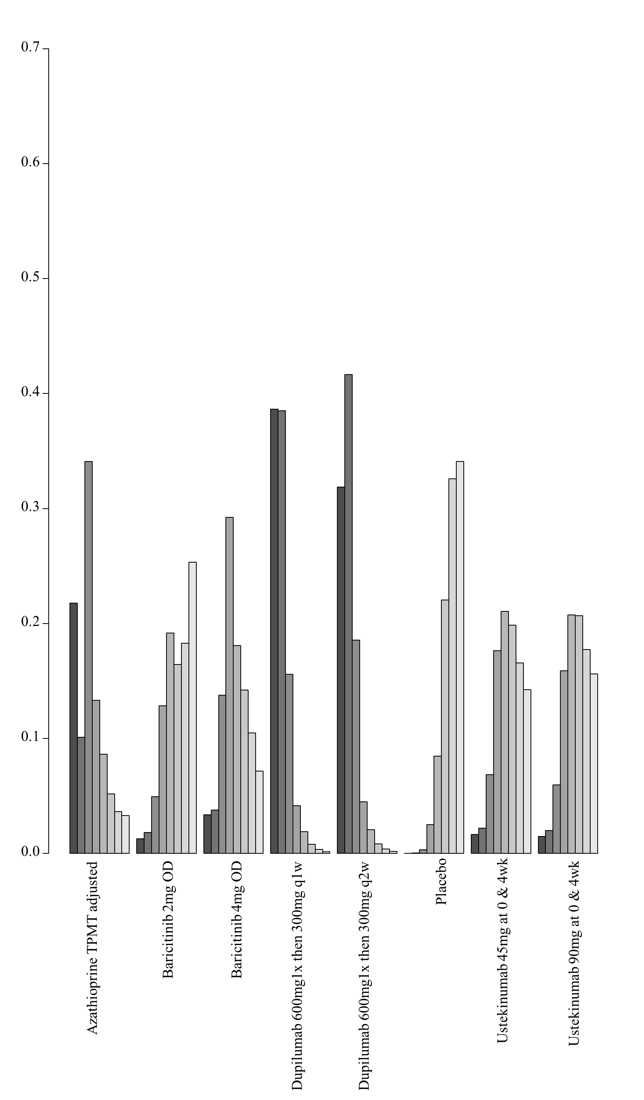

7G. Network meta-analysis of change in quality of life (QoL) on the standardized mean difference scale up to 16 weeks of treatment

1. Network meta-analysis of change in QoL on the standardized mean difference scale up to 16 weeks of treatment – main analysis

i. Network plot of arms included in the network meta-analysis of change in QoL on the standardized mean difference scale up to 16 weeks of treatment
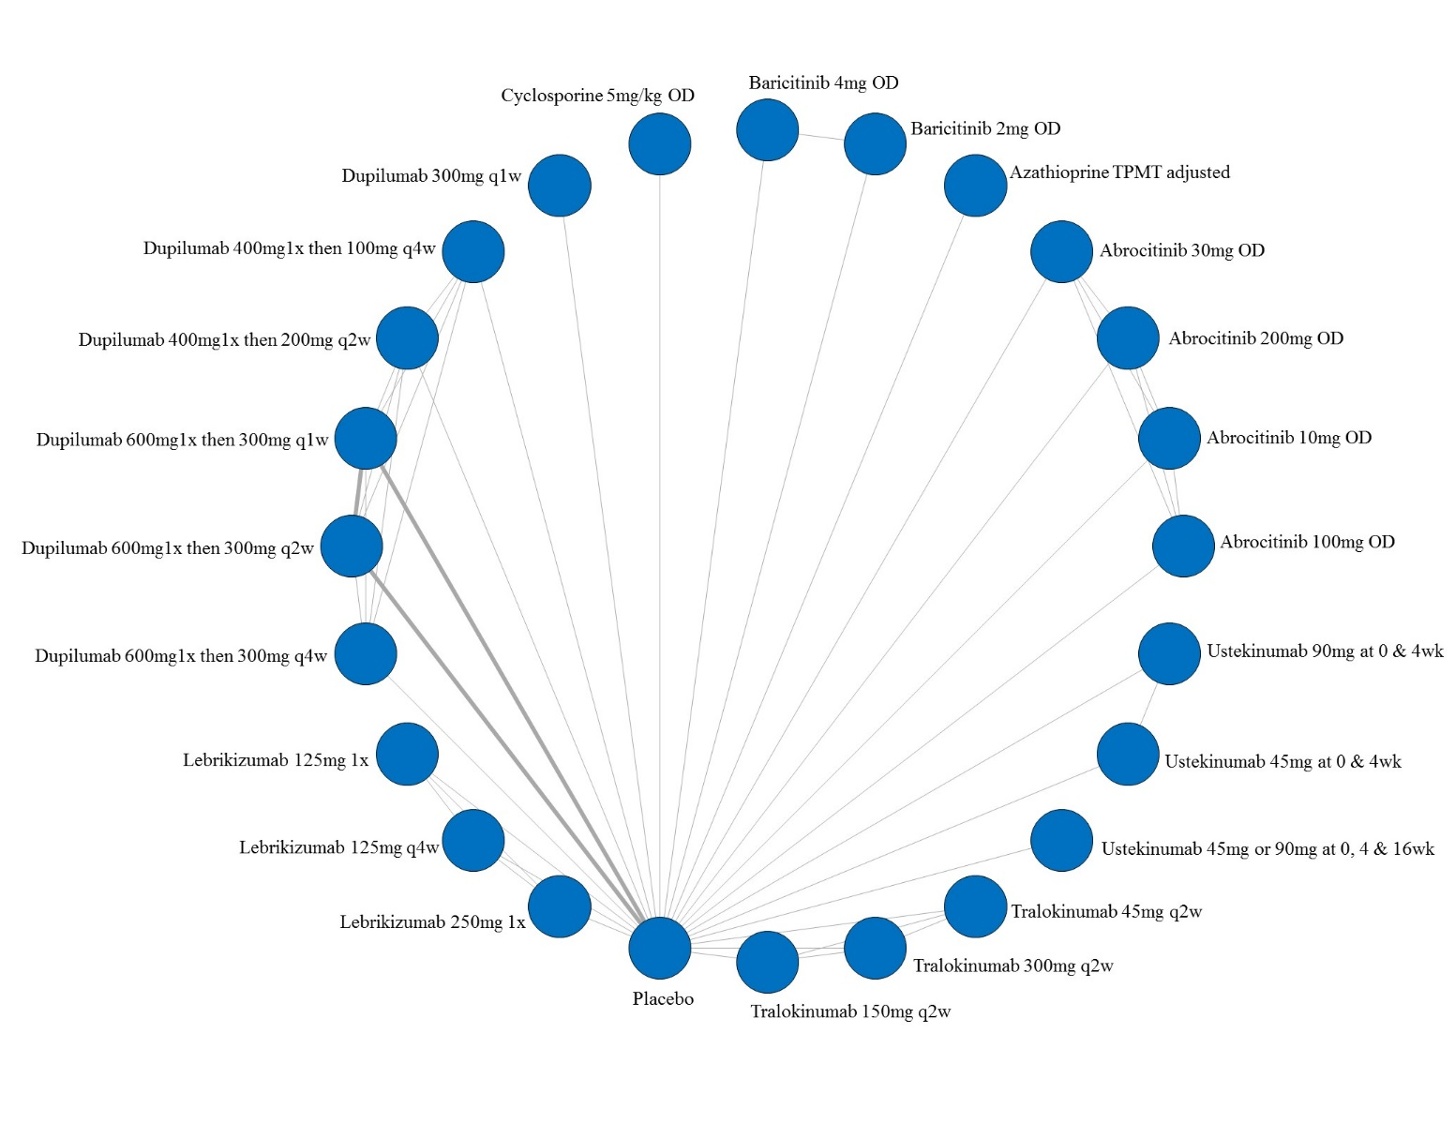

ii. League table of arms included in the network meta-analysis of change in QoL on the standardized mean difference scale up to 16 weeks of treatment. Results are presented as the mean difference (95% CrI) in QoL between the two arms. A positive effect estimate in a given cell favors the row-defining treatment. A negative effect estimate in a given cell favors the column-defining treatment.

iii. SUCRA values and ranking for change in QoL on the standardized mean difference scale up to 16 weeks of treatment for all medications
iv. Rank plot of arms included in the network meta-analysis of change in QoL on the standardized mean difference scale up to 16 weeks of treatment
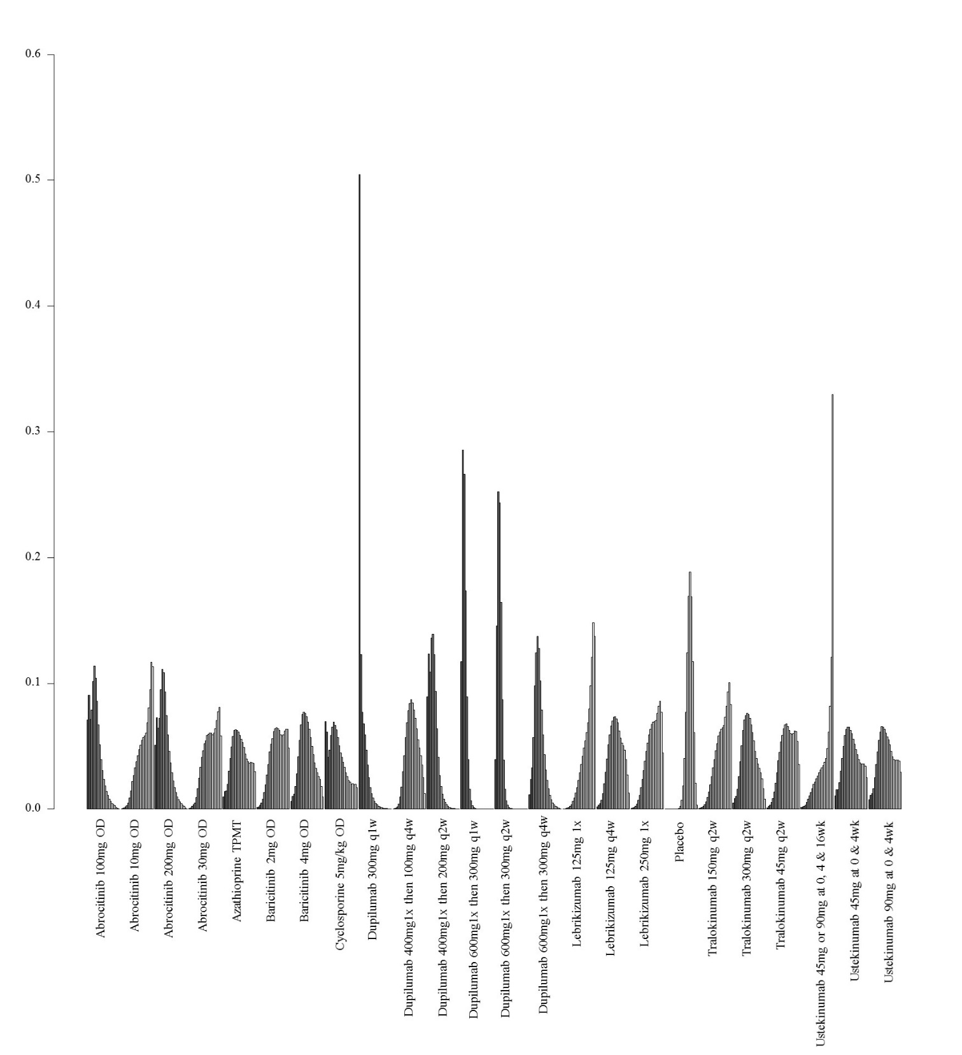

2. Network meta-analysis of change in QoL on the standardized mean difference scale up to 16 weeks of treatment – among medications currently in use
- Network plot of arms included in the network meta-analysis of change in QoL on the standardized mean difference scale among medications currently in use
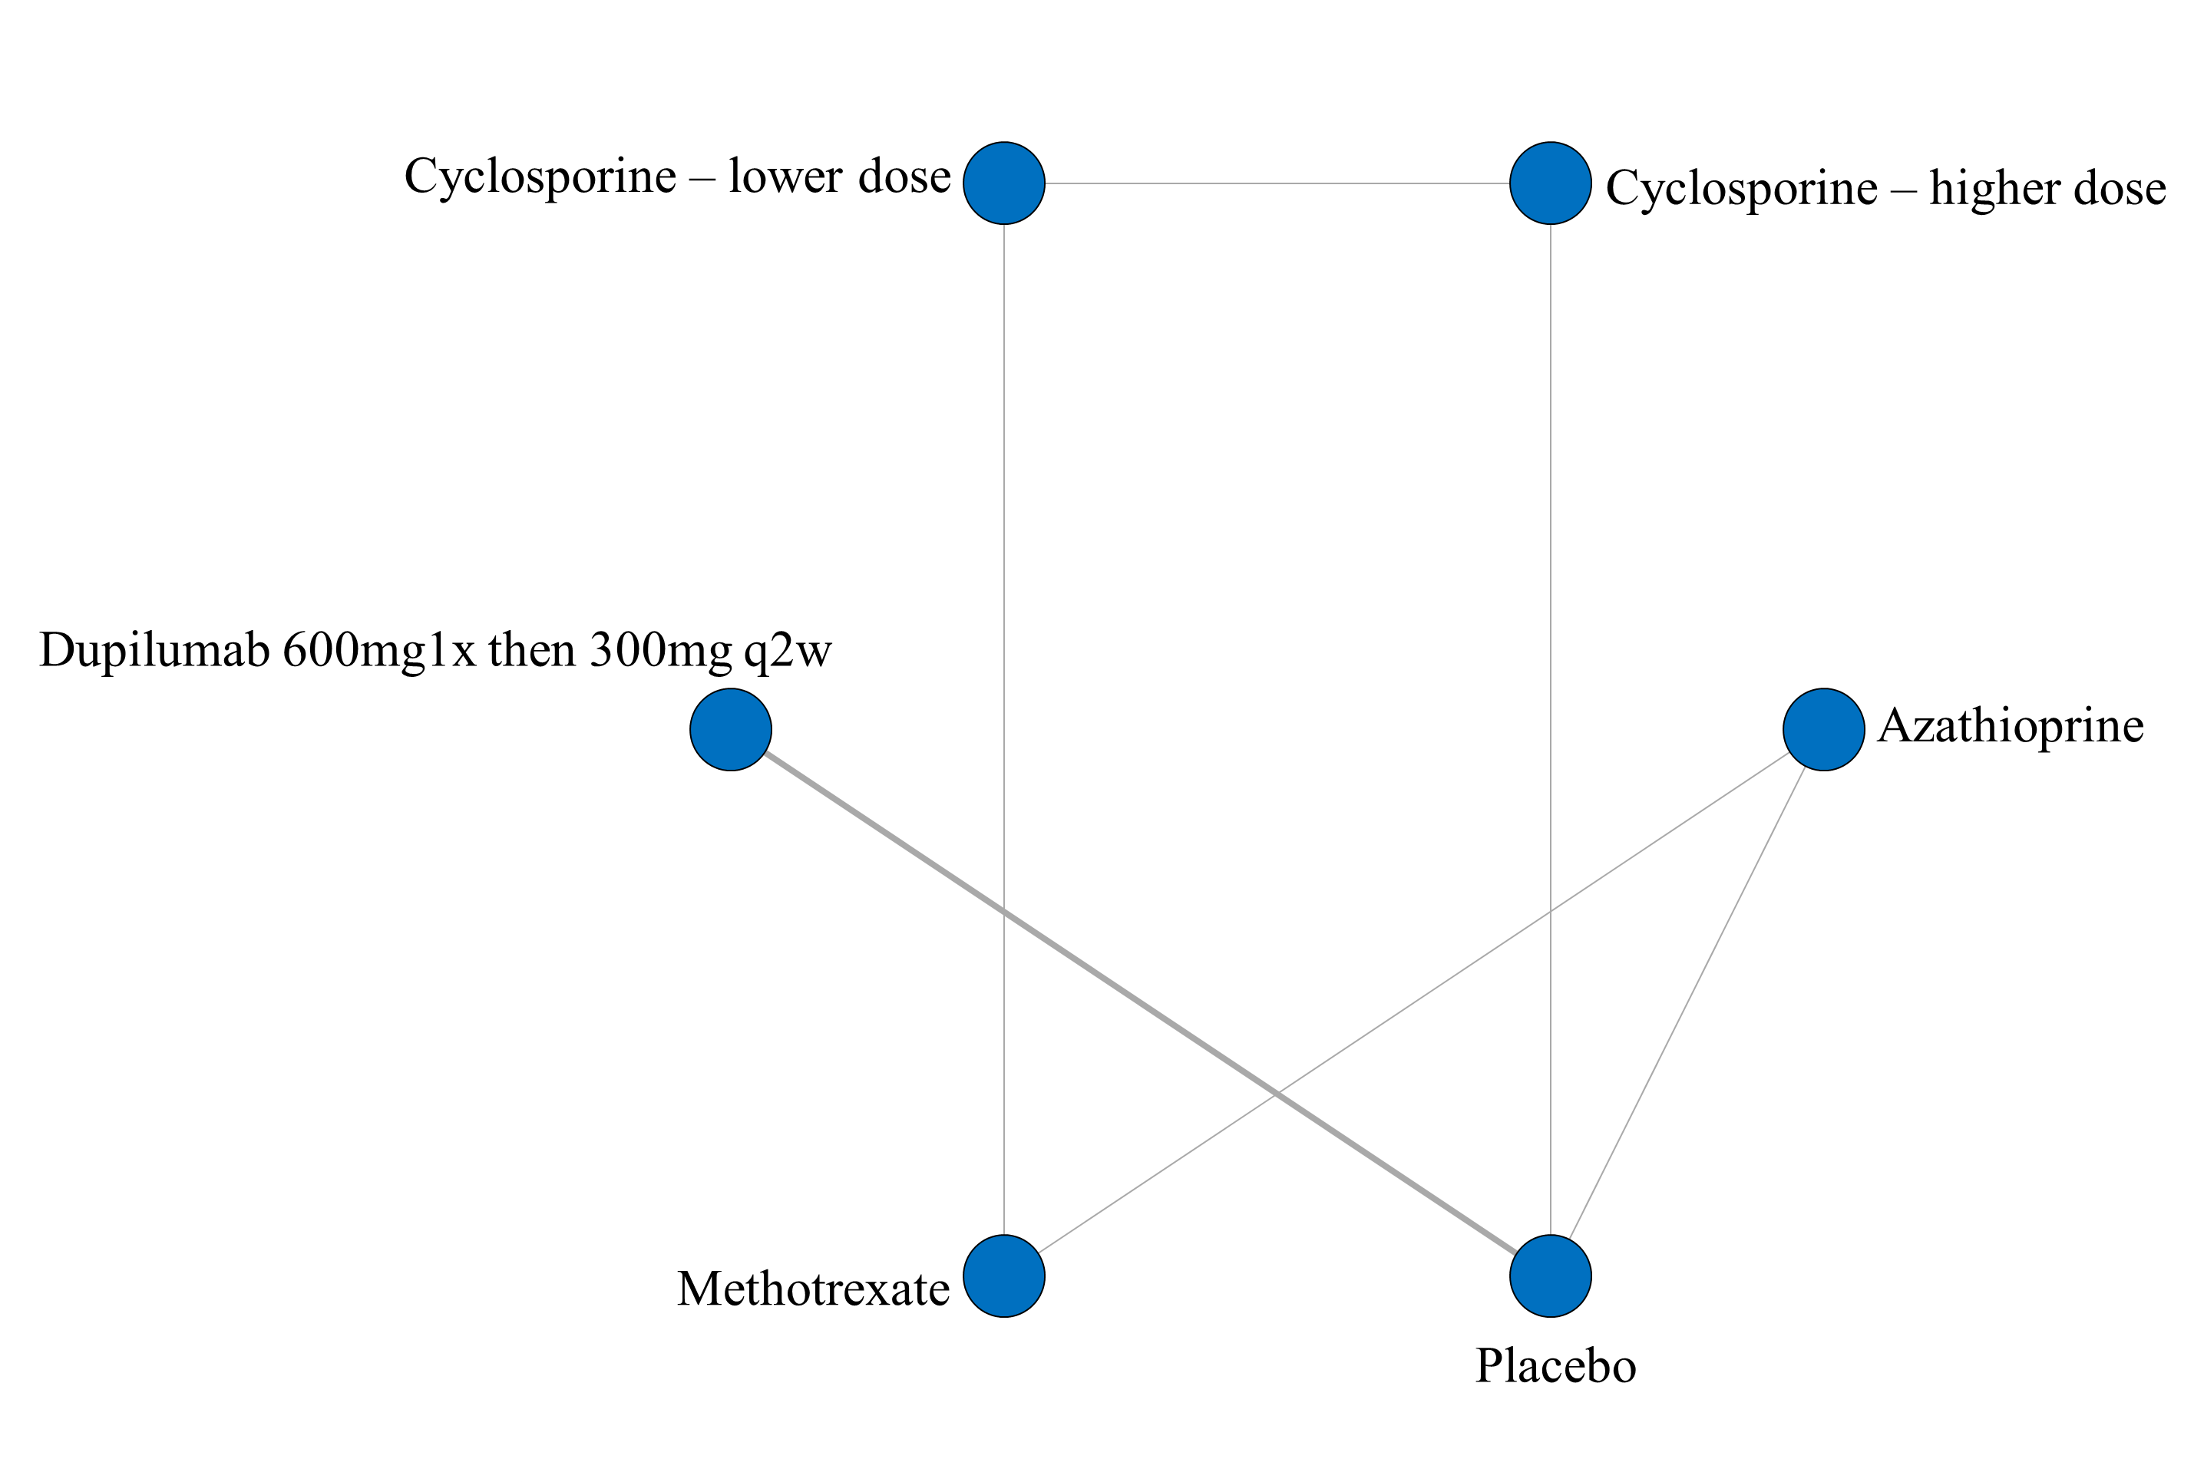

- League table of arms included in the network meta-analysis of change in QoL on the standardized mean difference scale up to 16 weeks of treatment among medications currently in use. Results are presented as the mean difference (95% CrI) in QoL between the two arms. A positive effect estimate in a given cell favors the row-defining treatment. A negative effect estimate in a given cell favors the column-defining treatment.

iii. GRADE assessment for change in QoL on the standardized mean difference scale up to 16 weeks of treatment among medications currently in use
QoL (SMD)
Comparison | GRADE Rating
  Cyclosporine - lower dose vs Cyclosprine - higher dose
  Cyclosprine - lower dose vs Methotrexate
  Methotrexate vs Axathioprine
  Azathioprine vs Placebo
  Dupilumab 600mg 300mg q2w vs Placebo
  Dupilumab 600mg 300mg q2w vs Azathioprine
  Azathioprine vs Cyclosporine – lower dose
  Azathioprine vs Cyclosporine – higher dose
  Cyclosporine – higher dose vs Placebo
  Cyclosporine – lower dose vs Placebo
  Methotrexate vs Placebo
  Low^{1,2,3}
  Low^{1,2,3}
  Low^{1,2,3}
  Low^{1,2,3}
  High
  Low⁴
  Low⁴
  Low⁴
  Low^{1,2,3}
  Low^{1,2,3}
  Low^{1,2,3}
1 – NMA estimate imprecise and would suggest different conclusions at either end of the 95% Credible Intervals
2 – Number of patients included in analysis below optimal information size
3 – significant issues related to risk of bias from included trials
4 – no direct estimate, first-order indirect loop includes low certainty evidence and therefore NMA estimate is low certainty

iv. SUCRA values and ranking for change in QoL on the standardized mean difference scale up to 16 weeks of treatment among medications currently in use

v. Rank plot of arms included in the network meta-analysis of change in QoL on the standardized mean difference scale up to 16 weeks of treatment among medications currently in use
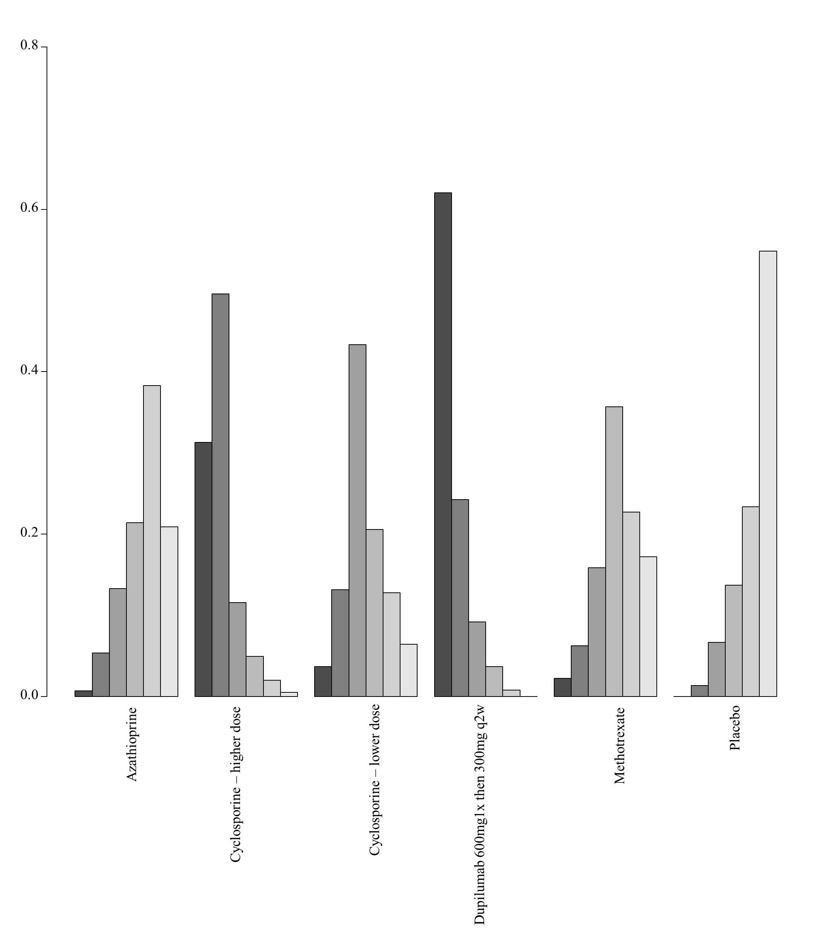

7H. Network meta-analysis of change in PPNRS scores up to 16 weeks of treatment

1. Network meta-analysis of change in PPNRS score up to 16 weeks of treatment – main analyses

i. Network plot of arms included in the network meta-analysis of change in PPNRS score up to 16 weeks of treatment
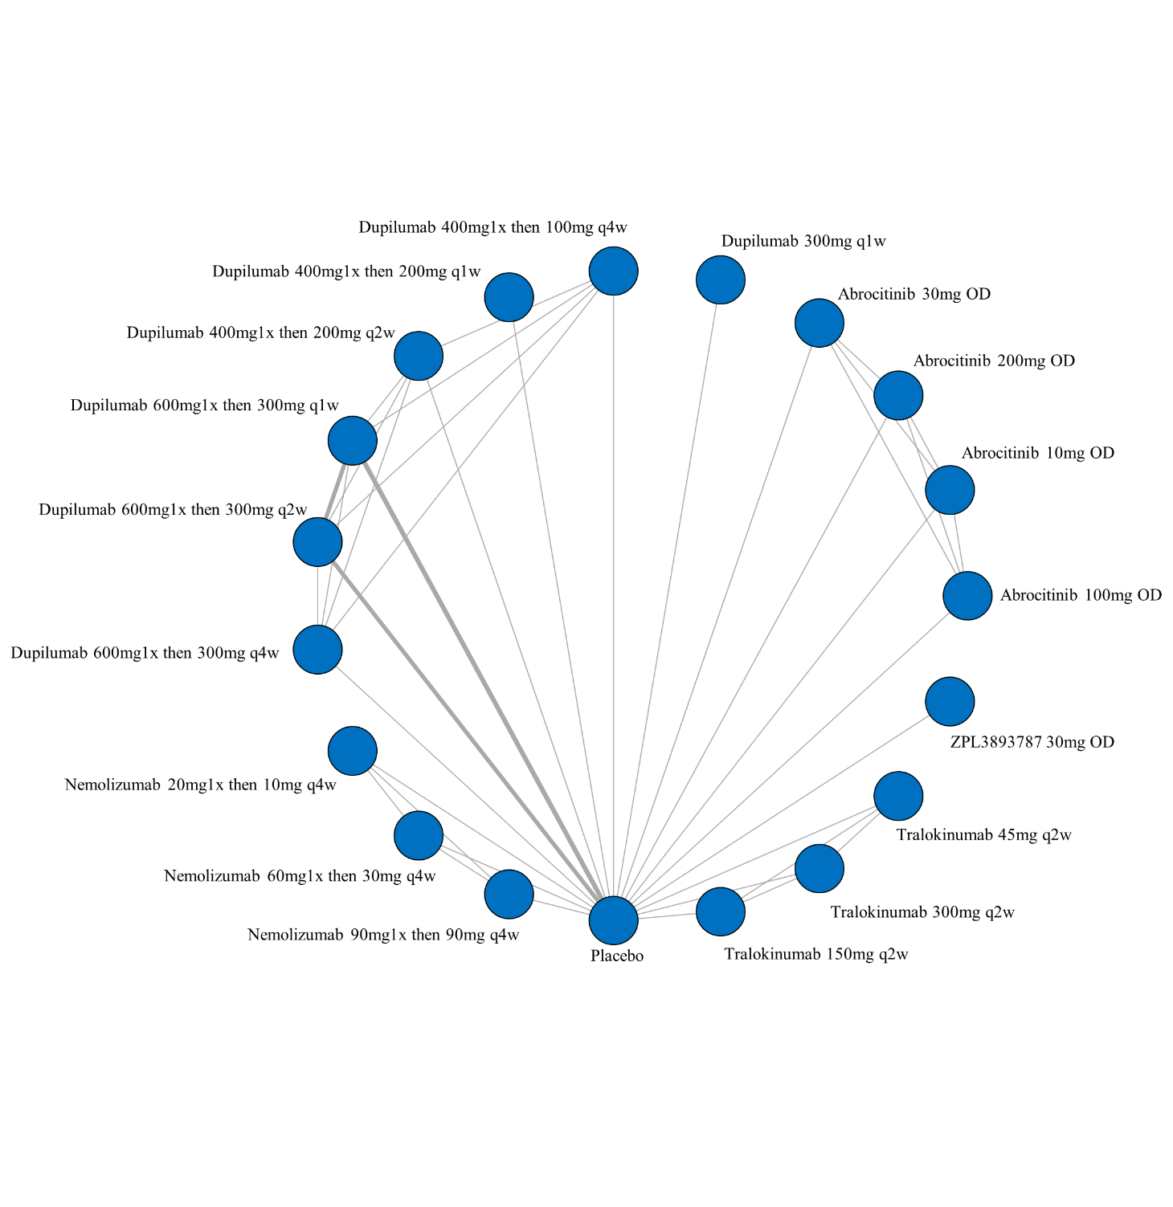

ii. League table of arms included in the network meta-analysis of change in PPNRS score up to 16 weeks of treatment. Results are presented as the mean difference (95% CrI) in PPNRS score between the two arms. A positive effect estimate in a given cell favors the row-defining treatment. A negative effect estimate in a given cell favors the column-defining treatment.

iii. GRADE assessment of PPNRS scores up to 16 weeks of treatment

iv. SUCRA values and ranking for change in PPNRS score up to 16 weeks of treatment
v. Rank plot of arms included in the network meta-analysis of change in PPNRS score up to 16 weeks of treatment
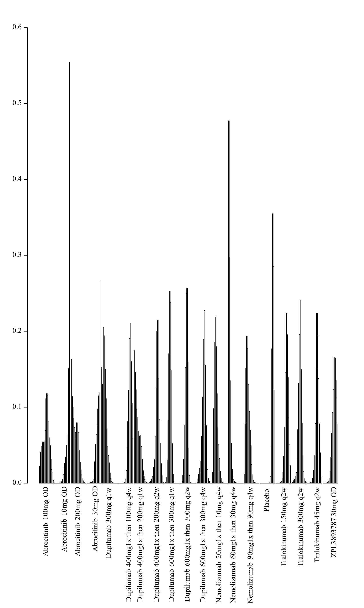

2. Network meta-analysis of change in PPNRS score up to 16 weeks of treatment – analysis including only studies at low risk of bias

i. Network plot of arms included in the network meta-analysis of change in PPNRS score up to 16 weeks of treatment – including only studies at low risk of bias
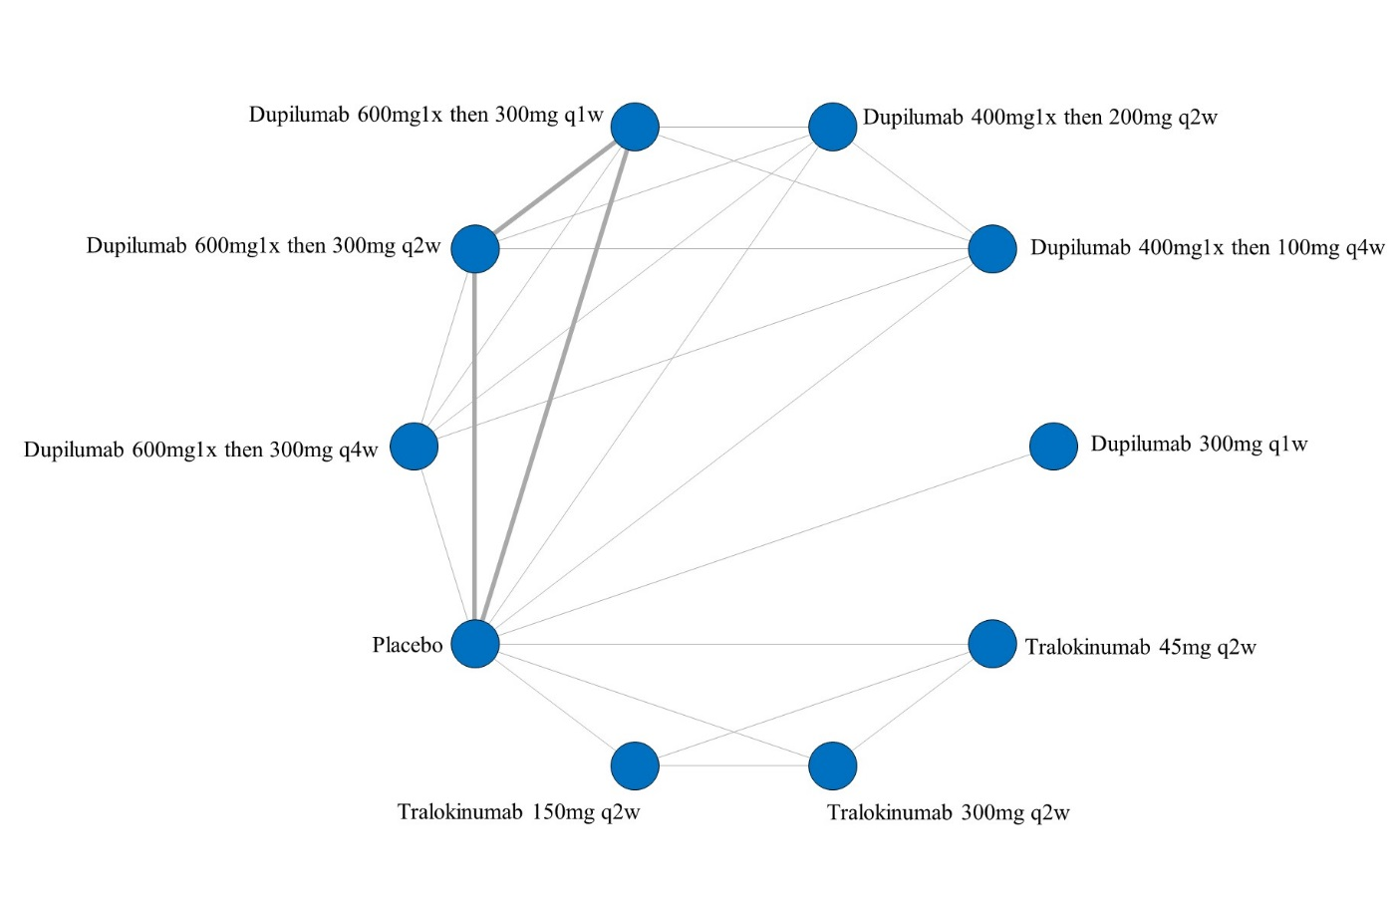
ii. League table of arms included in the network meta-analysis of change in PPNRS score of studies at low risk of bias up to 16 weeks of treatment. Results are presented as the mean difference (95% CrI) in PPNRS score between the two arms. A positive effect estimate in a given cell favors the row-defining treatment. A negative effect estimate in a given cell favors the column-defining treatment.

iii. SUCRA values and ranking for change in PPNRS score up to 16 weeks of treatment – including only studies at low risk of bias
iv. Rank plot of arms included in the network meta-analysis of change in PPNRS score up to 16 weeks of treatment – including only studies at low risk of bias
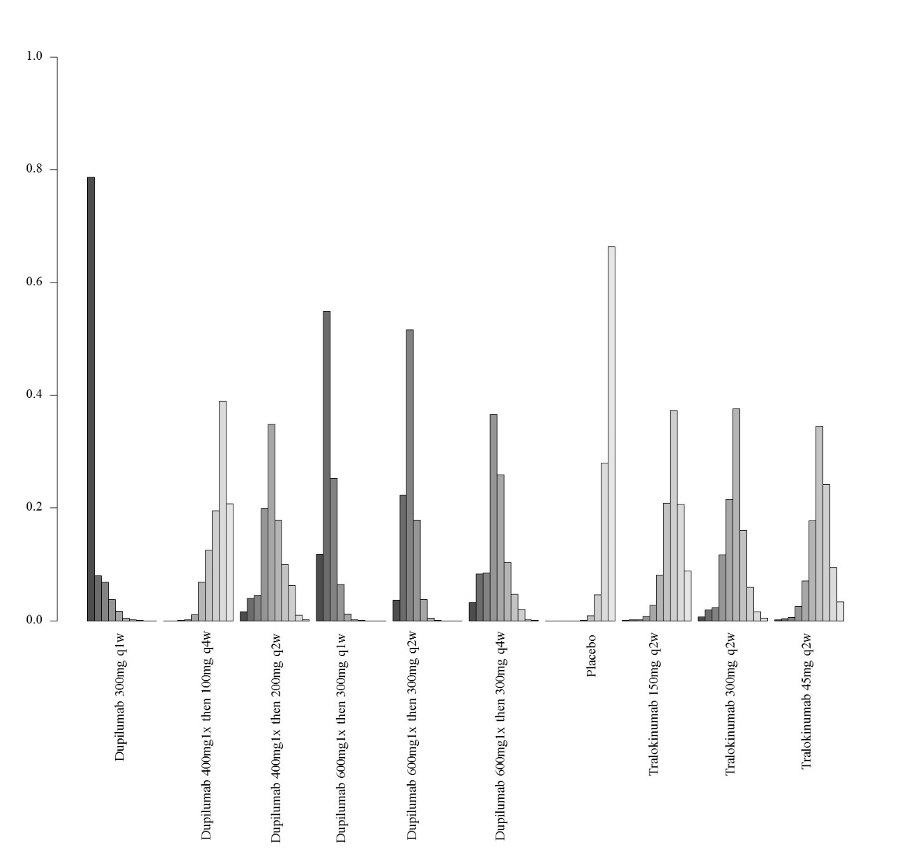

3. Network meta-analysis of change in PPNRS score up to 16 weeks of treatment– analysis including only studies that did not allow concomitant topical anti-inflammatory treatment

- Network plot of arms included in the network meta-analysis of change in PPNRS score up to 16 weeks of treatment– including only studies that did not allow concomitant topical anti-inflammatory treatment
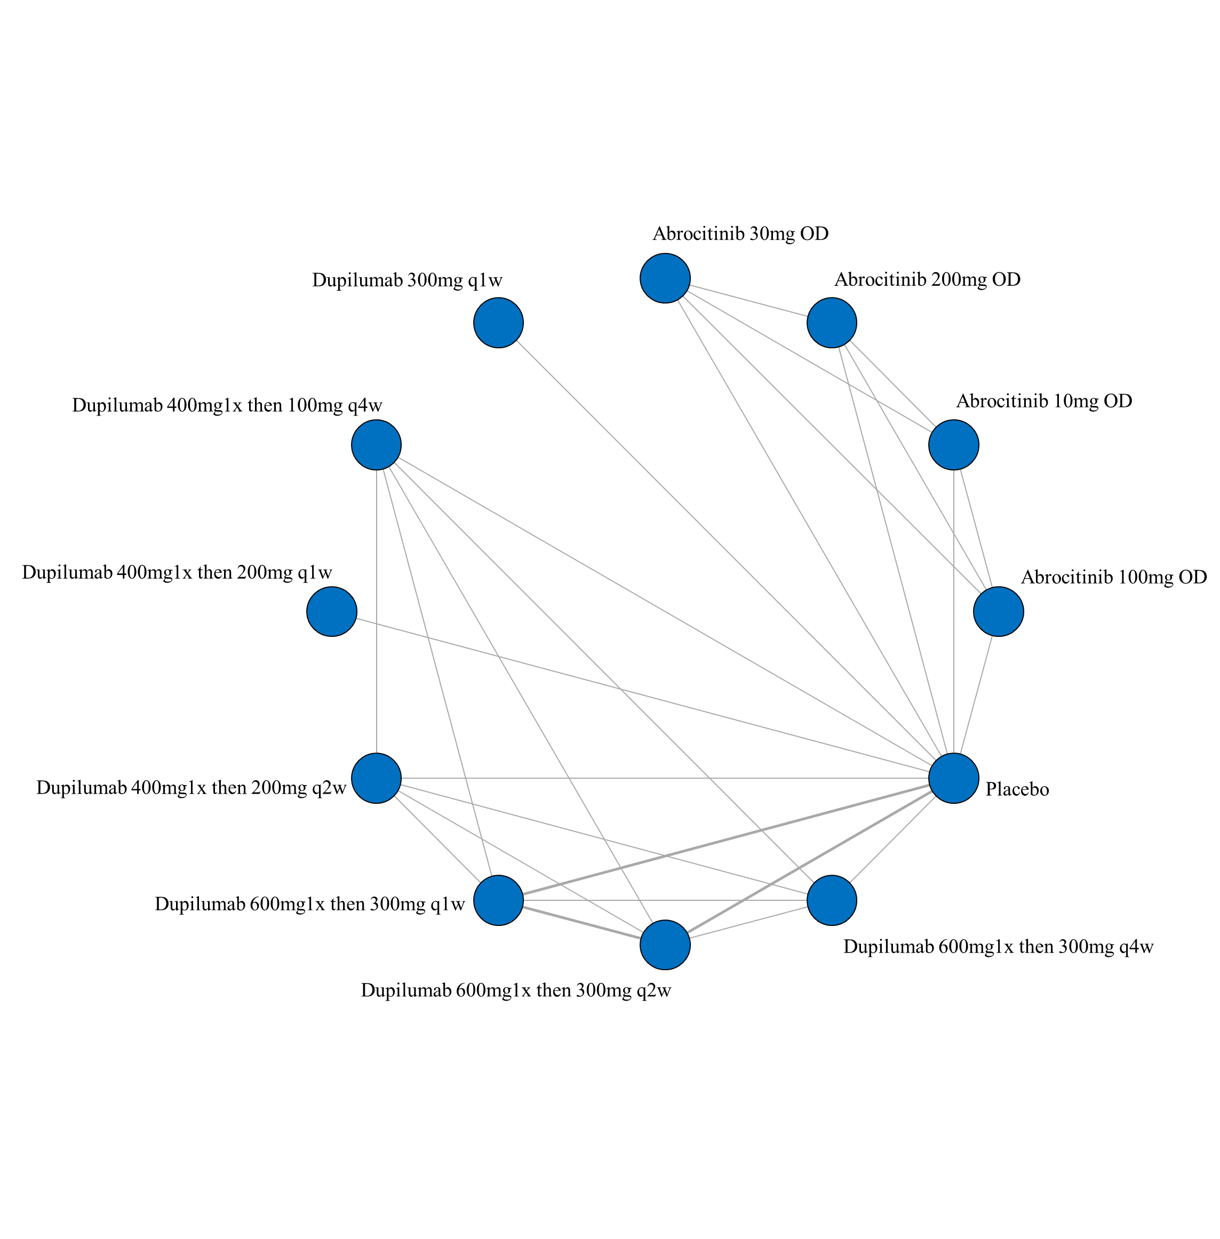

- League table of arms included in the network meta-analysis of change in PPNRS score of studies that did not allow concomitant topical anti-inflammatory treatment up to 16 weeks of treatment. Results are presented as the mean difference (95% CrI) in PPNRS score between the two arms. A positive effect estimate in a given cell favors the row-defining treatment. A negative effect estimate in a given cell favors the column-defining treatment.

iii. SUCRA values and ranking for change in PPNRS score up to 16 weeks of treatment – including only studies that did not allow concomitant topical anti-inflammatory treatment
iv. Rank plot of arms included in the network meta-analysis of change in PPNRS score – including only studies that did not allow concomitant topical anti-inflammatory treatment
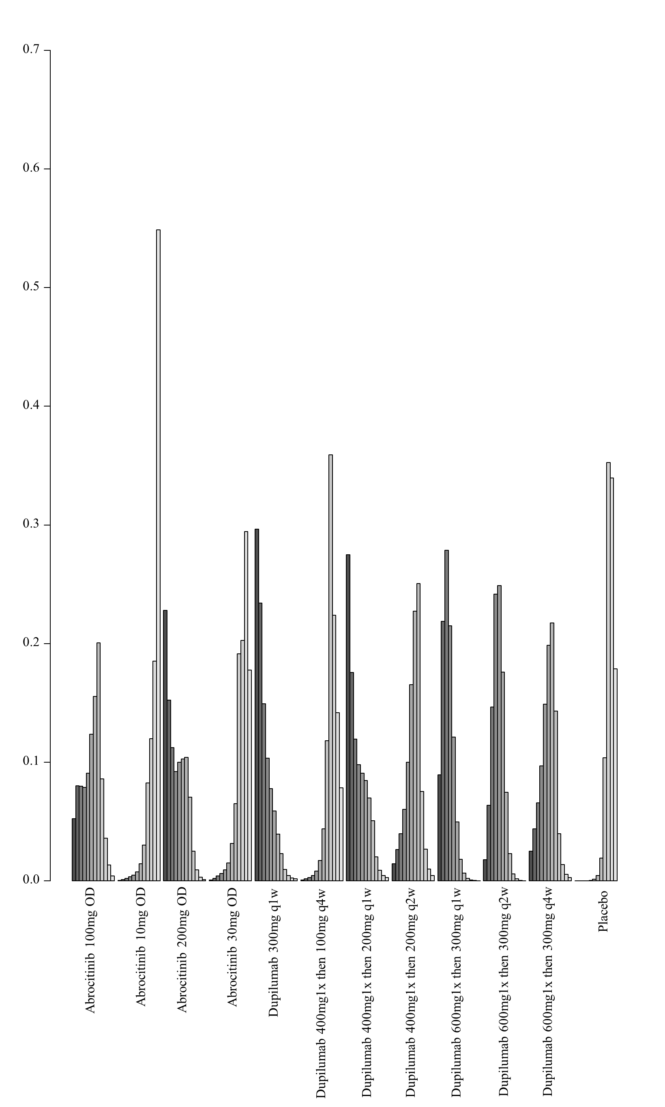

4. Network meta-analysis of change in PPNRS score up to 16 weeks of treatment – analysis including only studies that allowed concomitant topical anti-inflammatory treatment

- Network plot of arms included in the network meta-analysis of change in PPNRS score up to 16 weeks of treatment – including only studies that allowed concomitant topical anti-inflammatory treatment
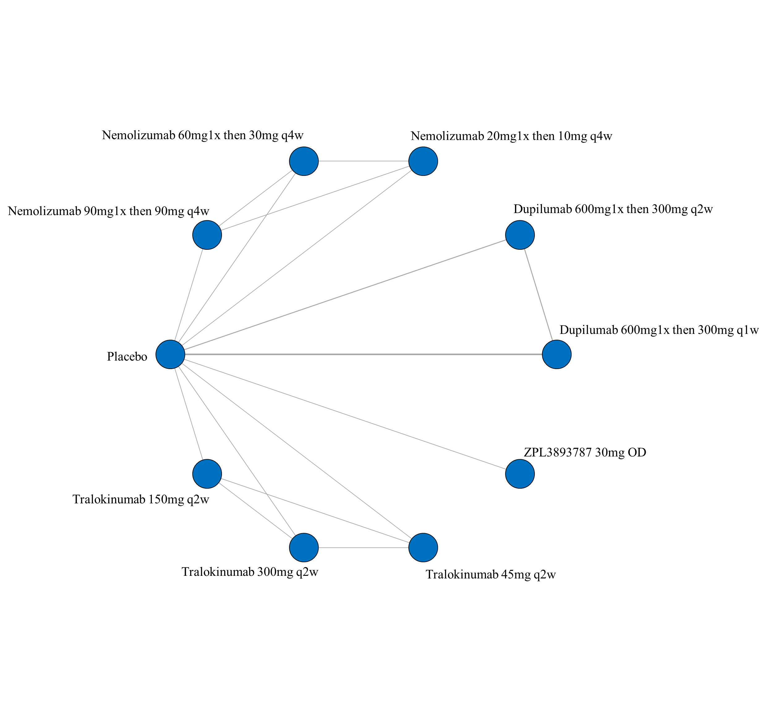

ii. League table of arms included in the network meta-analysis of change in PPNRS score of studies that allowed concomitant topical anti-inflammatory treatment up to 16 weeks of treatment. Results are presented as the mean difference (95% CrI) in PPNRS score between the two arms. A positive effect estimate in a given cell favors the row-defining treatment. A negative effect estimate in a given cell favors the column-defining treatment.
iii. SUCRA values and ranking for change in PPNRS score up to 16 weeks of treatment – including only studies that allowed concomitant topical anti-inflammatory treatment

iv. Rank plot of arms included in the network meta-analysis of change in PPNRS score up to 16 weeks of treatment – including only studies that allowed concomitant topical anti-inflammatory treatment
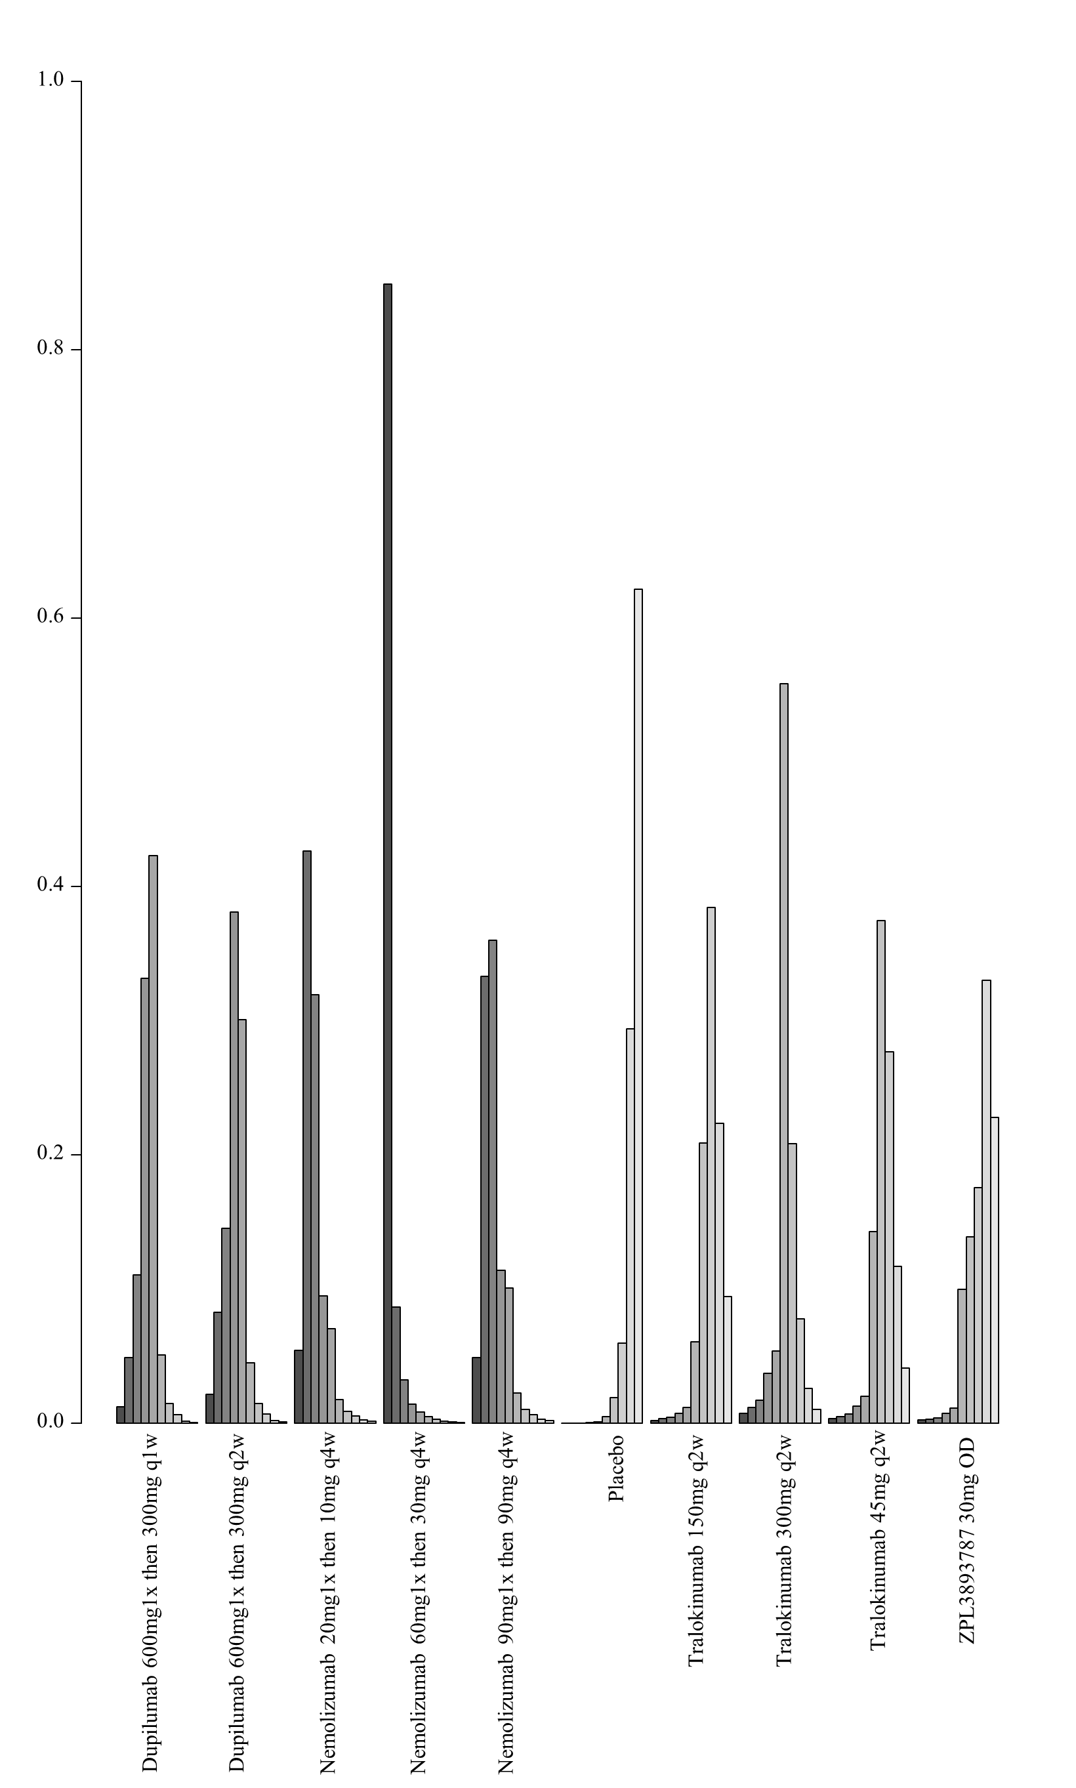

5. Network meta-analysis of change in PPNRS score up to 16 weeks of treatment – analysis including only studies that report results as change from baseline

- Network plot of arms included in the network meta-analysis of change in PPNRS score up to 16 weeks of treatment – including only studies that report results as change from baseline
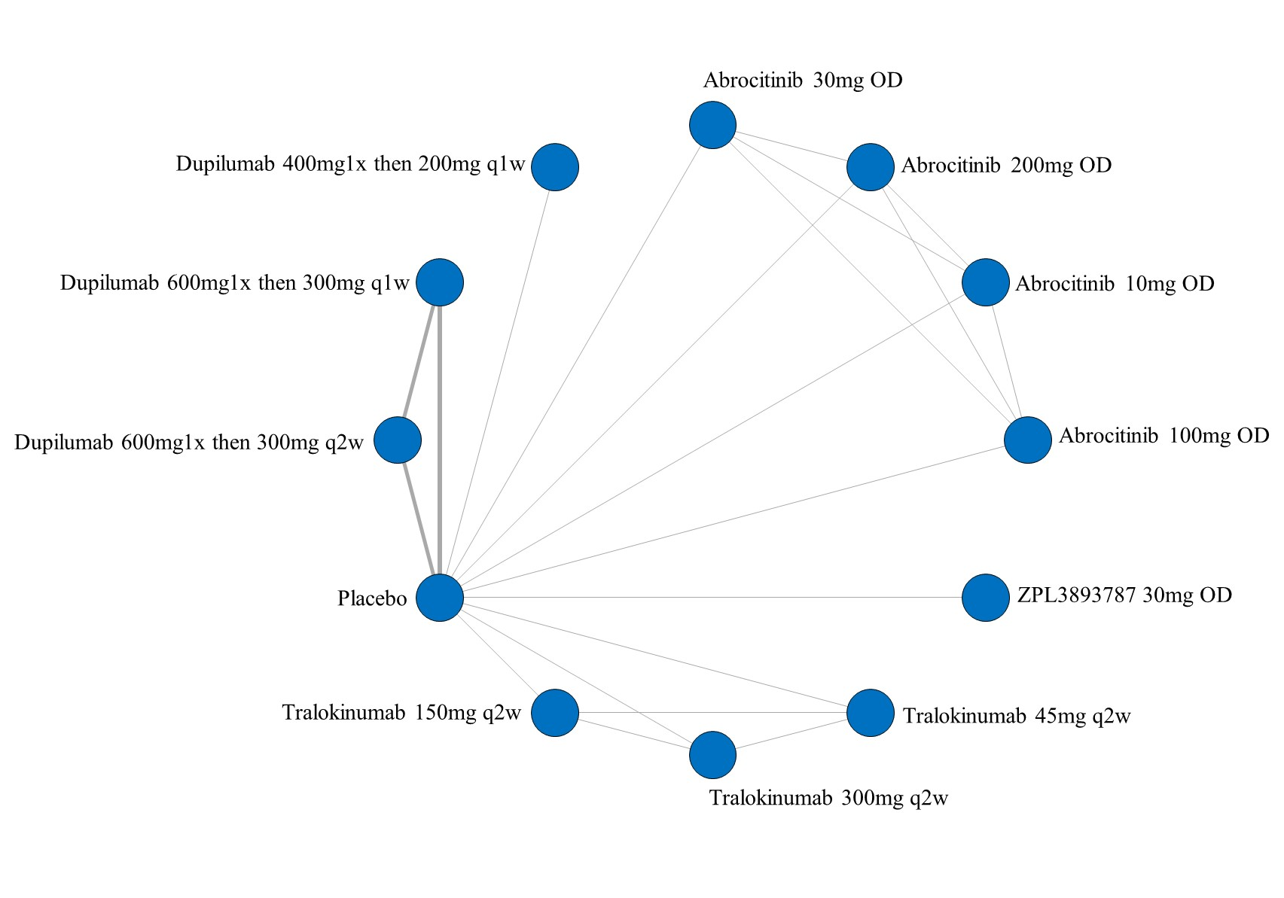

- League table of arms included in the network meta-analysis of change in PPNRS score up to 16 weeks of treatment of the studies that report results as change from baseline. Results are presented as the mean difference (95% CrI) in PPNRS score between the two arms. A positive effect estimate in a given cell favors the row-defining treatment. A negative effect estimate in a given cell favors the column-defining treatment.

iii. SUCRA values and ranking for change in PPNRS score up to 16 weeks of treatment – including only studies that report results as change from baseline

iv. Rank plot of arms included in the network meta-analysis of change in PPNRS score up to 16 weeks of treatment – including only studies that report results as change from baseline
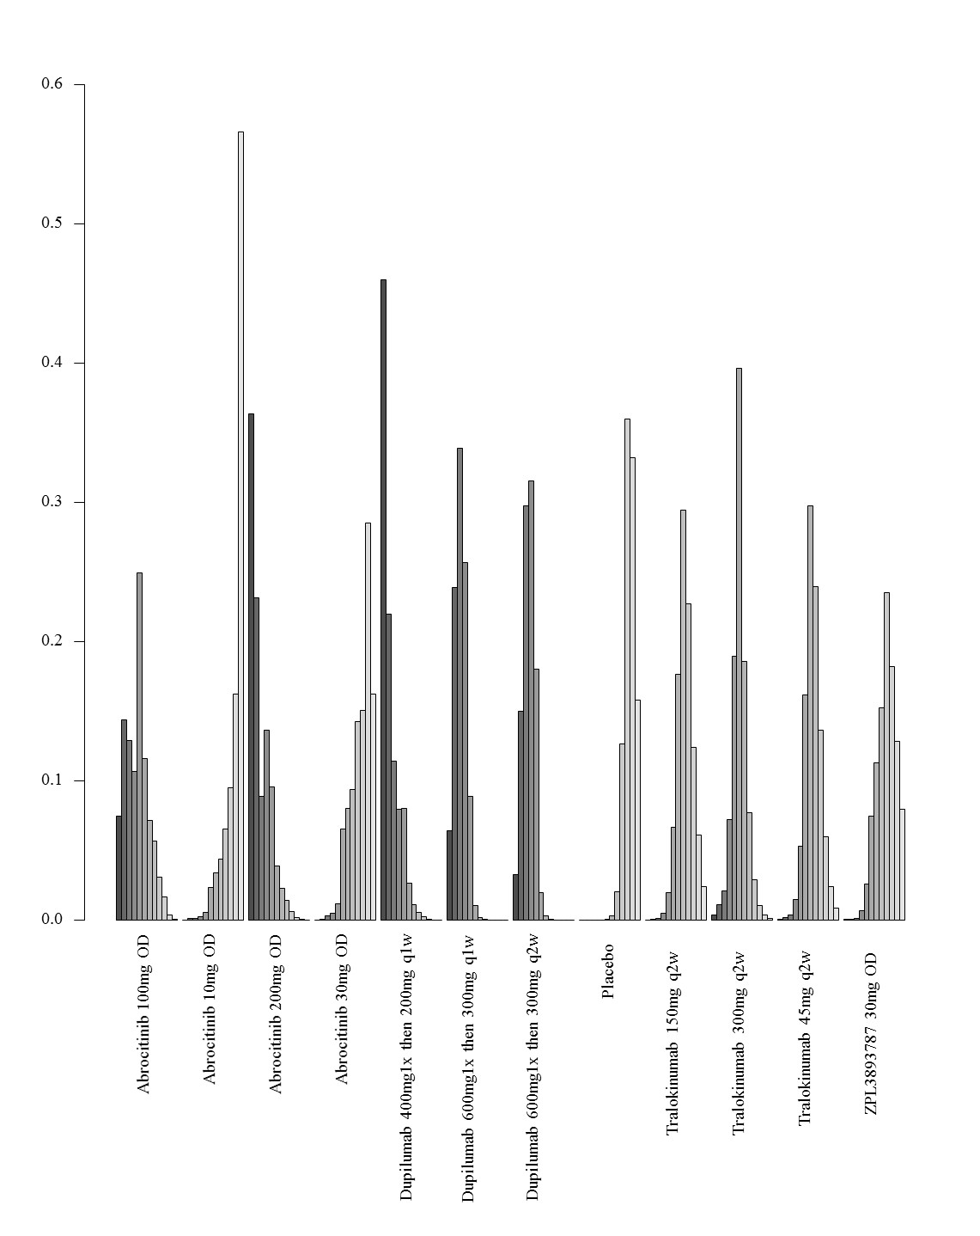

6. Network meta-analysis of change in PPNRS score up to 16 weeks of treatment– analysis including only studies that report results as change from baseline and were at low risk of bias

- Network plot of arms included in the network meta-analysis of change in PPNRS score up to 16 weeks of treatment – including only studies that report results as change from baseline and were at low risk of bias
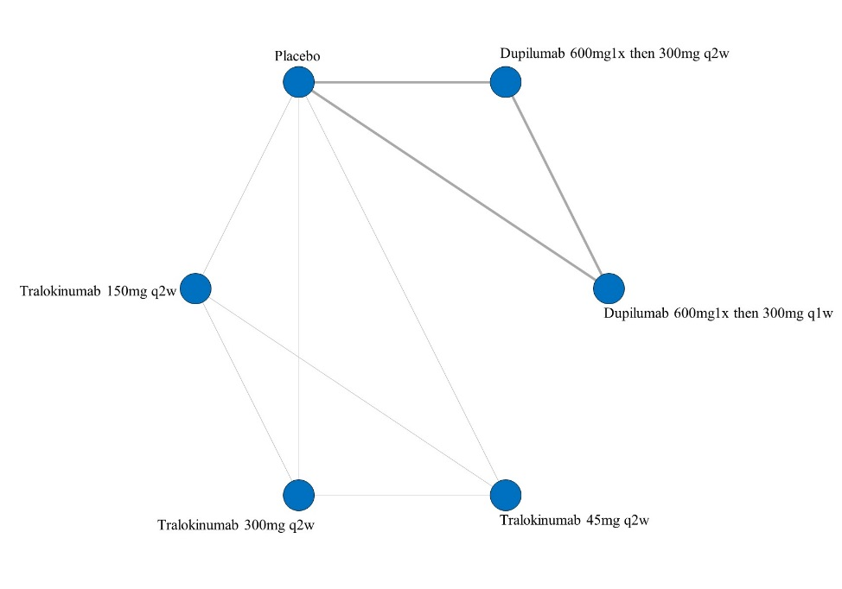
- League table of arms included in the network meta-analysis of change in PPNRS score of the studies that report results as change from baseline and were at low risk of bias up to 16 weeks of treatment. Results are presented as the mean difference (95% CrI) in PPNRS score between the two arms. A positive effect estimate in a given cell favors the row-defining treatment. A negative effect estimate in a given cell favors the column-defining treatment.
iii. SUCRA values and ranking for change in PPNRS score up to 16 weeks of treatment – including only studies that report results as change from baseline and were at low risk of bias

iv. Rank plot of arms included in the network meta-analysis of change in PPNRS score up to 16 weeks of treatment – including only studies that report results as change from baseline and were at low risk of bias
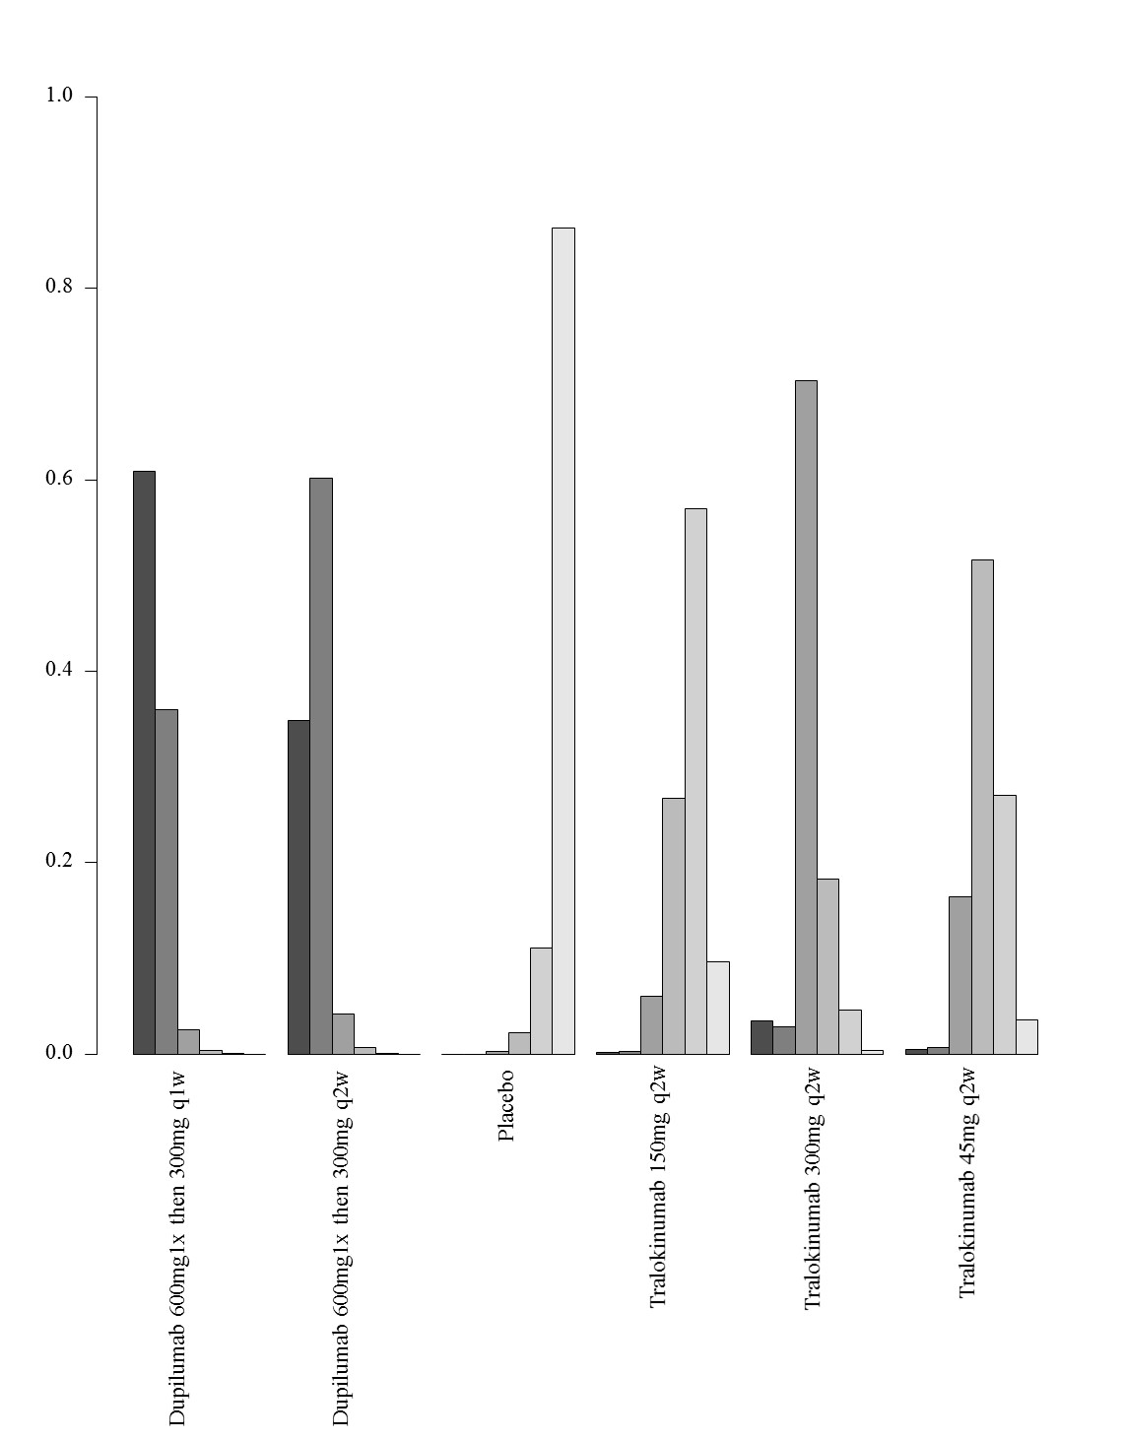

7. Network meta-analysis of change in PPNRS score up to 16 weeks of treatment – analysis including only studies that report results as change from baseline and did not allow concomitant topical anti-inflammatory treatment

- Network plot of arms included in the network meta-analysis of change in PPNRS score up to 16 weeks of treatment – including studies that report results as change from baseline and did not allow concomitant topical anti-inflammatory treatment

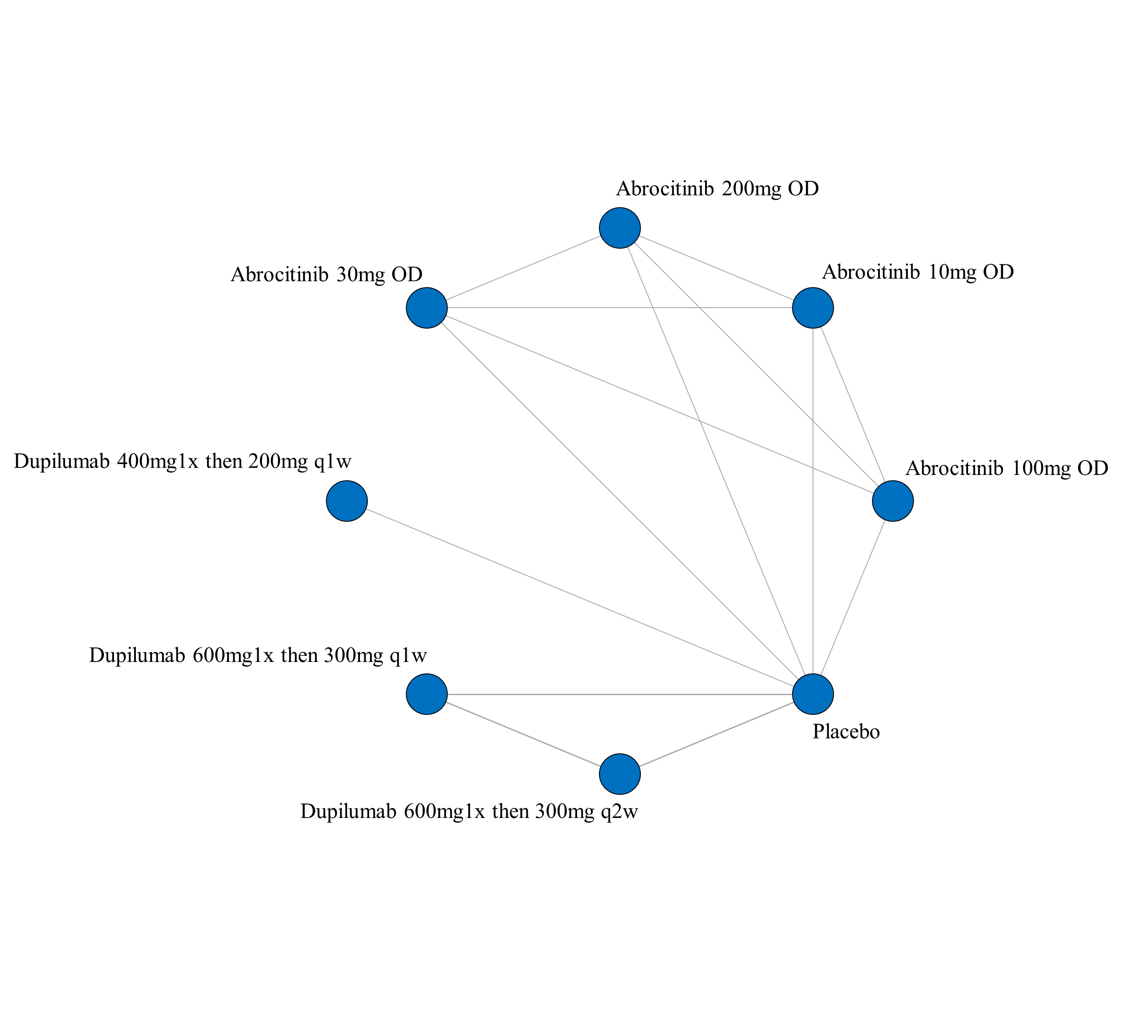
ii. League table of arms included in the network meta-analysis of change in PPNRS score of the studies that report results as change from baseline and did not allow concomitant topical anti-inflammatory treatment up to 16 weeks of treatment. Results are presented as the mean difference (95% CrI) in PPNRS score between the two arms. A positive effect estimate in a given cell favors the row-defining treatment. A negative effect estimate in a given cell favors the column-defining treatment.

iii. SUCRA values and ranking for change in PPNRS score up to 16 weeks of treatment – including only studies that report results as change from baseline and did not allow concomitant topical anti-inflammatory treatment
iv. Rank plot of arms included in the network meta-analysis of change in PPNRS score up to 16 weeks of treatment – including only studies that report results as change from baseline and did not allow concomitant topical anti-inflammatory treatment
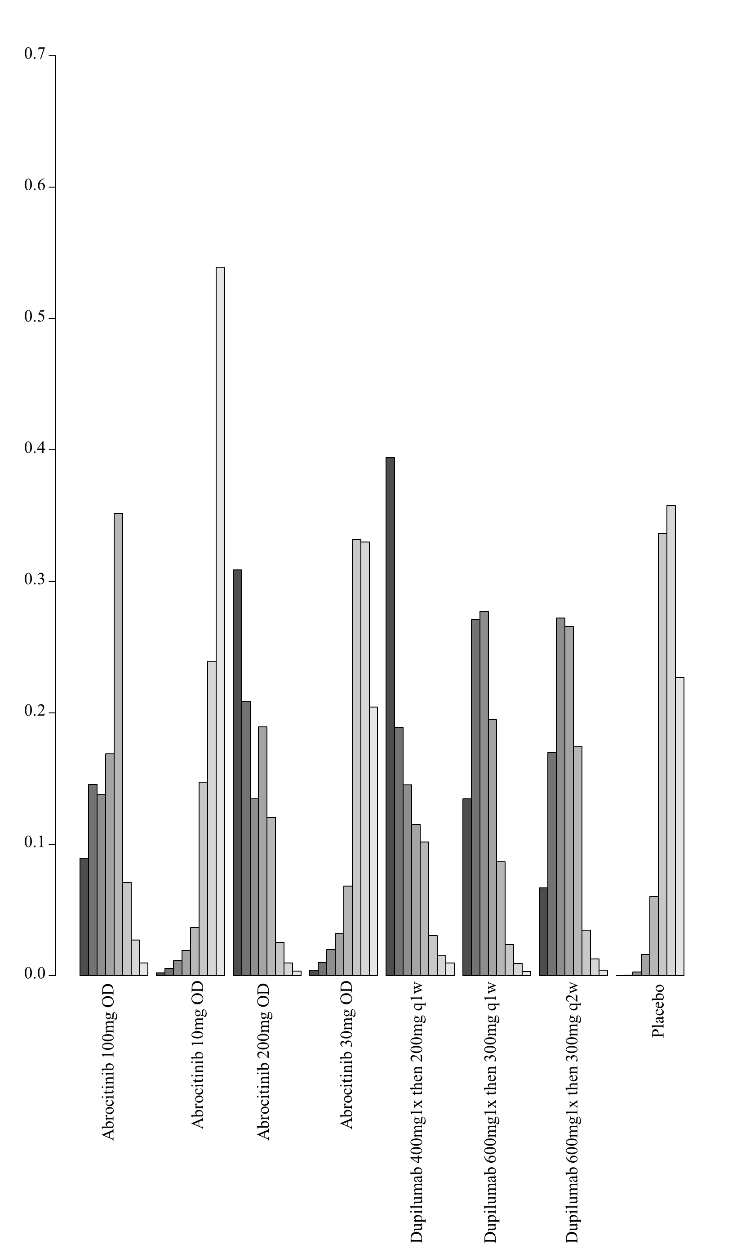

8. Network meta-analysis of change in PPNRS score up to 16 weeks of treatment – analysis including only studies that report results as change from baseline and allowed concomitant topical anti-inflammatory treatment

i. Network plot of arms included in the network meta-analysis of change in PPNRS score up to 16 weeks of treatment – including studies that report results as change from baseline and allowed concomitant topical anti-inflammatory treatment
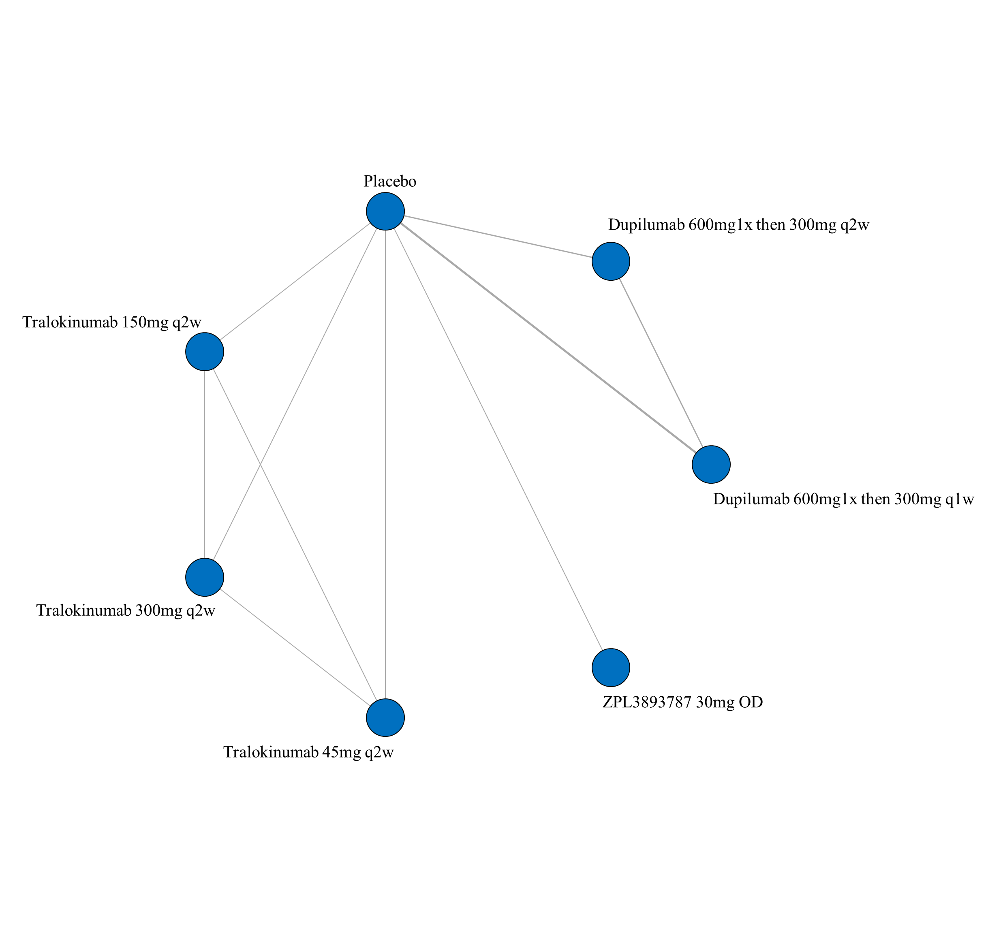

- League table of arms included in the network meta-analysis of change in PPNRS score of the studies that report results as change from baseline and allowed concomitant topical anti-inflammatory treatment up to 16 weeks of treatment. Results are presented as the mean difference (95% CrI) in PPNRS score between the two arms. A positive effect estimate in a given cell favors the row-defining treatment. A negative effect estimate in a given cell favors the column-defining treatment.

iii. SUCRA values and ranking for change in PPNRS score up to 16 weeks of treatment – including only studies that report results as change from baseline and allowed concomitant topical anti-inflammatory treatment

iv. Rank plot of arms included in the network meta-analysis of change in PPNRS score up to 16 weeks of treatment – including only studies that report results as change from baseline and allowed concomitant topical anti-inflammatory treatment
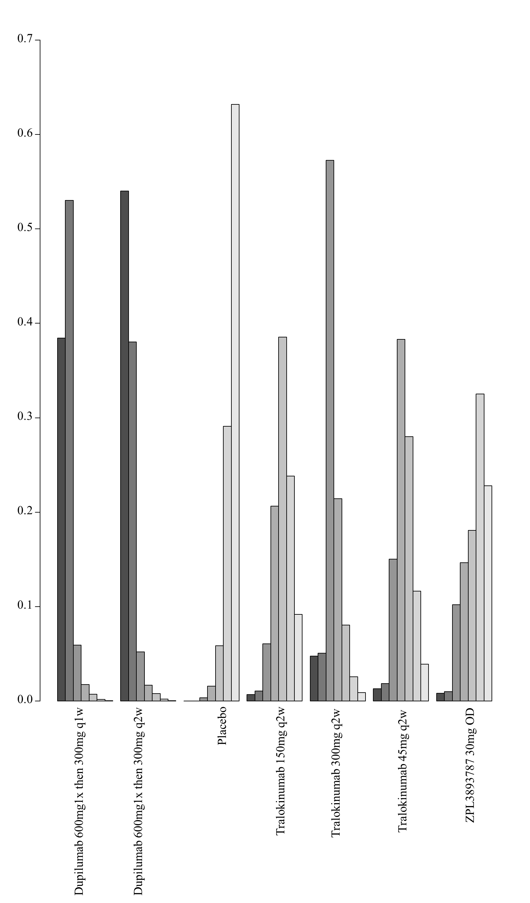

9. Network meta-analysis of change in PPNRS score up to 16 weeks of treatment– analysis including only studies that report results as percent change from baseline

- Network plot of arms included in the network meta-analysis of change in PPNRS score up to 16 weeks of treatment – sensitivity analysis for studies reporting the percent change from baseline
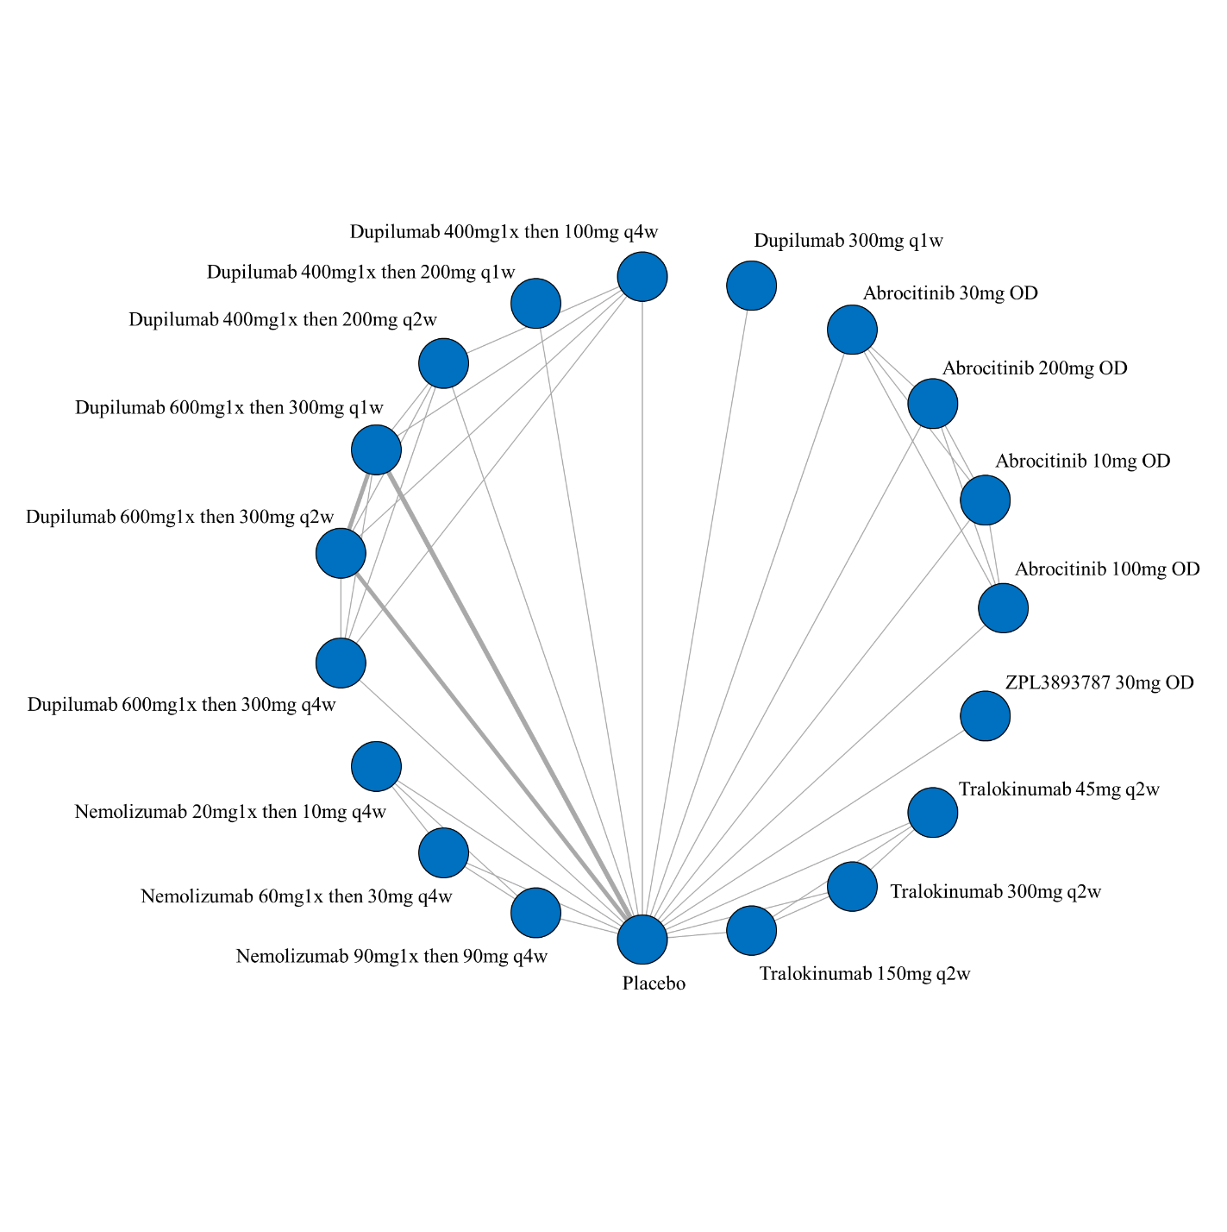

- League table of arms included in the network meta-analysis of change in PPNRS score of all studies that report results up to 16 weeks of treatment (sensitivity analysis for studies reporting the percentage change from baseline). Results are presented as the mean difference (95% CrI) in PPNRS score between the two arms. A positive effect estimate in a given cell favors the row-defining treatment. A negative effect estimate in a given cell favors the column-defining treatment.

iii. SUCRA values and ranking for change in PPNRS score up to 16 weeks of treatment – sensitivity analysis for studies reporting the percent change from baseline

iv. Rank plot of arms included in the network meta-analysis of change in PPNRS score up to 16 weeks of treatment – sensitivity analysis for studies reporting the percent change from baseline
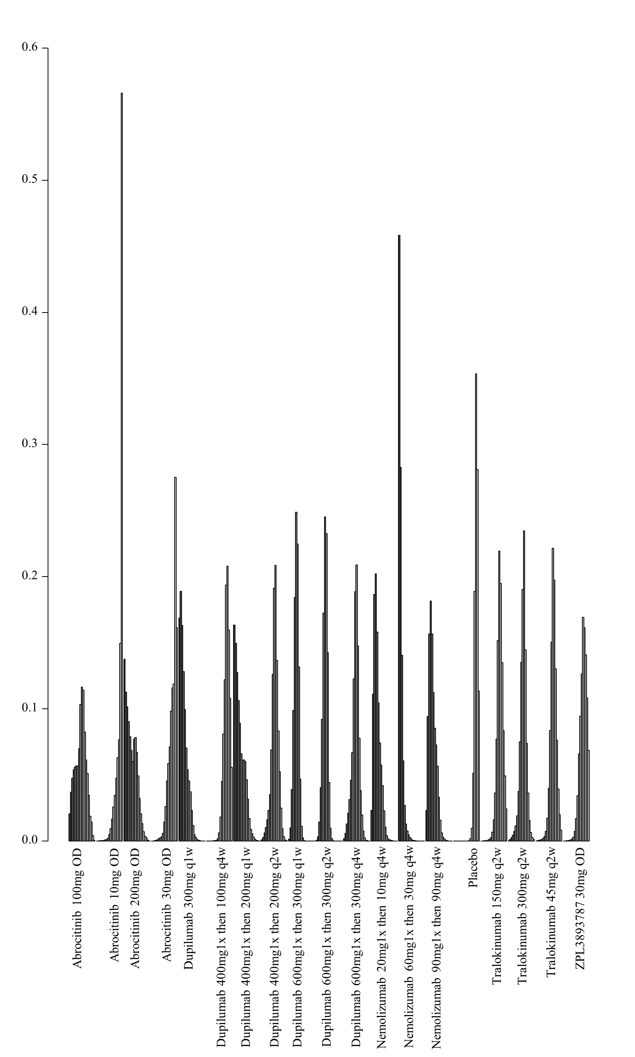

7I. Network meta-analysis of change in itch VAS scores up to 16 weeks of treatment

1. Network meta-analysis of change in itch VAS scores up to 16 weeks of treatment – main analysis

i. Network plot of arms included in the network meta-analysis of change in itch VAS score up to 16 weeks of treatment
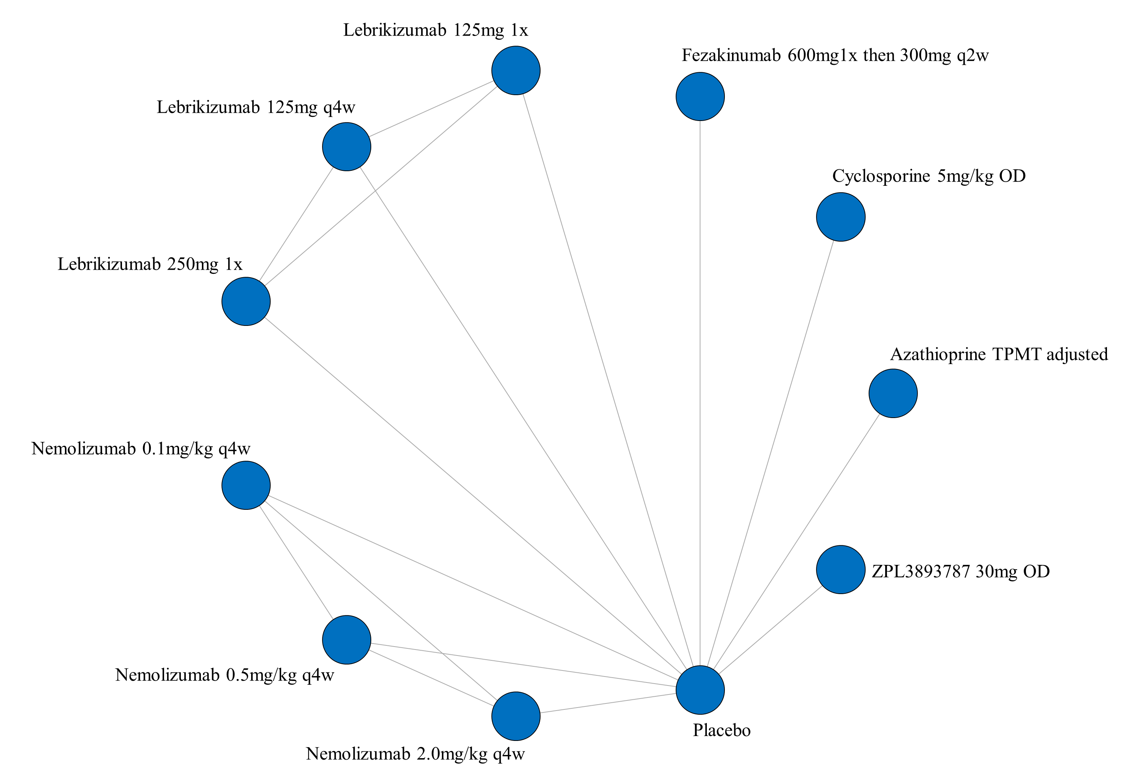

ii. League table of arms included in the network meta-analysis of change in itch VAS score for up to 16 weeks of treatment. Results are presented as the mean difference (95% CrI) in itch VAS score between the two arms. A positive effect estimate in a given cell favors the row-defining treatment. A negative effect estimate in a given cell favors the column-defining treatment.

iii. GRADE assessment of change in itch VAS scores up to 16 weeks of treatment
Itch VAS
All versus Placebo
Drug | GRADE Rating
  Azathioprine TPMT
  Cyclosporine 5mg/kg OD
  Fezakinumab 600mg 300mg q2w
  Lebrikizumab 125mg 1x
  Lebrikizumab 125mg q4w
  Lebrikizumab 250mg 1x
  Nemolizumab 0.1mg/kg q4w
  Nemolizumab 0.5mg/kg q4w
  Nemolizumab 2.0mg/kg q4w
  ZPL3893787 30mg OD
  Low^{1,2,3}
  Low^{1,2,3}
  Low^{1,2,3}
  Low^{1,2,3}
  Low^{1,2,3}
  Low^{1,2,3}
  Low^{1,2,3}
  Low^{1,2,3}
  Low^{1,2,3}
  Low^{1,2,3}
1 – NMA estimate imprecise and would suggest different conclusions at either end of the 95% Credible Intervals
2 – Number of patients included in analysis below optimal information size
3 – significant issues related to risk of bias from included trials
Given the exclusive hub and spoke arrangement, any head to head comparison will be the lowest rated of the two interventions as compared to placebo.

iv. SUCRA values and ranking for change in itch VAS score up to 16 weeks of treatment
v. Rank plot of arms included in the network meta-analysis of change in itch VAS score up to 16 weeks of treatment
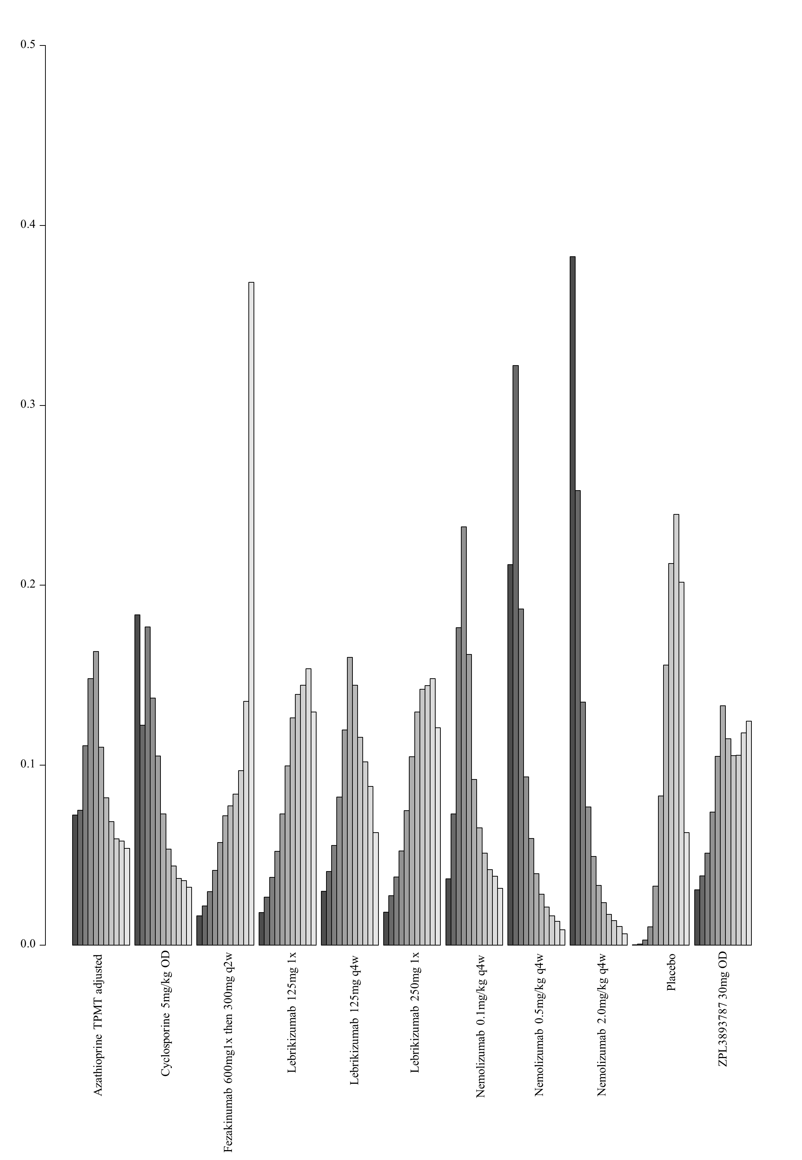

2. Network meta-analysis of change in itch VAS scores up to 16 weeks of treatment – analysis including only studies that allowed concomitant topical anti-inflammatory treatment

i. Network plot of arms included in the network meta-analysis of change in itch VAS score up to 16 weeks of treatment – including only studies that allowed concomitant topical anti-inflammatory treatment
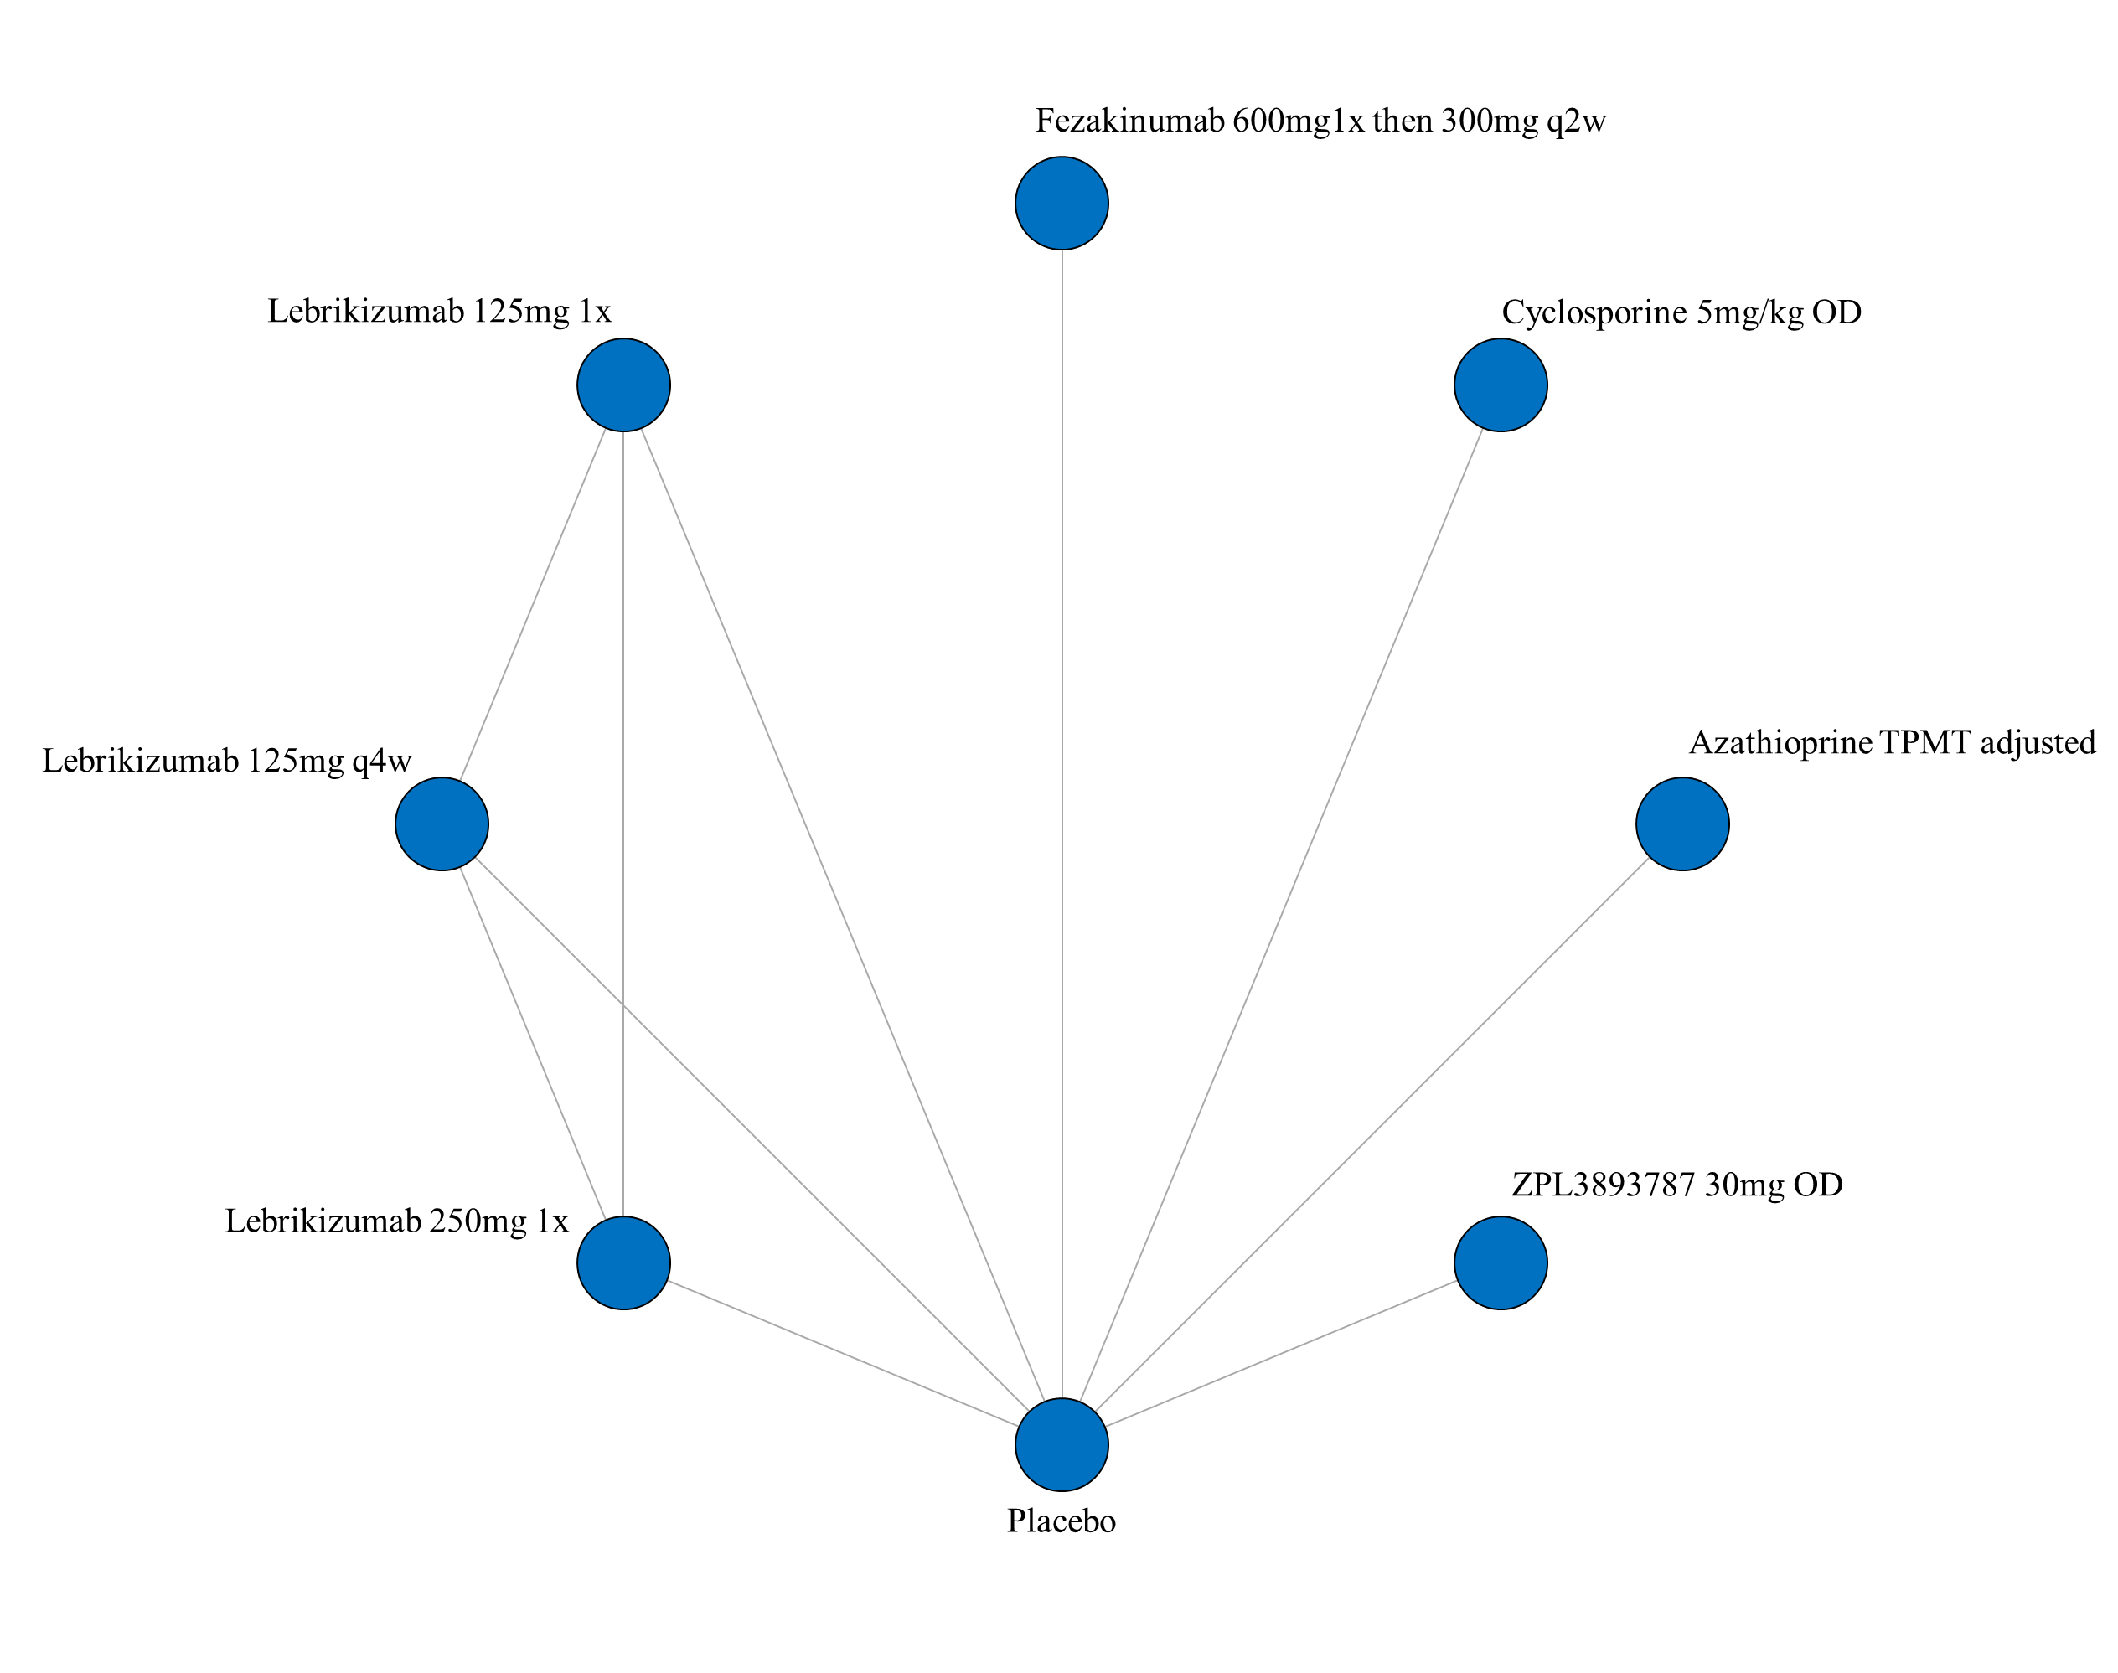

ii. League table of arms included in the network meta-analysis of change in itch VAS score for up to 16 weeks of treatment for studies that allowed concomitant topical anti-inflammatory treatment. Results are presented as the mean difference (95% CrI) in itch VAS score between the two arms. A positive effect estimate in a given cell favors the row-defining treatment. A negative effect estimate in a given cell favors the column-defining treatment.

iii. SUCRA values and ranking for change in itch VAS score up to 16 weeks of treatment – including only studies that allowed concomitant topical anti-inflammatory treatment

iv. Rank plot of arms included in the network meta-analysis of change in itch VAS score up to 16 weeks of treatment – including only studies that allowed concomitant topical anti-inflammatory treatment
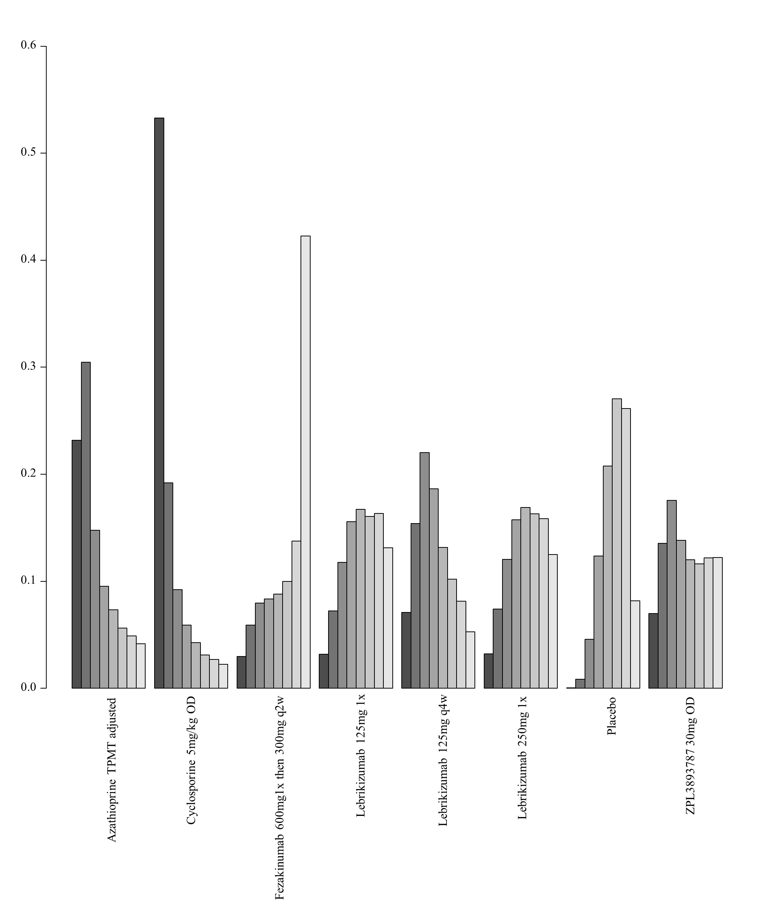

3. Network meta-analysis of change in itch VAS scores up to 16 weeks of treatment – analysis including only studies that report results as change from baseline

i. Network plot of arms included in the network meta-analysis of change in itch VAS score up to 16 weeks of treatment – sensitivity analysis for studies reporting the percent change from baseline
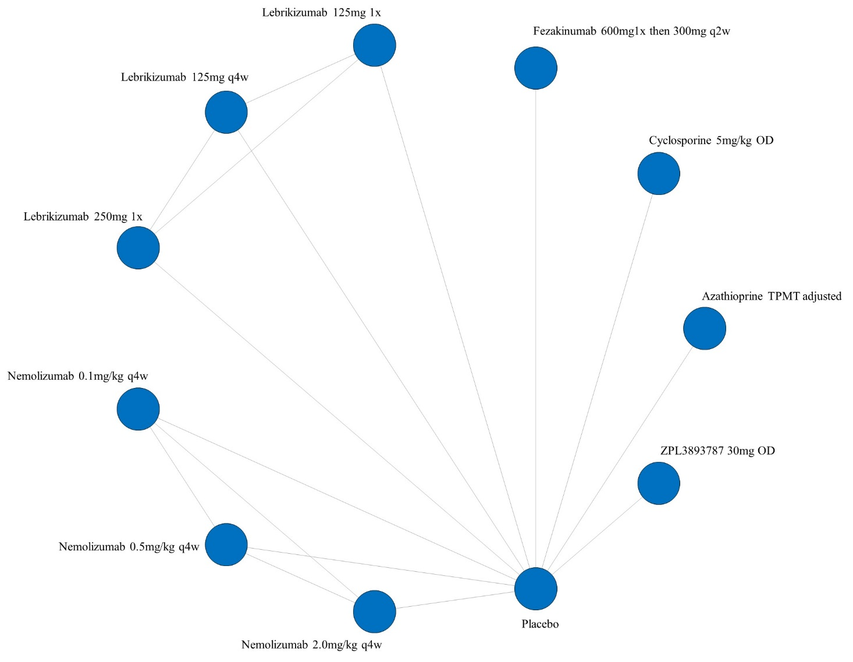

ii. League table of arms included in the network meta-analysis of change in itch VAS score for all studies that report results up to 16 weeks of treatment (sensitivity analysis for studies reporting the percentage change from baseline). Results are presented as the mean difference (95% CrI) in itch VAS score between the two arms. A positive effect estimate in a given cell favors the row-defining treatment. A negative effect estimate in a given cell favors the column-defining treatment.

iii. SUCRA values and ranking for change in itch VAS score up to 16 weeks of treatment – sensitivity analysis for studies reporting the percent change from baseline

iv. Rank plot of arms included in the network meta-analysis of change in itch VAS score up to 16 weeks of treatment– sensitivity analysis for studies reporting the percent change from baseline
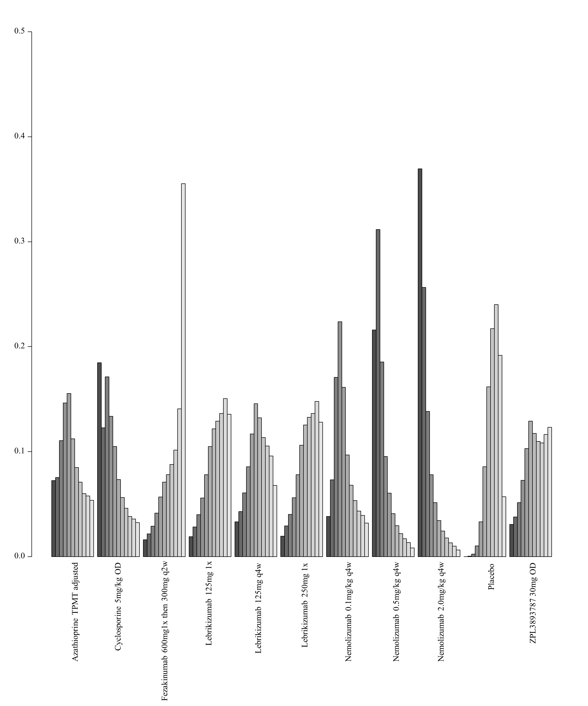

7J. Network meta-analysis of change in itch on the standardized mean difference scale up to 16 weeks of treatment

1. Network meta-analysis of change in itch on the standardized mean difference scale up to 16 weeks of treatment– main analysis

i. Network plot of arms included in the network meta-analysis of change in itch on the standardized mean difference scale up to 16 weeks of treatment
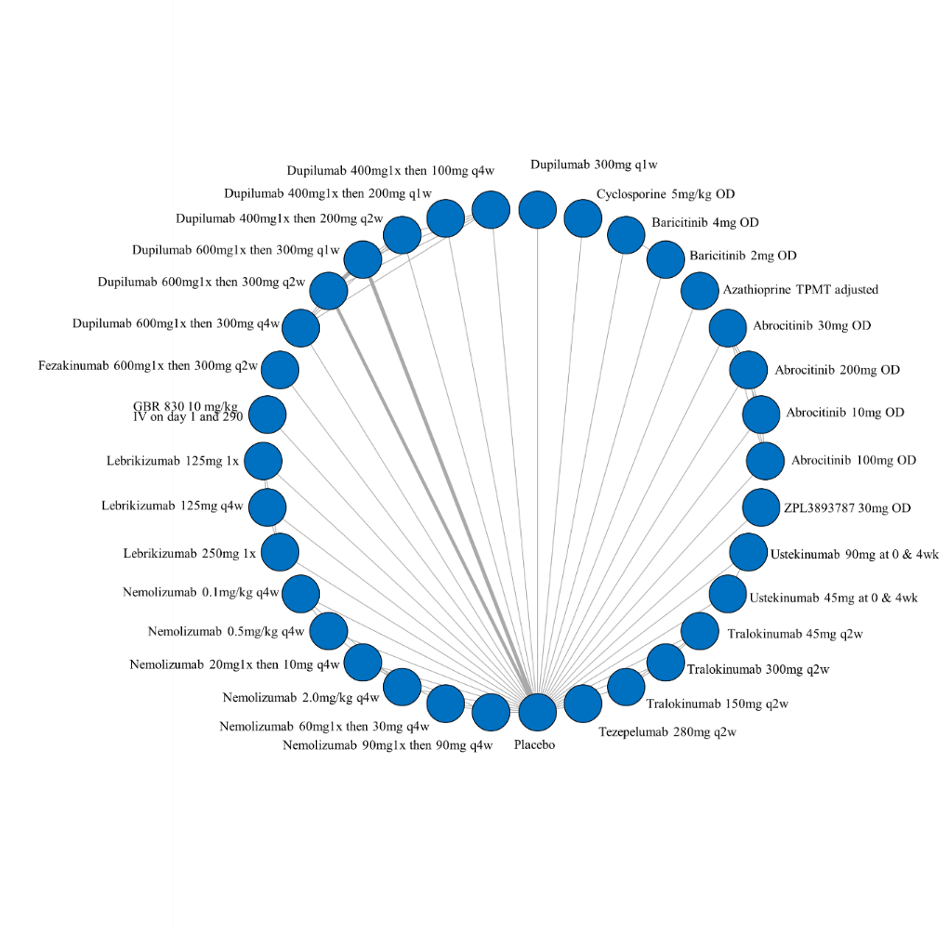

ii. League table of arms included in the network meta-analysis of change in itch on the standardized mean difference scale up to 16 weeks of treatment. Results are presented as the mean difference (95% CrI) in itch between the two arms on the standardized mean difference scale. A positive effect estimate in a given cell favors the row-defining treatment. A negative effect estimate in a given cell favors the column-defining treatment.

iii. SUCRA values and ranking for change in itch on the standardized mean difference scale up to 16 weeks of treatment for all medications

iv. Rank plot of arms included in the network meta-analysis of change in itch on the standardized mean difference scale up to 16 weeks of treatment
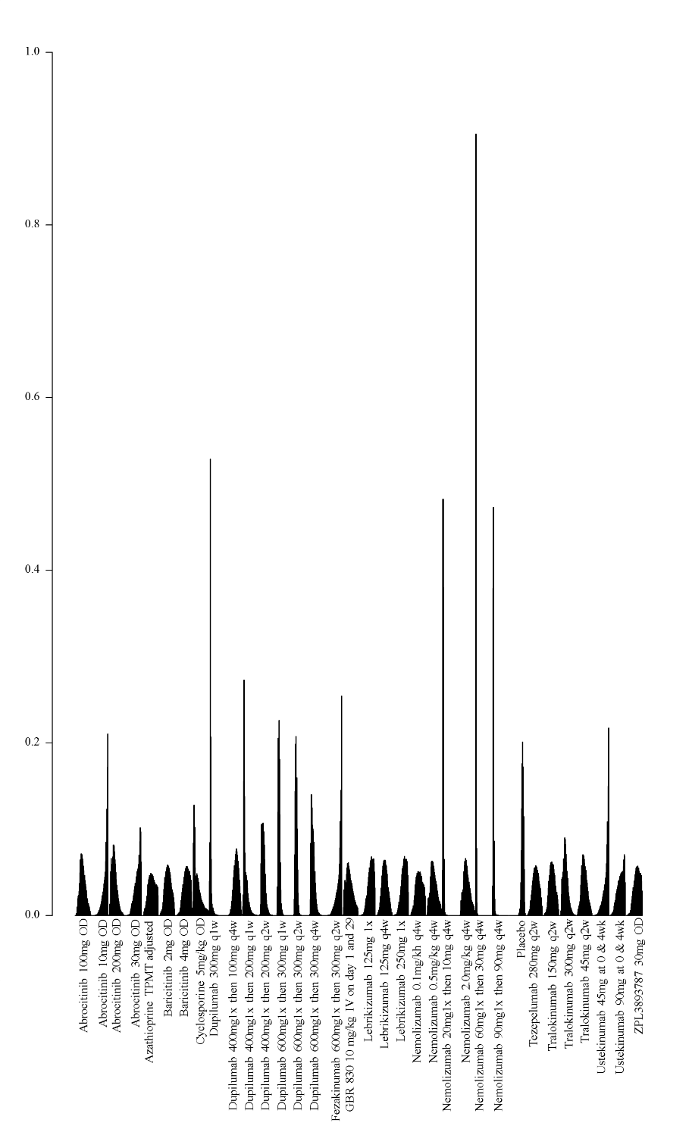

2. Network meta-analysis of change in itch on the standardized mean difference scale up to 16 weeks of treatment – among medications currently in use

- Network plot of arms included in the network meta-analysis of change in itch on the standardized mean difference scale up to 16 weeks of treatment – among medications currently in use
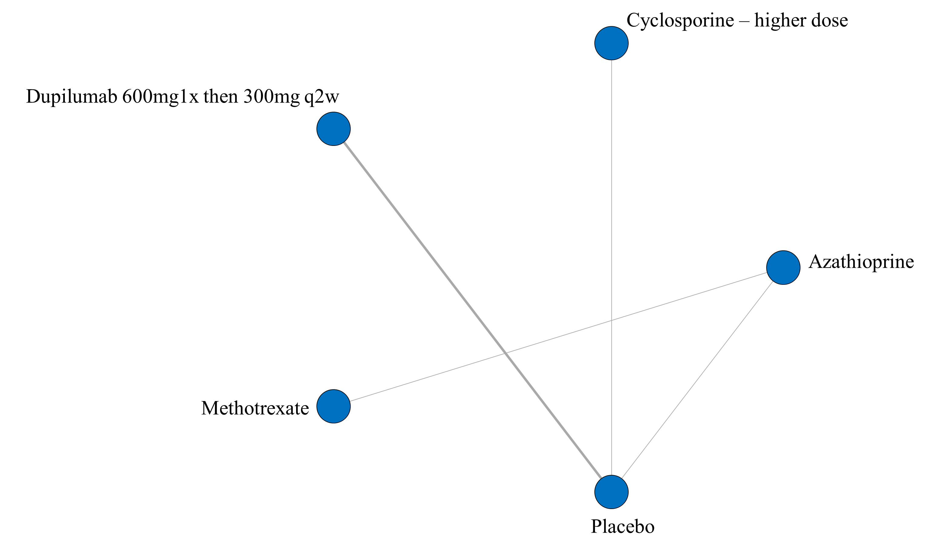
- League table of arms included in the network meta-analysis of change in itch on the standardized mean difference scale up to 16 weeks of treatment among medications currently in use. Results are presented as the mean difference (95% CrI) in itch between the two arms on the standardized mean difference. A positive effect estimate in a given cell favors the row-defining treatment. A negative effect estimate in a given cell favors the column-defining treatment.

iii. GRADE assessment of change in itch on the standardized mean difference scale up to 16 weeks of treatment among medications currently in use
Itch (SMD)
Comparison | GRADE Rating
  Azathioprine vs placebo
  Cyclosporine - higher dose vs placebo
  Dupilumab 600mg1x then 300mg q2w vs placebo
  Methotrexate vs placebo
  Azathioprine vs Methotrexate
  Azathioprine vs Cyclosporine – higher dose
  Azathioprine vs Dupilumab 600mg1x then 300mg q2w
  Cyclosporine – higher dose vs Methotrexate
  Cyclosporine – higher dose vs Dupilumab 600mg1x then 300mg q2w
  Methotrexate vs Dupilumab 600mg1x then 300mg q2w
  Very Low^{1,2,3}
  Very Low^{1,2,3}
  High
  Very Low⁴
  Very Low^{1,2,3}
  Very Low⁴
  Very Low⁴
  Very Low⁵
  Very Low⁴
  Very Low⁵
1 – very serious imprecision (lowered 2 levels) for very imprecise NMA estimate
2 – Number of patients included in analysis below optimal information size
3 – significant issues related to risk of bias from included trials
4 – no direct estimate, first-order indirect loop includes very low certainty evidence and therefore NMA estimate is very low certainty
5 – no direct estimate, no first-order indirect loop, 2nd-order loop includes very low certainty evidence and therefore NMA estimate is very low certainty

iv. SUCRA values and ranking for change in itch on the standardized mean difference scale up to 16 weeks of treatment among medications currently in use
v. Rank plot of arms included in the network meta-analysis of change in itch on the standardized mean difference scale up to 16 weeks of treatment – among medications currently in use
